Steam Release: | Find that Foot (template)

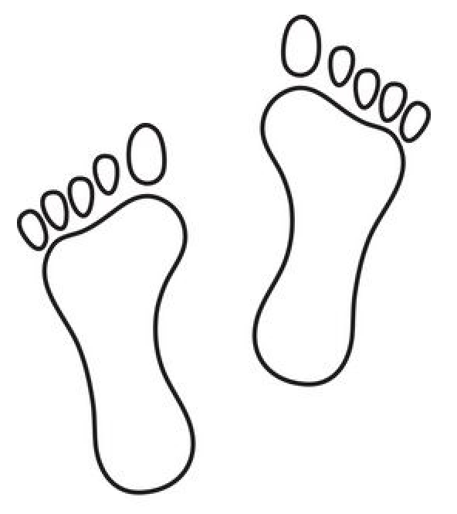

Work Session: | Flags and Countries

Caracal | - Behave correctly during flag ceremonies and during the singing of national anthems.
Cheetah | - Know all the parts of the flag.  - Learn the words of the national anthem and sing it together with other Cubs.  - Draw and colour the South African flag correctly.
Leopard | - Prepare, hoist, break and lower the flag correctly.  - Using a sheet bend join the flag to the halyard.
Lion | - Be able to recognize our five national symbols.

Please don’t forget to evaluate this programme:

