Yarn: | The Captains Vest

PAPER BOAT
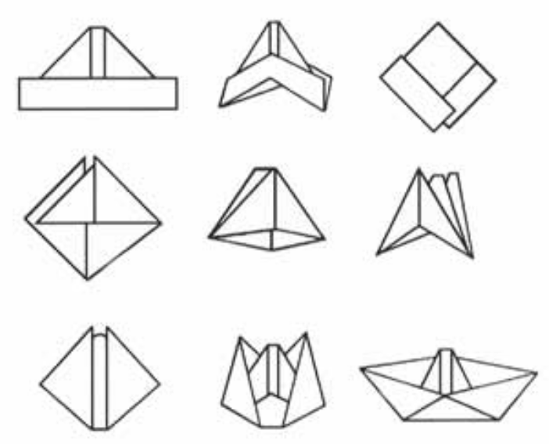
- Fold a sheet of A4 paper in half. Fold down both corners of the paper so they almost meet.
- Fold up the bottom edges of the paper so the paper now looks like a pointed hat.
- Bring the ends together so the paper forms a square.
- Fold up each edge so the paper takes the shape of an isosceles triangle.
- Bring the two equal angles of the triangle together to form another square and flatten the paper.
- Open the square by pulling the two points away from each other.
- Smooth the edges of the paper with your fingertips to form the gunwales and give the boat enough free board to float without taking on water.

THE SHIRT

Follow the directions as you tell the story.

One day a boat left to go fishing. The weather was fine and everything went well – at first. But as the boat got further out to sea, black clouds filled the sky and a terrible storm hit the boat.

The little boat was soon caught in the grip of huge waves. The wind was so strong that the mast snapped clean off. (Tear off the top of the boat’s mast).

Then the boat was hurled against some rocks and the whole of the front came away. (Tear off the front of the boat).

The waves went on battering the boat mercilessly until soon the stern also disappeared under the sea. (Tear off the back of the boat).

The boat went down (hide your hands behind your back and open out the paper), and later when the storm had abated, all that was seen was the captain’s shirt floating on the water where once the boat had been. (Produce the piece of paper triumphantly from behind your back).

Singing: | My Bonnie lies over the ocean

My Bonnie lies over the ocean,
My Bonnie lies over the sea,
My Bonnie lies over the ocean,
Oh, bring back my Bonnie to me, to me.

Bring back, oh bring back,
Oh, bring back my Bonnie to me, to me,
Bring back, oh bring back,
Oh, bring back my Bonnie to me.

Work Session: | Knotting

Caracal | Make and use the following knots correctly:  - Reef  - Slip reef  - Hank a short tope
Cheetah | Make and use the following knots:  - Round turn and two half hitches  - Figure of eight
Leopard | Make and use the following knots:  - Sheet bend  - Hank a long rope
Lion | Make and use the following knots:  - Clove hitch  - Bowline  - Sheep shank

Please don’t forget to evaluate this programme:

