Playacting: | Charades (ideas)

Pirate | Witch | At gym | Fishing
Reading | Writing | Swimming | Playing the piano
Playing the guitar | Listening to music | Dancing | Singing
Elephant | Horse | Bird | Fish
Lion | Happy | Sad | Bathing
Drinking something hot | Eating | Being rude | Surprised
Scared | Cold | Hot | Laughing

Work Session: | Safety
Caracal | - Demonstrate safety on the road as a pedestrian and know the safety rules to follow when in or near water.
Cheetah | - Be aware of possible dangers at your home, school or pack meeting place.
Leopard | - Organise a road safety activity for younger cubs.  OR  Demonstrate safety on the road for a cyclist.
Lion | - Explain how to avoid getting lost in the veld.  - Demonstrate three ways of making distress signals.  - Demonstrate how to purify water.

Activity: | Map Drawing

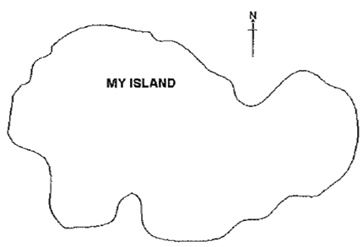

- Draw on the sheet of paper an island to fill most of the page (example above)
- Put a compass rose in the top right corner of the map as above.
- In the centre of the island draw a lake.
- From the lake draw a river running south into the sea.
- Where it meets the sea, draw a house on the east bank.
- On the far east of the island, draw some trees.
- South of the trees, draw a windmill.
- At the northeast point of the island draw a lighthouse.
- Next to the lighthouse draw a heliport (where they land the helicopters – big circle with an H in the middle).
- From the lighthouse draw a road to finish at the house.
- At the west side of the island draw a police station in between two houses.
- From the police station draw a footpath to the lighthouse along the coast.
- From the houses, draw another road to the first house, crossing the river by a bridge.
- Connect the windmill to the road by drawing another road.
- On the northwest side, draw a hill.
- Connect the hill to the lighthouse with a railway line.
- Etc – you can make up your own instructions ….
- At the end of the exercise tell them to mark an X at the police station so that they know where they are.

Please don’t forget to evaluate this programme:

