Yarn: | Go Fly a Kite

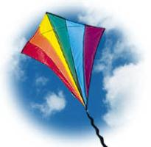
Rachel was very excited. Akela was taking the Cubs on a special adventure this Saturday and she had said that she had a big surprise for the Cubs today. Out of her trunk she pulled the biggest kite Rachel had ever seen! "Let’s go!" Akela shouted. Down to the beach they went. It was a very windy day, perfect for kite flying - or so they all thought.

OK Rachel – it is your turn to go first, you hold the kite and I'll pull it into the sky." Rachel ran down the beach with the kite and then held it tight. Akela yelled "Let go" as she pulled hard on the string. But it was so windy that Rachel didn’t hear her.

Akela called to Rachel. "OK. Now it’s Robert’s turn to fly the kite!" But when she looked around, she couldn’t see Rachel anywhere. There were no trees for her to hide behind. Where could she be? Then they all looked up. Waaayyyyyy up! They could just see Rachel peeking over the end of the kite. She was flying!

"Rachel! Get down here!” But Rachel could not get down. Akela started to reel in the kite. But just as Rachel was getting close to the ground - the string broke! The kite flew up, up, up with Rachel still holding tight!

"Get me down!" yelled Rachel. Akela was now running down the beach after her. "Come back here Rachel!" The kite headed straight for an apartment building.

Vroom!!! She flew right into an open window and through a living room where a man sat eating pop-corn and watching a football game. "Yikes" yelled the man. He was so surprised that his pop-corn flew all over the room.

Vroom!!! Down the hall Rachel flew. There was a lady just coming out of the bathroom. "Yikes" yelled the lady. She was so scared that she jumped up in the air and her feet landed in the toilet.

Vroom!!! Rachel flew through the bedroom where there was a little baby sitting in a crib. The baby laughed when Rachel flew by. Right out the bedroom window Rachel flew. By this time there were nine police cars and three fire engines chasing Rachel. She was heading straight for the zoo!

Vroom!!! Through the lion’s den she flew. They jumped up at her but she was flying too fast.

Vroom!!! Through the monkey’s cage she flew. She knocked one monkey right out of a tree.

Vroom!!! She flew right between the legs of a big giraffe!

Vroom!!! She was headed for the elephants. One big elephant lifted his trunk and caught Rachel by the leg. He put Rachel on his back just as 31 police cars and 9 fire trucks pulled up.
"Get me down from here" yelled Rachel. One of the fire trucks put out its ladder and a firefighter climbed up to lift Rachel down.

Rachel gave Akela a big hug. "Akela! You always have the best ideas! What are we going to do next week?"

Handcraft: | The Newspaper Kite

Materials: This kite has no rigid sticks used in its construction, instead you use rolled up newspaper, so if you have an old newspaper, a roll of sellotape, something for the tail and some scissors you have everything you need!

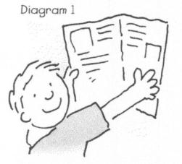  From a regular newspaper, take a full piece (usually four pages with the crease in the middle). See above. | 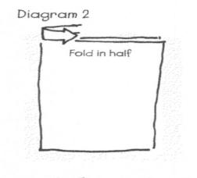  Fold in half using page crease – so the paper is taller than it is wide. | 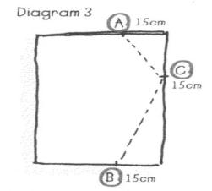  Make a mark 15 cm in from the edge on both the top (point A) and bottom (point B) of the folded paper. From the top corner, also make a mark 15 cm down the edge (point C). See above.  Draw a line on the top edge connecting the points A-C and C-B. Cut along these lines. | 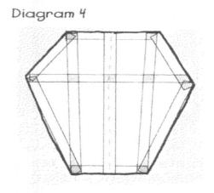  Open up the paper. Using tape, tape along the edges and on the inside as shown above. This is to keep the kite strong so it won’t tear while in the air.

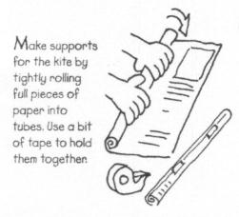  Now you need to make two supports for the kite. Using another full piece of paper, tightly roll it into a tube. Use a little bit of tape to help keep it rolled up. Do this twice.  KITE FLYER’S CODE  - I will fly kites in an open field, away from electric power lines and transmission towers.  - I will use dry string, never wire. (Wire could attract and conduct lightning. I won’t use anything metal in my kites.  - I will not try to remove a kite if it catches in an electric power line or on a high pole.  - I will not fly kites on or near public roads or highways.  - I will never fly a kite in wet or stormy weather. That only invites lightning. | 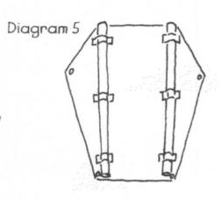  Now tape these tubes to the kite along the lines indicated in the above diagram. If the rolls are too long, cut them to size. | 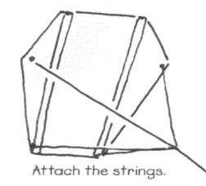  Next you need to make a hole in each side of the kite at the side points and at the bottom. A paper hole punch works well. You should be punching through tape so the hole doesn’t rip. Then you need to cut two pieces of string, the first one a metre and a half long. Tie the first one across the widest point of the kite. In the middle of the first one make a loop; this is the bridle that will allow you to attach the kite to your string.  The second piece of string can be about one metre long. Tie this between the two points at the bottom. Attach three to five metres of something light to act as a tail; chevron tape or streamers work well. | 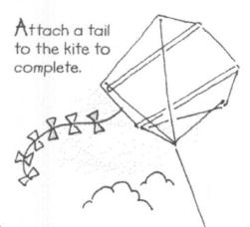  Go fly the kite! You can experiment with the length of the first piece of string along the widest part of the kite; tie the knot to shorten the midpoint and see what effect it has on how the kite flies. You can also experiment by adding a crosspiece of rolled paper between the two spars on the kite; does it help or hinder the kite? How does moving it at different points up and down the middle affect how the kite flies?

Work Session: | Knotting

Caracal | Make and use the following knots correctly:  - Reef  - Slip reef  - Hank a short tope
Cheetah | Make and use the following knots:  - Round turn and two half hitches  - Figure of eight
Leopard | Make and use the following knots:  - Sheet bend  - Hank a long rope
Lion | Make and use the following knots:  - Clove hitch  - Bowline  - Sheep shank

Sing Song: | If you’re happy…

If you’re happy and you know it,
Clap your hands,
If you’re happy and you know it,
Clap your hands,
If you’re happy and you know it,
And you really want to show it,
If you’re happy and you know it,
Clap our hands.

If you’re happy and you know it,
Click you thumbs.

Stamp your feet.
Shout “WE ARE”.
Do all four.

Please don’t forget to evaluate this programme:

