Yarn: | Ging Gang Gooli

During the first World Jamboree B-P was looking for a song that everyone could sing, no matter what their language was. Ging Gang Gooli was the result. It is of no language, but it means a lot of fun. The story was apparently created later.

In the deepest darkest Africa there is a legend concerning the Great Grey Ghost Elephant. Every year, after the rains, the Great Grey Ghost Elephant rose from the mists and wandered throughout the land at dawn. When he came to a village, he would stop and sniff the air, and then he would either go around the village or through it. If he went around the village, the village would have a prosperous year, if he went through it, there would be hunger and drought.

The village of War-Cha had been visited three years in a row by the elephant and things were very bad indeed. The village leader, Ging-Ganga was very worried, as was the village medicine man Ha-la-shay. Together, they decided to do something about the problem. Now Ging-Gang and his warriors were huge men with big shields and spears. They decided to stand in the path of the elephant and shake their shields and spears at it to frighten it away. Hay-la-shay and his followers were going to cast magic spells to deter the elephant by shaking their medicine bags as the elephant approached which made the sound shallawaly, shallawaly, shallawaly.

Very early in the morning of the day the Great Grey Ghost Elephant came, the villagers gathered at the edge of the village, on one side were Ging-Ganga and his warriors, (indicate right) and on the other was Hay-la-shay and his followers (indicate left). As they waited the warriors sang softly about their leader Ging gang gooli, gooli, gooli, gooli, watcha, Ging Gang goo, Ging gang goo, Ging gang gooli, gooli, gooli, gooli, watcha, Ging gang goo, Ging gang goo.

As they waited the medicine men sang of their leader Heyla, heyla sheyla, Heyla, sheyla, heyla ho, Heyla, heyla sheyla, Heyla sheyla, heyla ho.

As they shook their medicine bags, shalli-walli, shalli-walli, shalli-walli, shalli-walli. And from the river came the mighty Great Grey Ghost Elephant’s reply, Oompa, oompa, oompa….

The elephant came closer, so the warriors beat their shields and sang louder (signal warriors to stand and beat their thighs in time). Ging gang gooli, gooli, gooli, gooli, watch, Ging gang goo, Ging gang goo, Ging gang gooli, gooli, gooli, gooli watch, Ging Gang goo, Ging gang goo.

The medicine men rose and sang loudly, Heyla, heyla sheyla, Heyla, sheyla, heyla ho, Heyla, heyla sheyla, Heyla sheyla, heyla ho. And they shook their medicine bags, Shalli-walli, shalli-walli, Shalli-walli, shalli-walli. And the mighty grey elephant turned aside and went around the village saying Oompa, oompa, oompa…

There was great rejoicing in the village and all the villagers joined together to sing … Ging gang gooli …

Ack: Australian Scout, August 1996

Sing Song: | Ging Gang Gooli

Ging gang, gooli, gooli, gooli, gooli, watcha
Ging gang goo, Ging gang goo,
Ging gang, gooli, gooli, gooli, gooli, watcha
Ging gang goo, Ging gang goo,
Heyla, heyla sheyla, heyla sheyla, heyla ho,
Heyla, heyla sheyla, heyla sheyla, heyla ho,
Shalli-walli, shalli-walli, shalli-walli, shalli-walli
Oompa, oompa…

Activity: | Paper Elephant Chain

Instructions:

- Fold a sheet of A4 paper (or similar) in a concertina style making sure that the width of the fold will accommodate the width of the elephant template.
- Position the template on the folded paper so the arrows marked on the template are against the folds in the paper.
- Fix the template into place on the folded paper with paper clips or something similar.
- Cut along the outline of the shape, holding the folded paper firmly and repositioning the paper clips as required.

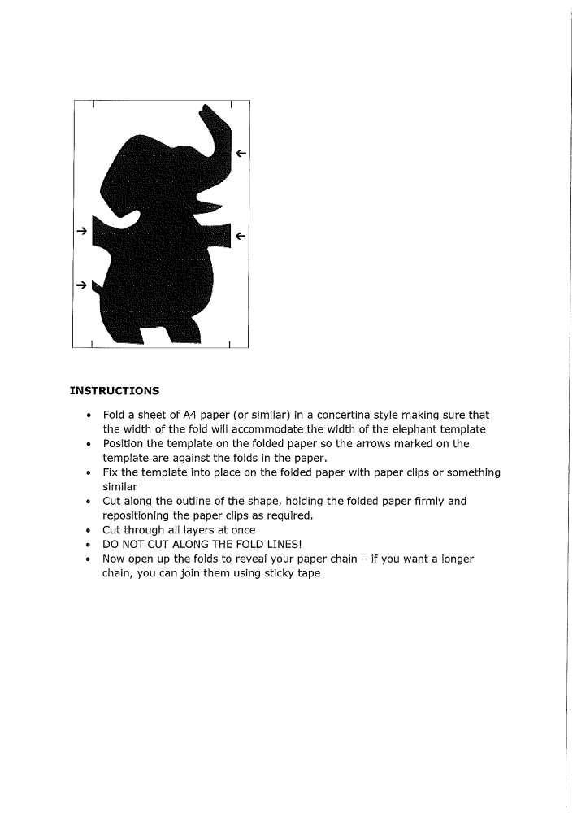
- Cut through all layers at once.
- DO NOT CUT ALONG THE FOLD LINES.
- Now open up the folds to reveal your paper chain. If you want a longer chain, you can join them using sticky tape.

Work Session: | Sensations

Caracal | - Know the story of Kim.  - Play Kim’s game using ONE of the five senses and succeed in identifying five out of ten objects.
Cheetah | - Play TWO different Kim’s games using TWO of the five senses and succeed in identifying seven out of ten objects, sounds or tastes in each one.
Leopard | - Play THREE different Kim’s games with THREE of the five senses, scoring at least ten out of fifteen in each one.
Lion | - Play FIVE different Kim’s games using each of the FIVE senses, scoring at least fifteen out of twenty in each one.

Please don’t forget to evaluate this programme:

