Yarn: | Hans and his dog

Hans lived in Switzerland with his aunt and uncle, as he hadn’t a father and mother of his own. His uncle was a guide. One day a prince came to the village and sent for his uncle as he needed a guide. Hans was taken to see the prince because he was just five years old. The prince asked his age, and gave him a gold piece as a birthday present, to buy what he wanted most. His aunt said he must buy a silver watch chain to wear on Sundays. After a time, it was put away in a chest with his best clothes; when Hans asked for it to play with once, his aunt was horrified at the idea. After a year, a fair came to the village. Hans wore his best clothes and went to it with his aunt. She had promised him a ride on the merry-go-round, but she got talking to friends and forgot.

A man came and sat down by Hans with a puppy. “Anyone like to buy him?” he asked the world at large. “I would,” said Hans, “but I only have this silver chain.” The man took the chain in exchange. Hans ran to find his aunt, who was still talking. She was angry, and tried to find the man again, but could not do so, and for this reason she let him keep the puppy. “A dog is better than nothing,” she reasoned. Hans called the dog “Prince”, after the giver of the gold piece. It grew in two years to be a fine St Bernard dog, and Hans was very fond of it. One snowy day, Hans’ soldier cousin borrowed the dog, and left it at an inn, having forgot it. “He’ll come back; if not, I’ll fetch him in the morning,” he told Hans.

But Hans was anxious about his dog. “Why not go myself?” he thought. He knew the way, so went. It was very cold. He could hardly whistle. After a time, he felt sleepy. “I’ll have a rest and then go on,” decided Hans. Soon he was a dark heap on the snow, and the snowflakes started to cover him. Just then, Prince came down the road. He had hastened after the soldier cousin when he discovered he had been left behind, and was thinking of Hans when he saw him there. All dogs in Switzerland know that those who sleep in the snow seldom wake up. Prince barked: “Bow-wow-wake up.” Hans did not hear, but the people in the village did, and they came to see what was the matter. Now even Hans’ aunt agrees with him that Prince is better than all the silver watch chains in the world.

Maude Lindsay

Handcraft: | Pencil Holder

Equipment:

Empty plastic container (such as a yoghurt cup)
Pieces of coloured paper
Scissors
Glue and glue brush
Pictures
Clear varnish
Brush
Florist’s ribbon (optional)

Directions:

- Wash and dry the container thoroughly.

- Cut various shapes from paper in assorted colours. Apply glue to the outside of a part of the container and cover it with pieces of paper. The edges of the paper must overlap. Repeat the process until the entire outside of the container is covered. The pieces of the paper must only be pasted up to the neck of the container. Cut out larger shapes and paste them onto the front. Allow to dry.

- Apply a coat of varnish to the outside of the container. Allow to dry thoroughly.

- Measure, cut and glue florist’s ribbon around the neck of the container.

Tips:

- Use gift-wrap with pictures of flowers, animals and so forth. Cut out the motifs and use them to cover the container.
- Pieces of paper can also be pasted in strips or dots for a different effect.

Singing: | The More We Get Together

Try this song as a round.

The more we get together, together, together
The more we get together
The happier we’ll be.

For your friends are my friends
And my friends are your friends
The more we get together the happier we’ll be.

Work Session: | As per progress chart

Caracal | - As per progress chart
Cheetah  Leopard | - As per progress chart  - As per progress chart
Lion | - As per progress chart

Relay Game | Friendship Puzzle

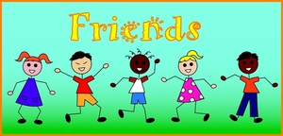
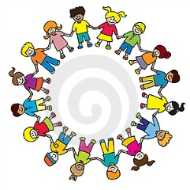


A new friend, a true friend
A cheers-me-when-I’m-blue friend
A sunny-day-hurray friend
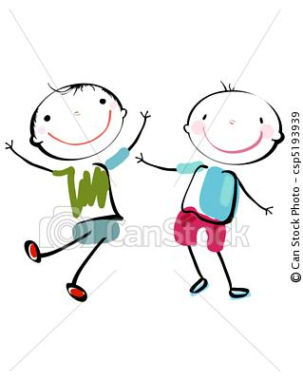
A come-over-and-play friend
A nice-in-every-way friend
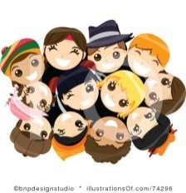
A new friend, a true friend
A turns-the-grey-skies-blue friend
A talk-and-talk-non-stop friend
A giggle-till-we-drop-friend
A none-can-ever-stop friend
A new friend, a true friend
A happy-I-met-you friend
Marie Flemming
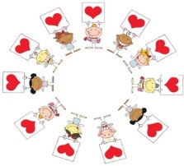
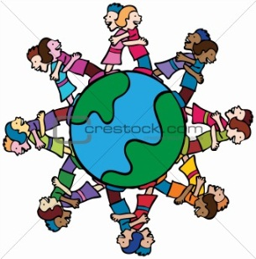


Please don’t forget to evaluate this programme:

