Handcraft: | Octopus

Equipment:

Template
Crayons
Glue
Scissors
1 x marble

Instructions:

Cubs are to colour in the octopus template. Once done, cut out the octopus; glue closed. Slightly bend the legs upwards; place the octopus over the marble and see how fast he can move. If time allows, let the Cubs have octopus races.

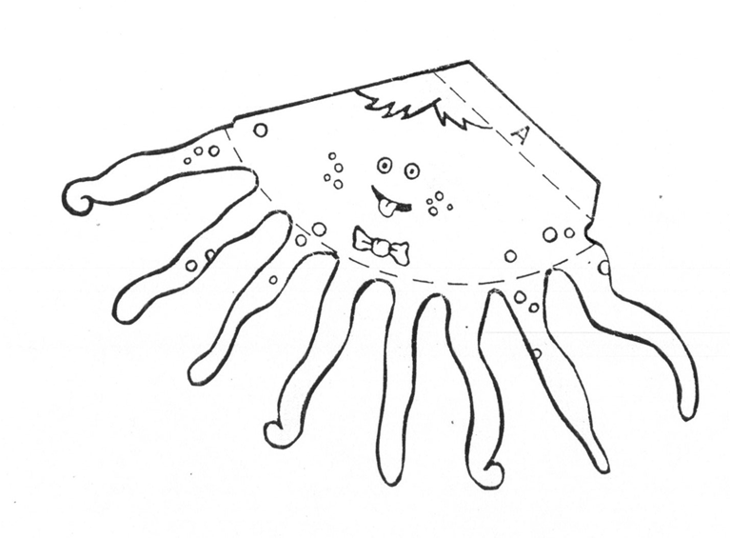

Work Session: | Knotting

Caracal | Make and use the following knots correctly:  - Reef  - Slip reef  - Hank a short tope
Cheetah | Make and use the following knots:  - Round turn and two half hitches  - Figure of eight
Leopard | Make and use the following knots:  - Sheet bend  - Hank a long rope
Lion | Make and use the following knots:  - Clove hitch  - Bowline  - Sheep shank

If you have trained your Cubs on all their knots already, use this time for revision.

Yarn: | Gulliver’s Travels

Gulliver woke up under a huge tree. There were two bees buzzing around him but they were ginormous like airplanes. He realized he was tiny compared to the world around him.

Gulliver thought that he had better hide under the leaves and wait but then he heard a munching noise that sounded like a bulldozer – it was the caterpillar eating his way through the leaf that was hiding him.

A butterfly stretched herself out of her chrysalis and flew away beating her wings like drums.

A huge lizard scuttled past him and quickly, Gulliver jumped on his back for a ride. As the lizard went out to find some sunlight, a lady bird flew down to say hello. She was very interested to see who lizard was entertaining on his back. The ant began to sing opera from the top of a log and the snail was slowly leaving his trail of slime as wide as a highway.

The mosquito was sleeping waiting for evening before he went to find his food. As the lizard stopped on a warm rock to sun himself, a spider came down to sit beside him.

Suddenly a frog jumped out of the pond to try and eat spider for his lunch. Before spider could scramble up his thread to safety, the huge wasp came out of the sky like a fighter-bomber and stung the frog on the end of the nose. The frog started shouting out in pain. Slowly the wise and clever Praying mantis climbed from his secret hiding place and said “Frog, don’t shout so loud. Can’t you see we have a tiny visitor who would like to meet us all?”

Gulliver was still very frightened of all the huge creatures around him, but realized they meant him no harm. He bravely put on a smile and met the flying friends of the praying mantis.

The huge moth that only flies at night woke up to greet Gulliver and the grasshopper jumped around Gulliver in excitement. The earthworm also came out and he thought it best to take Gulliver to meet the King and off all the creatures went, carrying Gulliver amongst them!

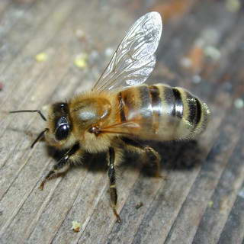

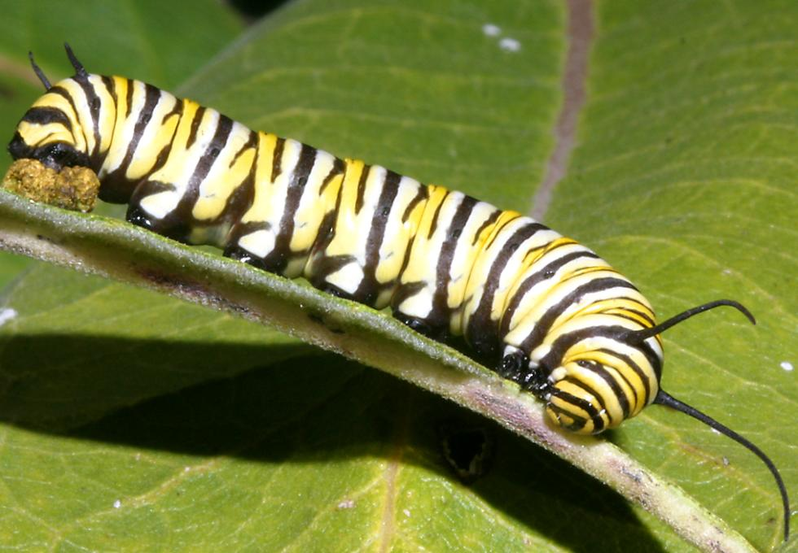 | 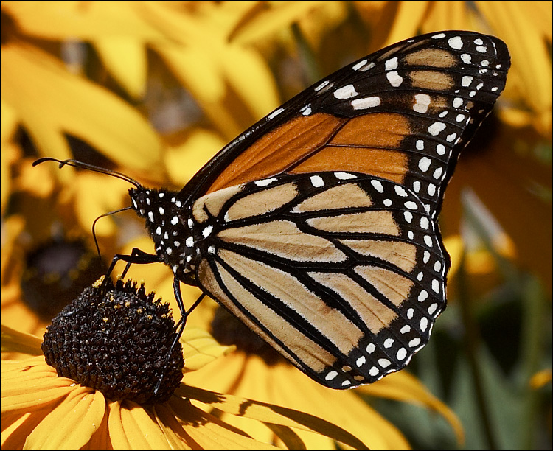
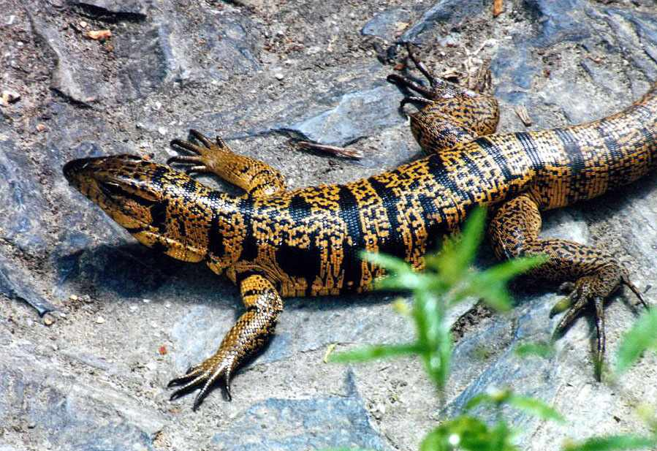  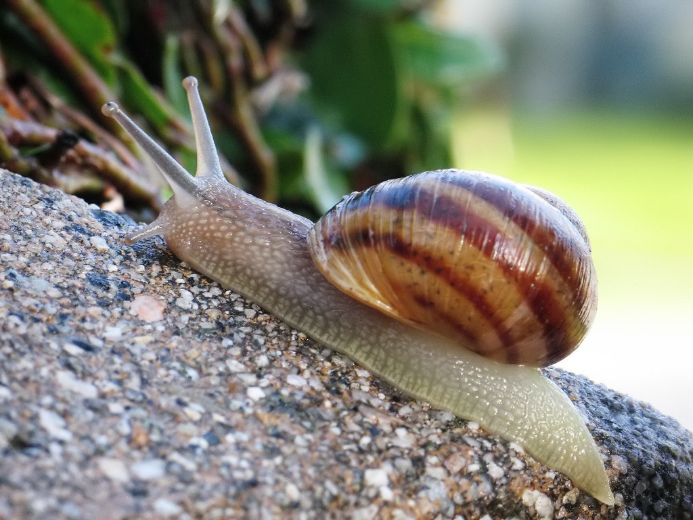 | 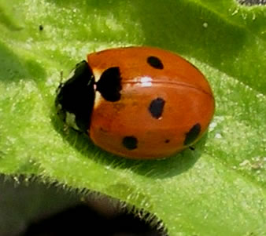  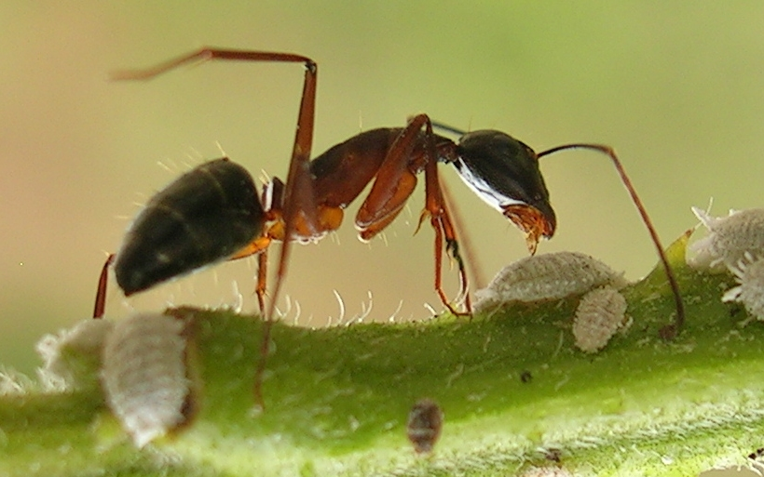

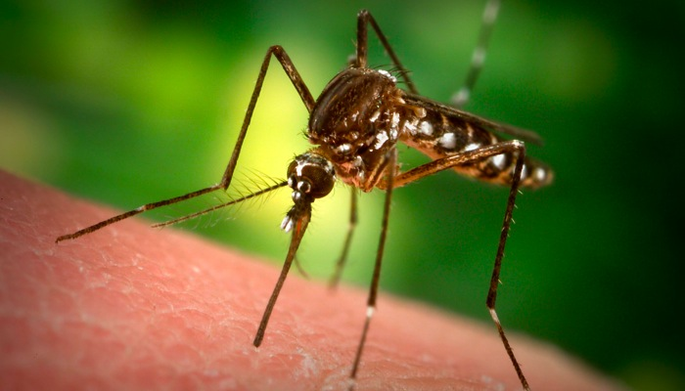 | 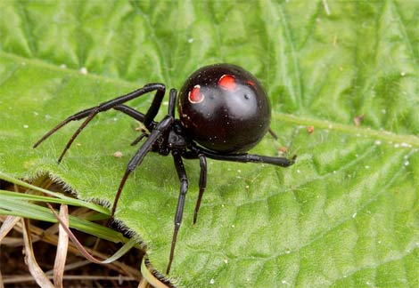
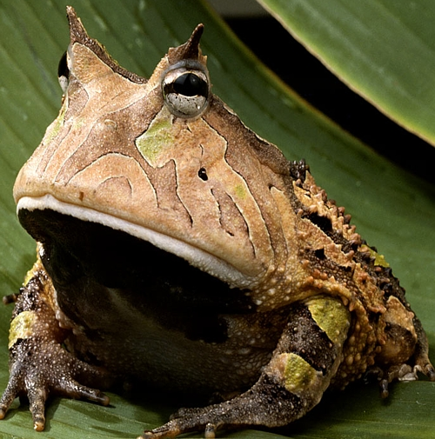 | 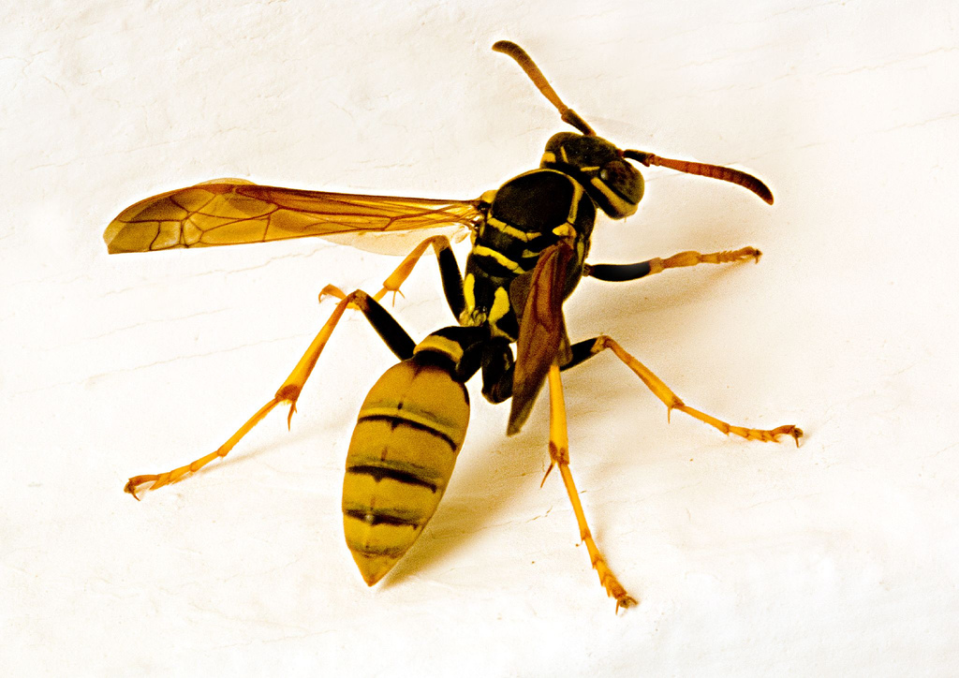
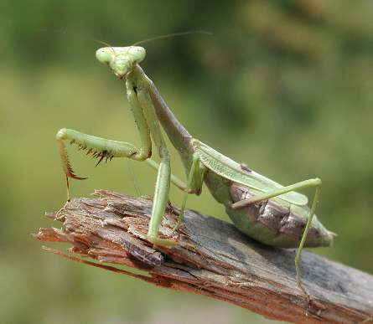 | 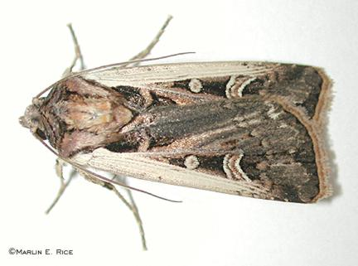

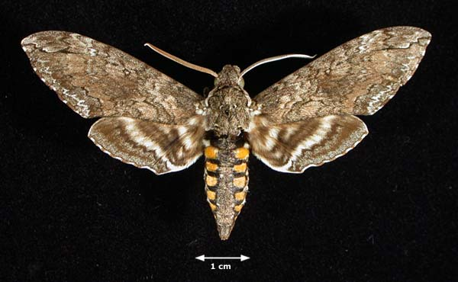 | 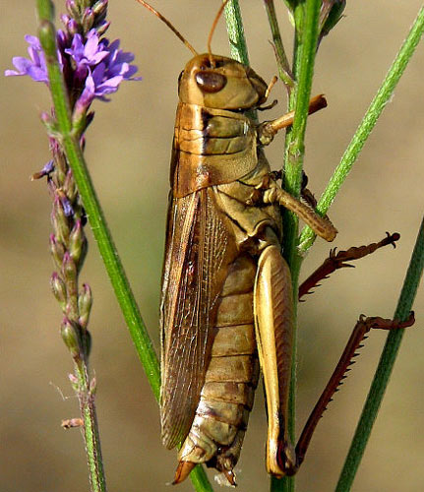

Please don’t forget to evaluate this programme:

