Work session: | Living with Nature; Compass & Mapping; Conservation

Caracal | As part of a Pack activity outdoors, show that you know and practice the Outdoor Code.
Cheetah | Know the eight major points of the compass.  Follow a simple trail of eight to ten moves to put your knowledge into practice.
Leopard | Know the sixteen points of the compass. With or without a compass, follow a simple trail based on these sixteen points.
Lion | Use solar energy to cook something.

Singing: | Two Little Fleas

Tune: Auld Lang Syne

Two little fleas together sat
They cried when one flea said;
“I’ve had no place to lay my head,
Since my old camel is dead.
I’ve travelled far from place to place
And farther will I roam.
But the next old camel that shows his face
Will be my home sweet home.”

Activity: | Terrarium

http://www.stormthecastle.com/terrarium/soda-bottle-terrarium.htm
Make this cold drink bottle terrarium. It is an easy project that anyone can do and it should take you about half an hour to complete it. This is a nice learning experiment to teach you about plants, closed environments; and while it is growing you can observe the life cycle of plants.
What you need to make this Cold drink Bottle Terrarium

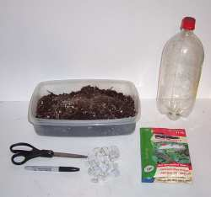 | - One 2-liter bottle (with cap)  - Potting Soil  - A handful of small stones or pebbles  - A Marker  - Scissors  - Seeds  - Seedlings (small plants) this is optional if you want to start right out with plants in your terrarium  Extra: If you want to make a really good terrarium you would also use activated charcoal and sphagnum moss. More on this below.
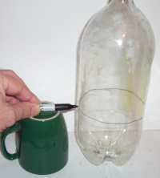 | Step 1: Draw a line around the bottle about six inches up
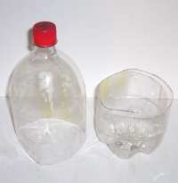 | Step 2: Cut the bottle along the line with a pair of scissors. You may need to start a small hole in the bottle before you can cut it with the scissors.

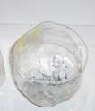 | Step 3: Place a handful of stones in the bottom half of the bottle. About 1-2 inches deep should be good.
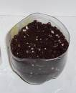 | Step 4: Place your other materials in the bottle. The charcoal then the moss then the soil. If you are not using charcoal or moss then put just the soil in. fill it to about 1 inch from the top.  Step 5: Now Plant your seeds! You should plant 6 to 10 seeds and later as they grow you can pluck out some of the weaker ones and leave the 2 or 3 best ones.  Don't forget to water your terrarium before placing the top on. The soil should be moist but not soaked.
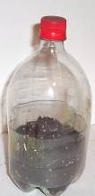 | Step 6: Now Place the top on. Squeeze the top onto the bottom so the top is on the outside.

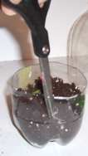 | If you have trouble fitting the two pieces together you can cut a slit about halfway down the bottom half of the bottle. This will help it close up a bit and make it easier to fit the top over it.
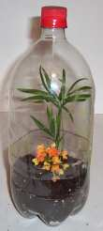 | Congratulations your terrarium is completed.  In a few days your seeds should germinate and in no time you will have a soda bottle terrarium that looks as nice as this one.

Taking Care of Your Terrarium

There are two important factors you have to consider when it comes to your terrarium: the amount of sunlight it gets and the amount of water that is inside.

Once the plants have sprouted you should make sure it gets sunlight but do not leave it in direct sunlight for the entire day. It is a closed environment and it can get very hot inside.

Water - Look carefully at the soil in the terrarium. It should look moist but not soaked or too dry. Beads of water should form on the top inside near edge and these will drip down the sides and continue to water the soil. If it appears to be too wet you can take the top off and leave it uncovered for a day or two.

Please don’t forget to evaluate this programme:

