Handcraft: | Camel Craft

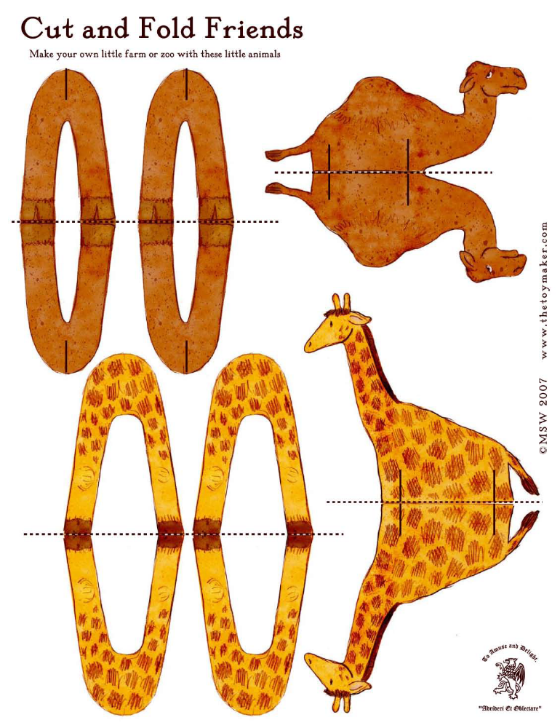

Trail: | Camel Footprints

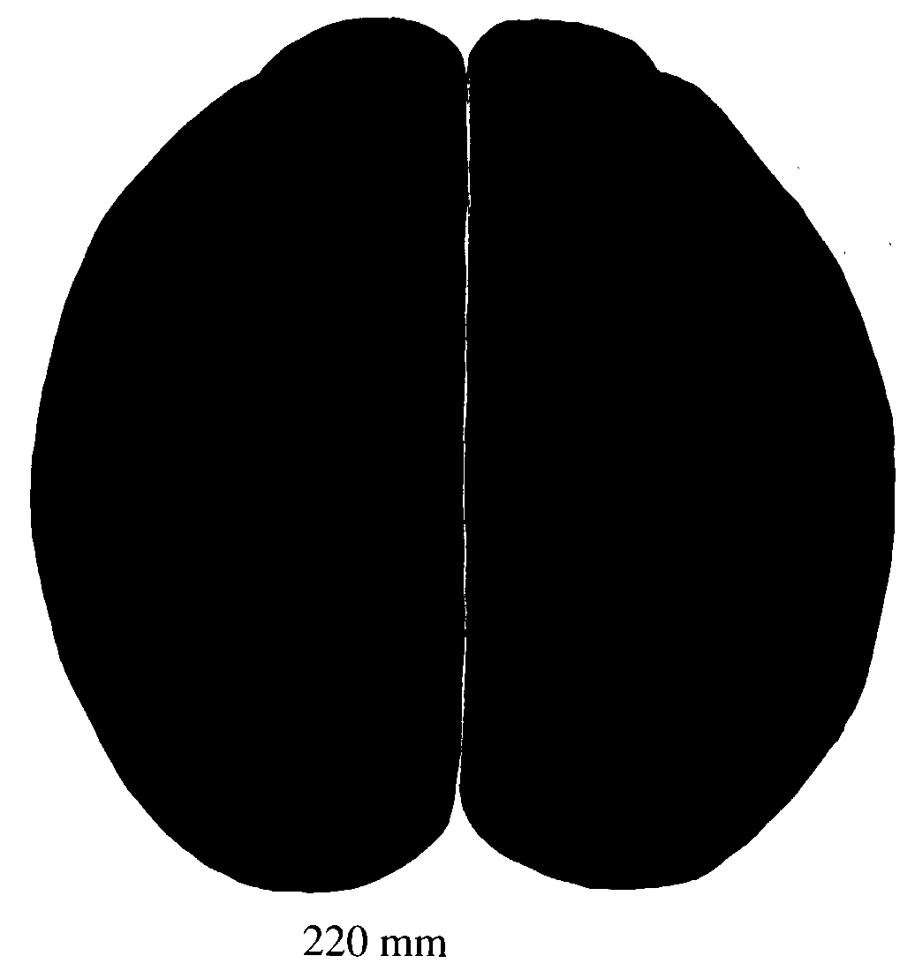

Yarn: | Lost in the Desert

The rock dropped to the bottom of the well and landed with a splash when it hit the water. Rabin was a beautiful little girl with dark brown eyes and hair as dark as the midnight sky. She laughed when she saw the water geyser up and the rock sink to the stone lined bottom. She raised her eyes and looked around on the ground for another pebble. Seeing no other, Rabin skipped off towards the tent where she lived.

As she approached, she saw that the goatskin walls had been raised to let the air circulate. Summer in the Egyptian desert could be unbearably hot and what breezes came along were precious and needed to be taken advantage of. Rabin’s tent was one of several in a small village in the arid desert, southwest of Cairo. Not many people ever came to the village to visit, but now and then a camel train would pass through and stop to fill their canteens with fresh water from the well or nearby pond. There weren’t many trees about, nor much other vegetation. An acacia tree sprouted up now and then near the small pond that was formed by springs bubbling forth from the parched earth.

Surrounding the village were several dirt paths. Rabin loved to walk them. One led to the pond, another led to some of the other villager’s tents and one led to where the small black and brown goats grazed. Other paths just seemed to wander off into nowhere.
Sometimes she’d ask her friends, Karim and Yasmine, to come and play with her. One day, as they were walking along one of the sandy trails, they came to an area where it was thick with acacia trees. Rabin saw something moving off the side of the path. She saw that it was a furry rabbit. It was brown with gray patches. It looked thin and hungry. She wanted to follow it but her mother had warned her never to leave the path; it was dangerous. She’d told Rabin that she might get hurt or lost and sometimes there were wild animals lingering about. But Rabin wanted to catch that rabbit.

She ran off the trail, following the rabbit through the rocks that jutted out of the sandy soil. Karim and Yasmine tried to call her back, but she wouldn’t listen. The rabbit hopped over a dead tree, so Rabin followed it. It ran up a small hill, so did Rabin. It leapt through a wide wadi, as did Rabin. It was when the rabbit jumped into some thorny bushes that Rabin lost sight of it.

She sat down in the shade of a tree. It felt good to rest. She looked around at the unfamiliar surroundings. In the tree above her hung a rather large beehive. As Rabin sat there, unaware of the hive, she noticed a lot of bees gathering around her. They were buzzing back and forth. She swooshed them away but more kept coming. Rabin didn’t like bees. She jumped up and ran as fast as she could.

She ran into the bushes and it didn’t take long for her to realize that she was lost. Nothing looked familiar to her. Where were Karim and Yasmine? Why hadn’t she listened to what her mother had said? She should have obeyed her. Now she was lost. She sat down on a rock and started to cry.

As she sobbed, she heard a hissing sound. It sounded like air gushing out of a full balloon. She looked at the ground; and saw a cobra. It was coiled up and its tongue was flickering in and out of its mouth. Its head was flat and wobbled back and forth as if dancing to a snake charmer’s flute. Rabin jumped up on top of the rock and watched the snake. It slithered across the sand. It even went around the bottom of the rock she stood on, but then, much to her relief, it slinked away. Now she really began to cry. She was very frightened.

Making sure the cobra was nowhere to be seen she hopped off the rock and started running back the way she came. She soon arrived back at the wadi. She walked along its path that had been made many years ago by spring rains flowing towards the Nile River. The water was long gone and all that remained was the dried riverbed. She was walking along and saw something move. Her heart leapt with joy as she thought it was the rabbit. Maybe, if she followed it again, it would lead her back to Yasmine and Karim. She ran over to it and was disappointed to see it was a small fox, reddish brown with a bushy tail. It scurried off into the bushes when she came too close.

She hung her head down and plodded along. She noticed tracks in the wadi, odd-looking tracks, like a crocodiles. She couldn’t see a crocodile! There must have been one here when the river was flowing through it. But, not wanting to take a chance that there was still one lingering nearby, she ran quickly down the wadi.

After what seemed like hours, Rabin felt tired, hungry and afraid. The sun was beginning to set below the horizon. The sky glowed a beautiful orange and red color, but she didn’t want to be alone in the dark. She sat down in the sand, too tired to move. She lay her head on her hands and fell asleep.

She woke up a little while later to find the rabbit she’d been chasing, standing near her head. Its little black nose was wet and rubbing against her cheek. Rabin stood up slowly. The rabbit didn’t run away. She reached down to pet it and it moved a little further away. It wanted Rabin to follow it.

She walked slowly and followed the rabbit back down the wadi, past the crocodile tracks, past the place where she’d seen the fox, past the rock where the cobra had slithered and past the tree filled with angry bees. She followed the hopping rabbit through the rocky soil. The rabbit suddenly stopped. Rabin heard her name being called, "Rabin. Where are you?" It was her father.

She called out, "I’m here. I’m here." Soon her father found her, picked her up in his arms and hugged her tightly.

‘Where were you, Rabin? We’ve been worried about you. Yasmine and Karim told us you’d wandered off the path. You know you aren’t supposed to do that," her father scolded.

"I know, Father. I am sorry that I disobeyed. I’ll never leave the path again," she apologized. She turned and looked for the rabbit. Where did it go? She saw it running off into the acacia trees. She smiled, took her father’s hand then walked back home.

Singing: | Alice the Camel

Alice the camel has 10 humps,
Alice the camel has 10 humps,
Alice the camel has 10 humps.
So go, Alice, GO!
Boom, boom, boom.

(Continue with 9, 8, 7….humps, until…)

Alice the camel has no humps,
Alice the camel has no humps,
Alice the camel has no humps.
‘Cause Alice is a HORSE!

Work Session: | Compass Patience

You will need: Sets of cards having the compass points printed on them. The Cards are placed randomly on a table. A Cub turns over a card and places the card at the correct compass position for that card.

N | S | E
W | NE | SE
NW | SW | NNE
SSE | NNW | SSW

Quiet Game: | Horse drawn cart

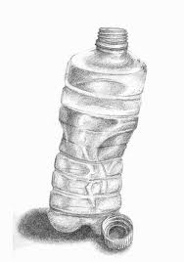
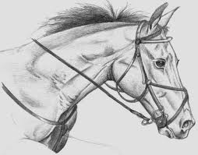

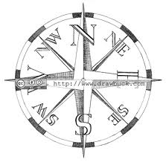

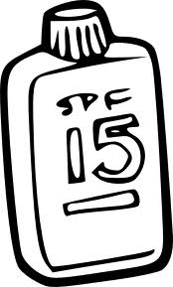

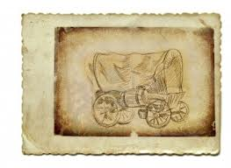


Please don’t forget to evaluate this programme:

