Yarn: | Born with no arms

Born in 1983 in Sierra Vista, Arizona, USA, Jessica has learned to live her life with her feet. Born without arms and all doctors did not know why.

There were many questions at the time about whether Jessica would be able to live a “normal” life. However, Jessica’s father has said he never shed a tear about her birth condition. He had full confidence in her potential.

With the support of her parents and family, Jessica became confident in herself as an adult and continued to explore the world with her feet.

As a child, Jessica studied dance in her home town. When the first performance arrived, she asked to be put in the back row. Her dance teacher told her there was no back row. Tentatively she took the stage with the other students and performed her routine. When she finished, the applause from the audience gave her encouragement and the confidence to continue dancing for 14 years.

Jessica’s parents eventually met a Taekwondo instructor named Jim Cunningham. His response when told of her birth condition was that she would be more than physically able and that only her attitude could hold her back. At the age of 14, Jessica earned her first Black Belt in the International Taekwondo Federation.

After graduating from high school, Jessica attended the University of Arizona where she earned a bachelor’s degree in Psychology. When talking about her degree, she frequently explains that psychology credits the way people think has a greater impact on their lives than a physical limitation.

Jessica’s most famous accomplishment was learning how to fly. It took three states, four airplanes, two flight instructors and a discouraging year to find the right aircraft: a 1946 415C Ercoupe Airplane. She received the Guinness World Record for being the first person certified to fly an airplane with only their feet.

Jessica now works as a motivational speaker. She travels the world sharing her story and encouraging people to be creative and innovative with the mantra “Think outside the shoe.”

By Jessica Cox
Age: 29

Trail Signs: | Foot Trail

 | CLUE:  BIG ANIMAL – GREY IN COLOUR
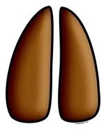 | CLUE:  HAS A VERY LONG NECK
 | CLUE:  HE GUARDS MY HOUSE

 | CLUE:  SHE HAS NINE LIVES
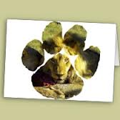 | CLUE:  KING OF THE JUNGLE
 | CLUE:  LOOKS LIKE A NUN

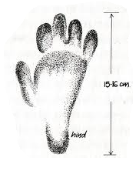 | CLUE:  LOOKS LIKE ONE OF US!
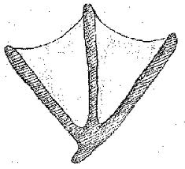 | CLUE:  QUACK, QUACK
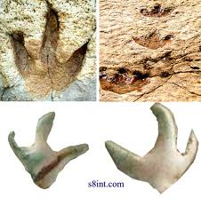 | CLUE:  LIVES IN THE RIVER

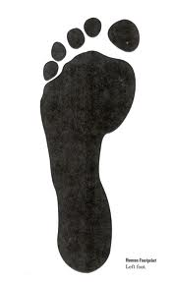 | CLUE:  YOU AND I

Please don’t forget to evaluate this programme:

