Activity: | Traditional Dance / Musical Instruments

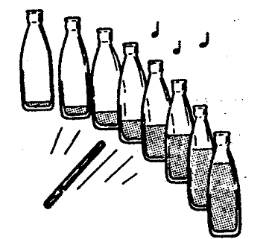
BOTTLE BAND:

Simply stand eight glass bottles, filled to varying degrees with water, on the ground. You must be careful what you use for a beater – anything too solid might end in a flood!

Number the bottles 1 to 8. Try the following tune:
3—2—1-----3—2—1-----5—4-43-----5—4-43----5
8-87687-55-58-87678-55-588887678-55-43—2—1

It should sound like Three Blind Mice.

TINGER:

Hammer different lengths of nails into a piece of wood. Hit with another large nail.
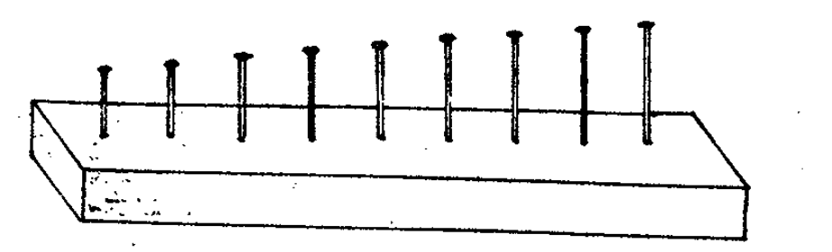

BALLOON RUMBLER:

Place four paper clips inside a balloon and blow it up. Knot the end, and shake it.

TAMBORINE:

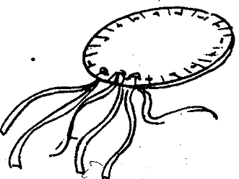

Decorate two pie or paper plates. Place some seeds in one plate face down on top of the first plate. Secure by stapling, taping or punching holes around the rim of both plates and sewing them together with yarn. Add some paper or ribbon streamers

Please don’t forget to evaluate this programme:

