Steam Release: | Mend the Calculator
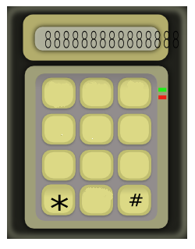

2
1
3
4
5

6
7
8
9
0

Handcraft: | Can do Robots

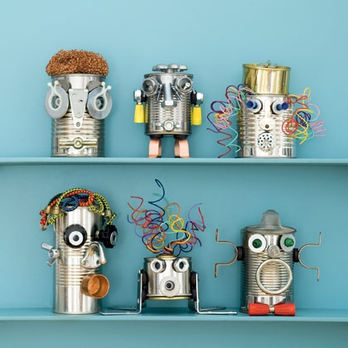
These friendly robots are more than just good-looking; magnets hold their features in place, making the 'bots the metallic equivalent of a Mr. Potato Head.

What you'll need:

- Tin can
- Electrical tape (optional)
- Hardware and various recyclables such as bottle caps, keys, old nuts, bolts, screws, steel wool, etc.
- Hot-glue gun (optional – can use cold glue or bostik).

How to make it:

- Open a tin can with a safety can opener so there are no sharp edges. (If you only have a regular opener, line the inside of the can's rim with electrical tape.)

- Empty, wash, and dry the can.

- For facial features, arms, propulsion devices, and communication arrays, look for items around the house and at the hardware store. We used bolts, brackets, hinges, keys, wing nuts, switches, bottle caps, washers, knobs, and more.

- Hot-glue the items or use bostik or cold glue (takes longer to dry).

Work Session: | Knotting

Make and use the following knots:

Caracal | - Reef  - Slip reef  - Hank a short rope
Cheetah | - Round turn and two half hitches  - Figure of eight
Leopard | - Sheet bend  - Hank a long rope
Lion | - Clove hitch  - Bowline  - Sheep shank

Please don’t forget to evaluate this programme:

