Team Game: | Check your Cards

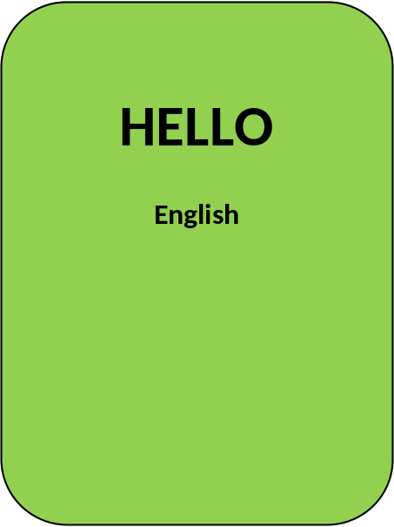
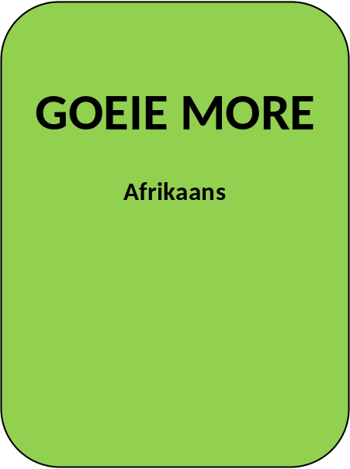
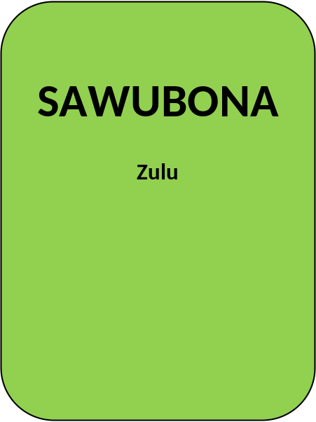



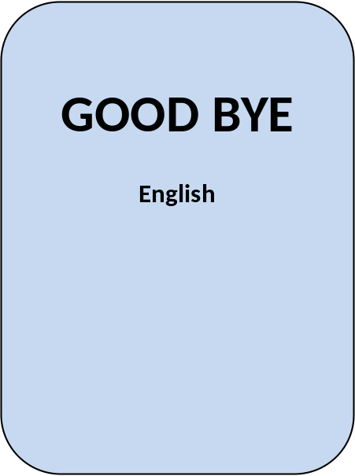
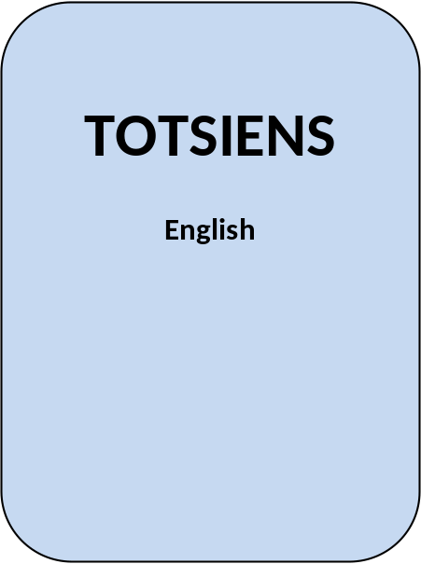
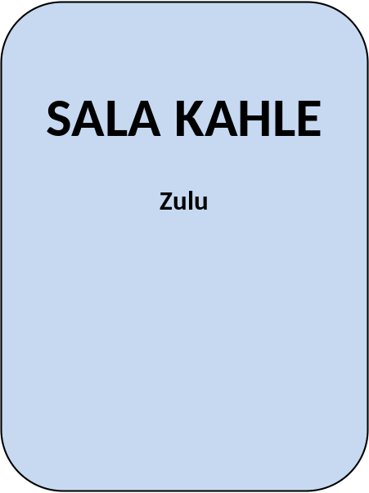



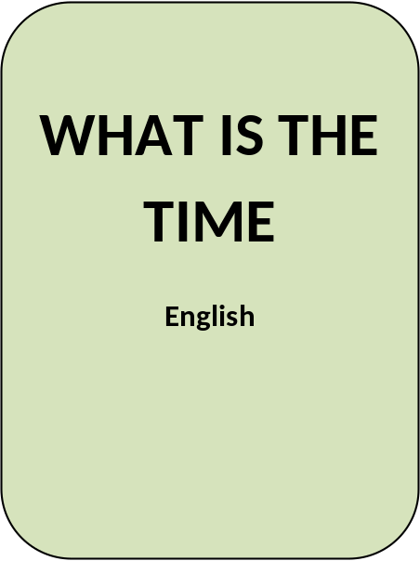
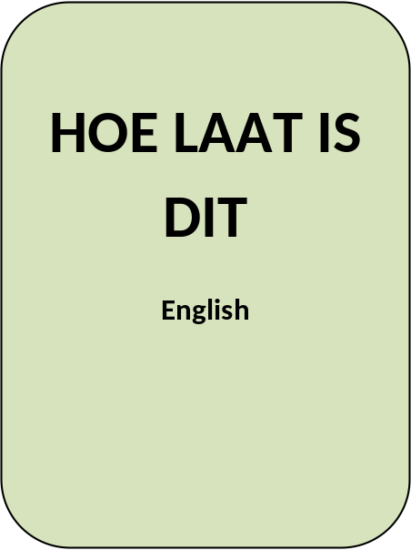




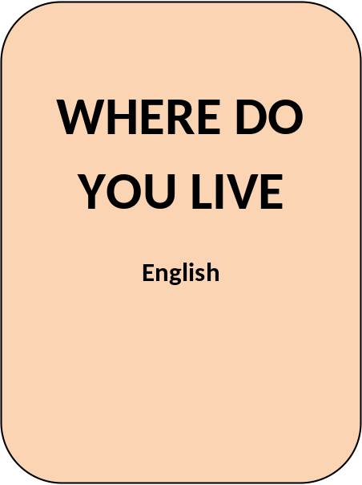
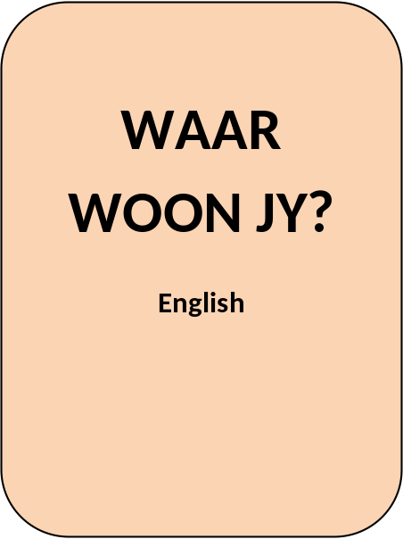
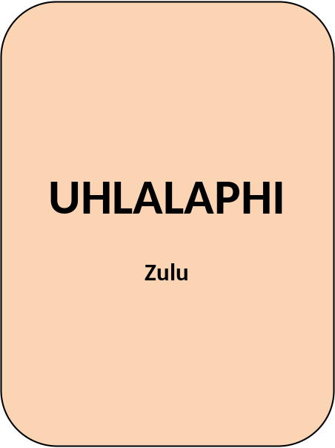



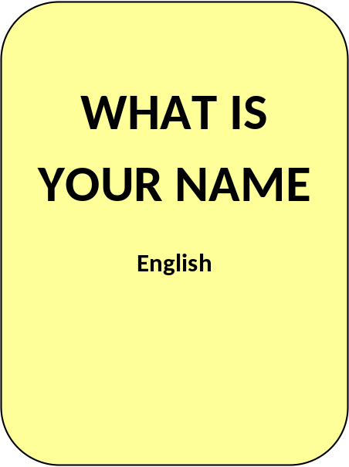
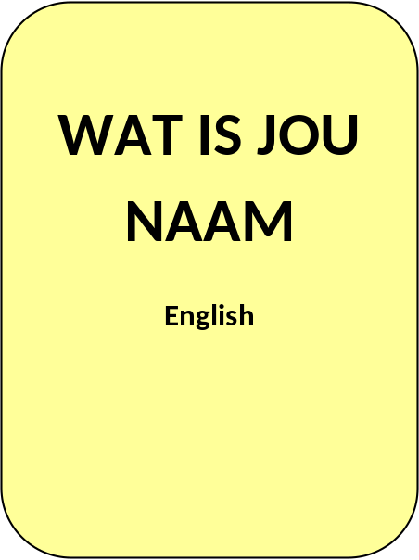
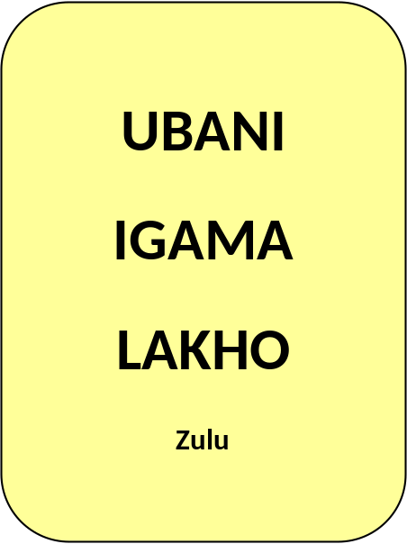



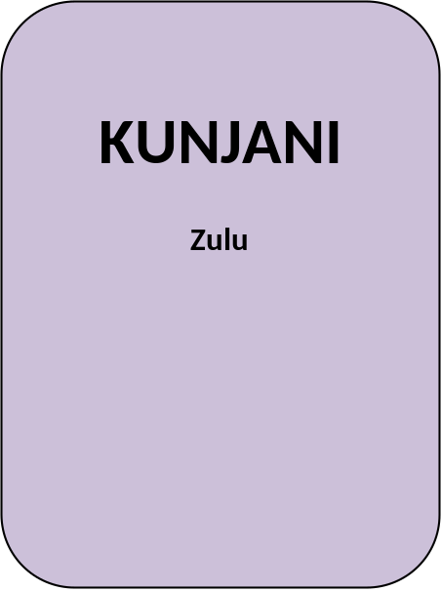

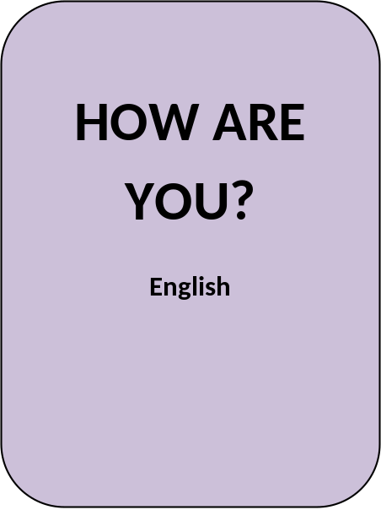




Activity: | Ocean Drum

An ocean drum is a truly unique instrument!

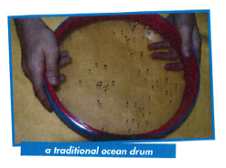
It looks like a frame drum from the Middle East, but it is filled with small round objects that, when tilted back and forth, sound remarkably like the waves at the seashore. Its sound is soothing and when ocean drums are filled with colourful or interesting objects, they are as beautiful to watch as they are to hear. Want to make your version of this amazing instrument? Supplies for this easy project are listed below.

HOW TO MAKE IT

Start with a sturdy box. It’s a good idea to decorate your box before experimenting with what you want to put inside. If you started with a plain box from a stationery supply store, you have a clean slate to create an ocean motif or decorate with paint, crayons, markers or glitter and glue. If you have an overly busy box, like a pizza box, you may wish to cover it with coloured paper (leaving space for the window of course) and decorate from there.

Next, create the window so you can watch the smaller items move around inside the drum. To do this, get some sturdy clear plastic and cut it into a large square or rectangle. Draw a slightly smaller square or rectangle on the inside of the top of your ocean drum box and cut it out. Secure the window in place inside the box using a strong tape such as packing tape, electrical tape, or masking tape.

Now choose something to create the sound of the surf. Small, round objects make a sound that is closest to a real ocean drum. However, you can get creative with what you’d like to try. You can choose tiny pasta like acini de pepe, pastina pasta, seed beads, bee bees, or mung beans. You can fill your drum with lentils, dried peas, marbles, pony beads, larger beans, or orzo pasta for a louder drum. You can mix and match to see what sounds best to your ear.

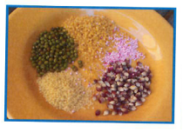
You may also want to make it interesting by adding colourful beads or other items like marbles, buttons, glitter or confetti that will add to the visual appeal of the drum.

Once you have chosen what you want to go inside, you are ready to seal the drum. Cover it with packing tape so that the contents will stay inside. Seal up all the edges where the smaller objects might come out and then you are ready to play your ocean drum.
SAMPLES OF OCEAN DRUMS BUT YOU CAN MAKE YOUR OWN

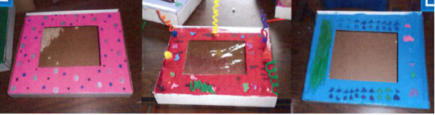

PLAYING THE OCEAN DRUM

This is a fun instrument to explore. Here are a few techniques you can use when playing it:

- Tilt it back and forth at gentle angles;
- Tilt it back and forth at more extreme angles;
- Tilt the drum for a gentle swooshing sound then turn it on its side to stop the sound;
- Tap the sides or top with your fingertips;
- Shake your instrument as it if were a rattle.

Many people find the sound and the changing patterns very calming and meditative. You can relax and play it without any other accompaniment or you can play this instrument along with soothing music or any of your favourite songs. Try to match the beat by tilting the ocean drum along with the rhythms of the song.

If you enjoy this type of drum, you may want to make several as each one will have a distinct sound or might fit better with different musical styles that you enjoy.

SUPPLY LIST FOR THIS PROJECT

A sturdy box: flat shipping boxes, or any sturdy small box.

Clear plastic: you can recycle old report covers, salad bar containers, clear tablecloth covers or purchase a small amount of clear vinyl at a fabric or hardware store.

Hint: Don’t use plastic wrap as it simply won’t hold up to the task.

Strong tape: packing tape, masking tape, or electrical tape are good choices.

Contents for the drum: Choose any small fillings such as seed beads, pastina pasta, acini de pepe pasta, orzo, pony beads, mung beans, lentils, dried beans, marbles, or small pebbles.

For kids on the Autism Spectrum – for children who have noise sensitivity or seem to connect with certain types of sounds in special ways, pay careful attention to “tuning” your drum for contents that sound right to the person who will use it. You can fill it several times and have him or her pick out what sounds the most pleasing before sealing it up.

Yarn: | Johnny Appleseed

Many years ago in America, there lived a boy called Johnny who loved all flowers, animals and trees. He used to climb apple trees, pick an apple and munch away until he came to the core. Then he would take out the little brown apple seeds and plant them.

When Johnny grew up he roamed about the countryside and everywhere he went he carried a big bag full of apple seeds and showed children he met how to plant them. Johnny made special friends with the Red Indians who often gave him food and shelter and because he was always so happy and cheerful, he was nicknamed Johnny Appleseed.

One winter’s night whilst roaming around, Johnny became ill. He fell down in the snow and whilst he lay there a bear came along and sniffed at him, but because Johnny was a friend to animals the bear did him no harm and wandered off and left him. His friends, the Red Indians, found the footprints of the bear and followed them.

The prints led them to Johnny their old friend. They took him back to their village and nursed him until he was well again. Johnny thanked his friends and once more set off on his travels planting apple seeds as he went.

Occasionally he returned to visit the Red Indians who had saved his life, and was always made welcome because people knew him as the man who had made their country rich with apple trees, where there had been nothing but brown earth.

Singing: | Three Chocolate Éclairs

Three chocolate éclairs, three chocolate éclairs.
Sitting on a plate, sitting on a plate.
Gobble, gobble, gobble, gobble.

Two chocolate éclairs, two chocolate éclairs.
Sitting on a plate, sitting on a plate.
Gobble, gobble, gobble, gobble.

One chocolate éclair, one chocolate éclair.
Sitting on a plate, sitting on a plate.
Gobble, gobble, gobble, gobble.

No chocolate éclairs, no chocolate éclairs.
Sitting on a plate, sitting on a plate.
Uuugghhh…… (pretend to vomit).

One chocolate éclair, one chocolate éclair.
Sitting on a plate, sitting on a plate.
Uuugghhh…… (pretend to vomit).

Two chocolate éclairs, two chocolate éclairs.
Sitting on a plate, sitting on a plate.
Uuugghhh…… (pretend to vomit).

Three chocolate éclairs, three chocolate éclairs.
Sitting on a plate, sitting on a plate.
Gobble, gobble, gobble, gobble.

Please don’t forget to evaluate this programme:

