Handcraft: | Pirate hat and eye patch

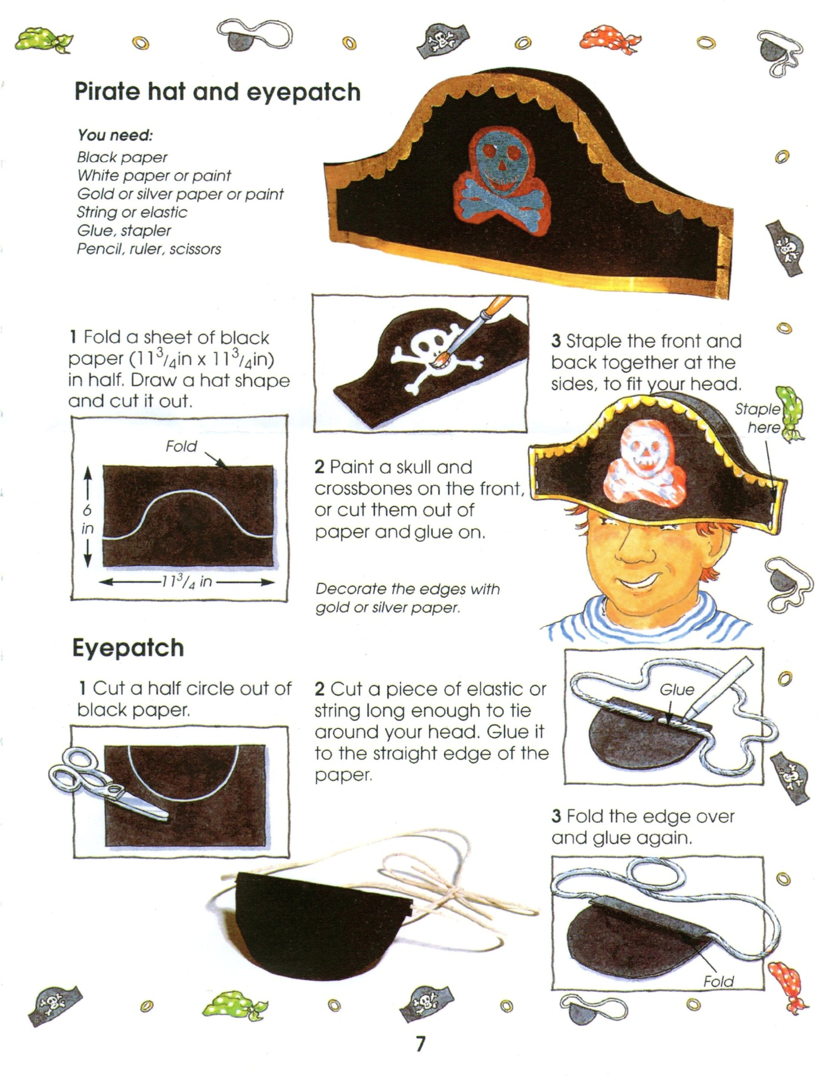

Handcraft: | Pirate sword

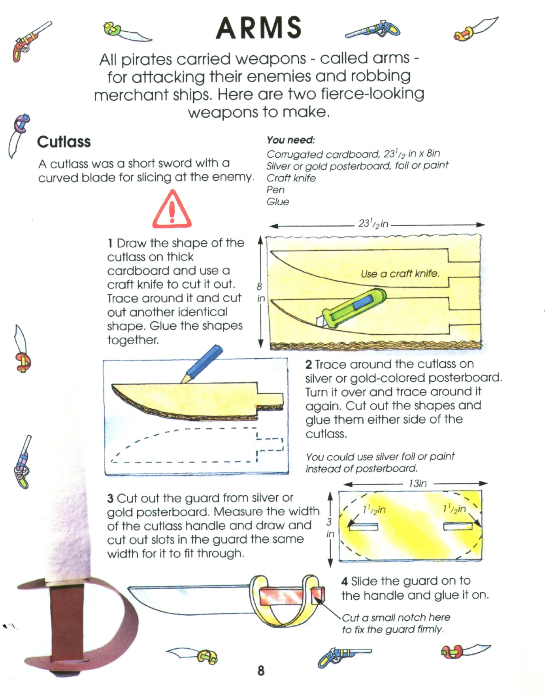

Please don’t forget to evaluate this programme:

