Handcraft: | Helicopter

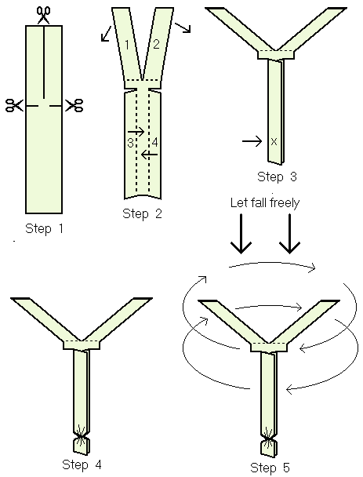

Work Session: | Sensations

Caracal | - Play Kim’s game using ONE of the five senses and succeed in identifying five out of ten objects.
Cheetah | - Play TWO different Kim’s games using TWO of the five senses and succeed in identifying seven out of ten objects, sounds or tastes in each one.
Leopard | - Play THREE different Kim’s games with THREE of the five senses, scoring at least ten out of fifteen in each one.
Lion | - Play FIVE different Kim’s games using each of the FIVE senses, scoring at lease fifteen out of twenty in each one.

Please don’t forget to evaluate this programme:

