Yarn: | Dress up Drama

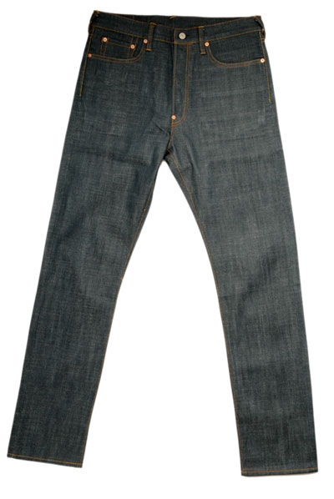 | 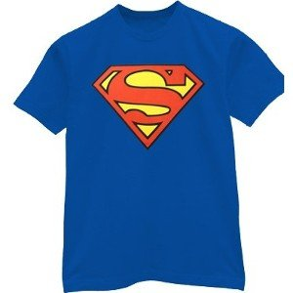
 | 
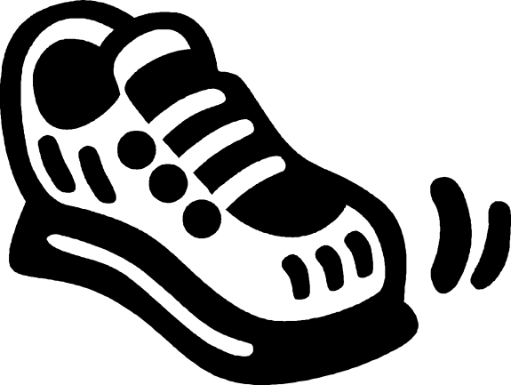 | 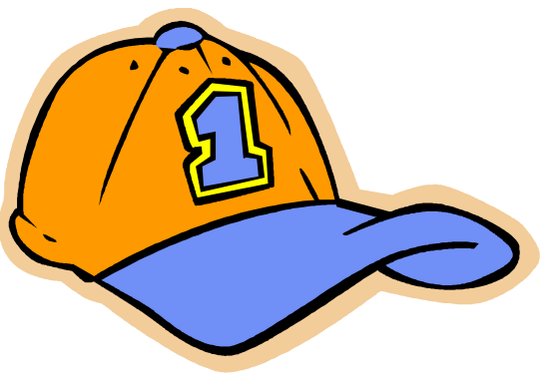

Yarn: | Through the Graveyard

The cubs began to creep slowly through the graveyard to have a closer look at the open grave. It was pitch dark. There was no moon and it was cloudy. None of the cub scouts could see where they were going so they had to feel their way around the graves. Unfortunately for them the grave-diggers were a lazy lot and they never bothered to dig the graves deep enough and seldom covered them properly.

Simon slid his hand forward carefully and felt something cold and soft and oval, but it was only MR MOSS’S EYE (grape/small stone covered in Vaseline) that had rolled out of the coffin when he was buried the previous Tuesday. Simon shivered and moved on. Then, his foot touched something that felt like porridge! When he felt it, he realized it was MR MOSS’S BRAINS (cooked spaghetti) that had dribbled out of his skull. They seem to gleam wetly. Simon was no coward, but he was beginning to feel scared. He moved away and this time Peter touched something hard and rectangular but these was only MR MOSS’S TEETH (mielie pips) that must have been knocked out of his skull.

All the cubs were terrified. Their skin crawled with fear. They were all too scared to go further. Simon looked up to call out for help but decided that they should all go on and perhaps they will find the caretaker. Peter and Simon slid on their stomachs as fast as they could. COLD WET HAIR, WET WITH BLOOD (wet rope) slipped past their face…. Peter jumped but crawled determined on. The BLOOD DRIPPED OFF THE HAIR AND OVER THEIR HANDS (oil dripped over hands) as he brushed the hair aside. They all had to get away and fast.

They all scrambled on – now careless in their efforts to get out of the graveyard and alas, Simon fell into the open grave. It had been dug that morning for old Mrs Higgins but the grave-diggers had managed to dig up part of another body as well.

Simon’s hand touched something wet and spongy, probably some LUNGS (wet sponges). Pulling his hand away he put his other hand into a wet hollow – this must have been the STOMACH (chamois leather). Hanging out of the stomach, Simon felt long tubes filled with something soft. The tubes seemed to go on forever. They must have been the INTESTINES (lambs sausage). Simon searched desperately but instead he touched a HEART (heart). It felt soft and slimy with tubes coming out of it.

He tried climbing out of the grave. This time he was successful but not before he touched some BONES (bones). As he scrambled out, he called for all the cubs to follow him as they ran for the graveyard gate!

Yarn: | Sun and Moon (alternate yarn)

You see the pale crescent moon high up in the night sky. Well, once he was as bright as the sun. Shall I tell you how he lost his colour?

When the world was young, Sun and Moon both shone as brightly as each other. The two of them were good friends and often did things together.

One day Sun said to Moon, “Why don’t we take our families out for the day? We could go to the river and have a swim.” Moon thought this was a good idea. When they arrived at the bank, Sun suggested that he and his family bathe round a bend in the river. “Why don’t you wait for us to get in. As soon as the water starts to bubble, you will know that we are in the river and then you can get in.” Moon agreed.

However, as soon as they had vanished from sight, Sun and his family made a fire and flung burning branches into the river. Soon the water was bubbling and seething. When Moon saw this, he and his family entered the water.

All at once, there was a huge cloud of steam. Moon and his family splashed around happily until they’d had enough. Then they climbed out of the water. But when Moon looked at himself, he saw that he was no longer bright yellow. All the bright colour and heat had drained out of him – he was a pale shadow of his former self.

When Sun saw his friend, he laughed until he cried. Then, wiping his eyes, he said to Moon, “Well, I am certainly the brightest thing round here!” Moon was deeply hurt.

He realized that Sun was not a true friend. He had tricked Moon into losing his colour so that he, Sun, could shine more radiantly than anything else in the world. “I don’t mind how long I wait, but I will take my revenge,” thought Moon.

Months passed. A terrible famine struck the land and many people and animals died. Moon decided to approach Sun. “We cannot keep our families in this time of crisis,” he said. “Rather than see them starve, it is better that we should kill our wives and children.” “Yes,” agreed Sun. “But how shall we do it?”

“Let us take our families to the river and kill them there,” replied Moon. “I’ll go up river. When you see the blood flowing downstream, you will know that I have done the deed. Then you can follow suit.”

Sun went to the river and waited with his family. When he saw water the colour of blood flowing towards him, he killed his wife and children and threw them in the river.

However, Moon had not got rid of his family. He and his children had collected the red earth that lay all around and had thrown it into the river, staining the water a blood colour. Moon had exacted his revenge. He had caused Sun to lose his family, while keeping his own.

To this day, Sun shines bright but alone in the sky. At night, it’s Moon’s turn. He hangs thin and pale in the dark sky with this wife and all his little children.

Ack: The Lion King (volume 5)

Work Session: | Mapping

Caracal | - Identify a simple object viewed from the side and top to illustrate the difference in shape.
Cheetah | - Draw a simple map of your home or meeting place showing the different rooms and door-ways.
Leopard | - Explain at least 6 map symbols.  - Show how to use a street map.
Lion | - Use a street map of your local area or draw a simple map showing the area around the Scout meeting place, OR you home OR your school. Use your knowledge of the compass to find the magnetic North point and line up the map to North.

Please don’t forget to evaluate this programme:

