Activity: | Popsicle Plane

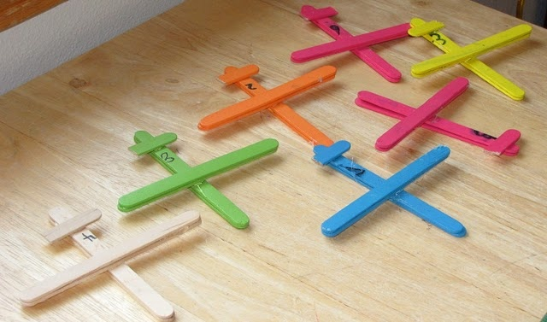

Equipment:

Ice-cream sticks
Glue

Method:

Glue two ice-cream sticks together to form the body of the plane. Glue another two ice-cream sticks together to form the wings. Glue the wings to the body of the plane. Cut an ice-cream stick into quarters and glue onto the body as a tail.

Relay Game: | Building a Boeing

Use the picture on the next page for the puzzle. Cut to required number of parts.

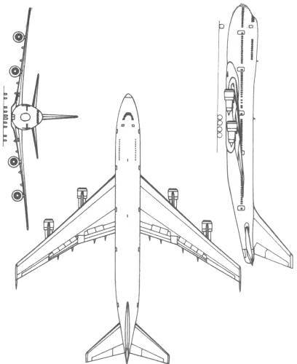

Yarn: | Laika – first dog in space

It’s one of those rags-to-riches stories that Hollywood makes movies about: an orphan living on the streets is plucked from obscurity and achieves worldwide fame for her immense talents. In this case, however, the tale involves not a person but a dog and the story has a tragic ending. Meet Laika, the first dog in space.
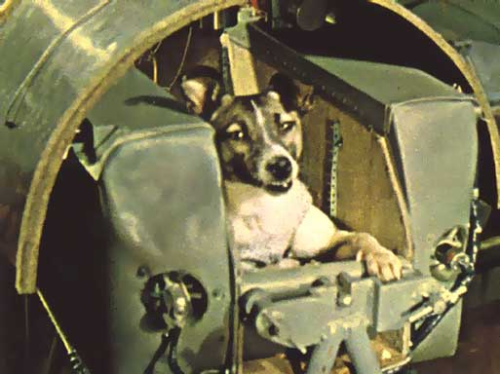
Laika (whose name means “barker”) was a 3-year-old mongrel stray wandering the streets of Moscow when she was picked up and taken to a secret Soviet space laboratory. Scientists selected strays because they had already learned to adapt to cold and harsh conditions.
Along with two strays named Albina and Muska, Laika was put through a series of rigorous tests to prepare for spaceflight. The dogs were placed in centrifuges where they were subjected to the g-forces associated with launches. They were also kept in a series of progressively smaller cages to simulate the space capsule they would ride in. In the end, Laika was deemed most fit to become the first dog in space. The selection would have tragic consequences for the friendly stray.
While Laika underwent training, engineers were rushing to get her spacecraft ready to fly. Following the successful launch of Sputnik 1 on Oct. 4, 1957, Soviet Premier Nikita Khrushchev decreed that he wanted an even more spectacular space first to be launched by Nov. 7, the 40th anniversary of the Bolshevik Revolution.
Planners decided to move up Laika’s flight, which had been set for some time in 1958. The resulting spacecraft was a rush job thrown together in less than a month that featured a life-support system, cooling fan, and enough gelled dog food to last seven days. Laika was fitted with a harness to restrict her movements and instruments to measure her heart rate, breathing, and other functions.
The spacecraft lacked one crucial element: a heat shield. Soviet engineers had not yet perfected the technique for returning capsules from space. Before the flight, Dr. Vladimir Yazdovfsky took Laika home to play with his children. "I wanted to do something nice for her,” he would later write. “She had so little time left to live."
Laika was launched aboard Sputnik 2 on Nov. 3, 1957. Although the nose cone separately cleanly, the core rocket did not. This prevented the spacecraft’s thermal control system from functioning normally, sending the interior temperature zooming to 104 degrees Fahrenheit.
Laika's heart rate, which was 103 beats per minute prior to launch, more than doubled to 240 beats per minute as the R-7 rocket accelerated toward orbit. Her heart rate finally settled down three hours into the flight. The first dog in space was alive and eating her food during her early hours in orbit. However, all signs of life ceased about five to seven hours after liftoff. Laika had died of excessive heat and stress, causes that was not revealed publicly for 40 years. The Soviets originally claimed the dog had survived in orbit for days.
Laika became famous worldwide as her brave exploits were hailed as another glorious first for the Soviet space program. Animal rights advocates protested her death as animal cruelty. The Russians designed their future dog flights for recovery. The first dog in space is honored with a statue that sits in Star City, where Russian cosmonauts train.
- See more at: http://www.rocketcityspacepioneers.com/space/first-dog-in-space#sthash.EbVBwj6R.dpuf

Work Session: | Communication

Caracal | - Know how to answer the telephone correctly in your home language?
Cheetah | - Know how to make a telephone call and relay a message politely and correctly.  - Greet others in four out of the eleven official languages.
Leopard | - Carry a message and deliver it politely and correctly.  - Make and send an invitation or a thank-you letter to someone and see that it is delivered.
Lion | - Write an article for your Pack log book/newsletter or Pack/School notice board.

Please don’t forget to evaluate this programme:

