Yarn: | The happy little tree

Once there was a little tree. It had a special place all to itself in a beautiful forest, and with the warm winds and gentle rains, the seedling began to grow. Soon, a few small leaves appeared, and the little tree spent the long summer days opening itself to the sun.

For some reason, however, growing straight and tall in this wonderful sunny spot wasn’t enough, something was missing; the little seedling was lonely and needed friends. Before long, other little trees gathered round, and the little tree was finally happy.

The other trees began to grow tall and sturdy, but the poor seedling, now covered by their shade, could hardly grow at all. This didn’t matter, however, because the little tree’s only concern was the happiness of its friends.

Winters came, followed by springs, and time stood still — yet somehow moved — as the little tree, just a few feet tall, found itself surrounded by giant trees. They were so tall that the little tree could barely see their tops, and, sadly, it lost touch with them. But the little tree was happy, nonetheless, that its friends had grown so big and strong.

One day, years later, one of the large trees, now old and diseased, fell over and crushed the little tree. The little tree’s heart was broken, not because it now lay under a huge, dead log, but because it’s old friend had died and could no longer feel the wind through its branches and the sun on its leaves — things the little tree could remember from long ago. And in thinking about its friend, the little tree forgot all about itself.

Only one of its tiny leaves could be seen peeking out from under the massive log that had fallen on it, but as the old tree fell, it also opened a small window in the canopy of the forest, and for the first time since it was a small seedling, the little tree felt the warmth of the sun, as the sun touched its solitary leaf.

The years continued to pass, as they do, and another tree fell, then another, and soon the little tree was alone again. In time, it was able to grow out from under its fallen friend, and although it was now twisted and deformed from its efforts, it blamed nobody. It was at peace with itself and the forest.

The little tree could never see beyond its small, special home in the wilderness, but somehow it became very wise. It knew the feeling of joy — of the sun and of the wind, and it learned to accept darkness as well. It knew that things can happen beyond our control, and, more importantly, that love can only happen beyond our control.

It understood that small trees are, at times, criticized by not living up to their potential of becoming large trees, and how, sadly, they might then try to become something they can never be, not seeing the beauty of what they already are.

It knew that within the insignificance of little trees can be found the greatness of large trees, and so the little tree loved them all, great or small.

The little tree never grew very big, living out its life reaching toward the light. And then, unexpectedly, one beautiful, spring morning the little tree died, so quietly and peacefully, that the forest never even noticed.

Circle Game: | Beetle Drive

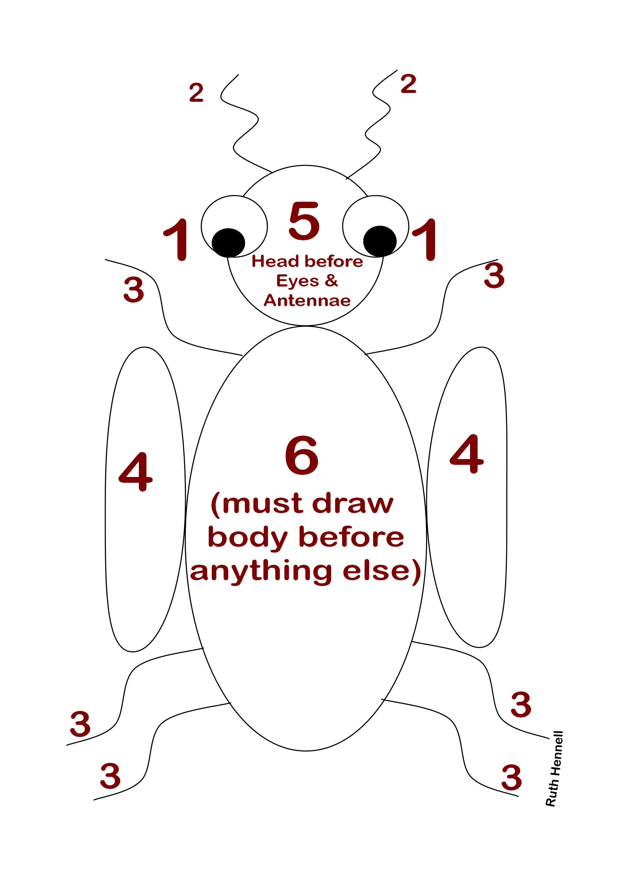

Work Session: | Growing Things

Caracal | Grow a seed (pea, bean, mealie or bulb) in a transparent container. When it is big enough plant it in soil.
Cheetah | Make and use compost from unwanted vegetation.  Explain the importance of using mulch and use it when preparing your seed bed.  Prepare a seed bed and plant flower seeds.  OR  Grow flowers in a container from seeds or bulbs.
Leopard | Make or lay out a vegetable bed or herb garden.  Make a bottle garden and give as a gift to someone.
Lion | As per progress chart.

You might like to try this instead: Miniature Fruit Trees

Make pots out of empty orange or grapefruit skins after you have eaten the flesh. Give them a coat of clear varnish and let them dry out. When dry, fill your pots with soil and plant a pip in each. Label them so that you know which is in which pot. Water, being careful not to over-water as there are no drainage holes. Keep moist and in a dark place until the shoots are well-established. Then put in a sunny spot – about three to four hours of sunlight a day is needed from here on. If the roots push through the skin, cut them off and you will get a perfect miniature tree. When the time comes that the pot will definitely not hold the plant any longer, transplant into a larger pot or the garden.

Singing: | Tarzan

I like bananas, monkey nuts and grapes,
I like bananas, monkey nuts and grapes,
I like bananas, monkey nuts and grapes,
That’s why they call me TARZAN OF THE APES!

Activity: | Tree Collage

Equipment:

Outline of a tree – see example – drawn on a large sheet of paper
Scissors
Glue
Pictures of leaves, insects, buck, flowers, birds, etc.

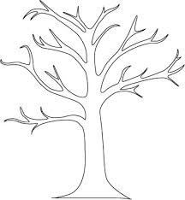

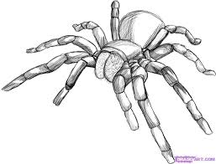
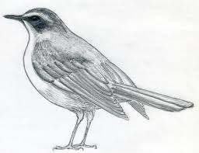
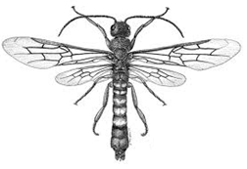

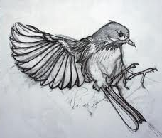
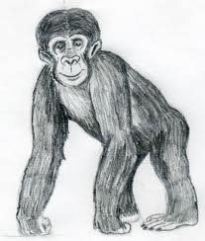
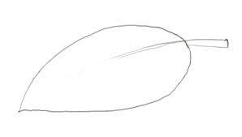

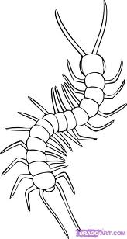

Please don’t forget to evaluate this programme:

