Handcraft: | Bird Mask

 | Print template on heavy duty paper, such as card stock. Decorate with brightly coloured feathers, wool, glitter, sequins or just colour in with bright colours.
See template on next page.

Work Session: | People and Places

Caracal | - Make contact with other Cubs.  - Visit a place of interest in your community and tell a Pack Scouter about it.
Cheetah | - Meet or visit someone who lives or works in your area and tell your Six about it.  - Make and serve a hot drink.
Leopard | - Talk to someone involved in a service organization in your community and tell the Pack how this organization helps the community.
Lion | - Give some of your own time to help other people. This may be done either on your own or as a Six or a Pack.
Singing: | Russell went Up in a Balloon House

Adaptation of “Baloo went over the mountain”.
Russell went up in a balloon house,  Russell went up in a balloon house,  Russell went up in a balloon house,  To see what he could see.  And what do you think he saw,  And what do you think he saw, | Paradise Falls in its beauty,  Paradise Falls in its beauty,  Paradise Falls in its beauty,  Is all that Russell could see.
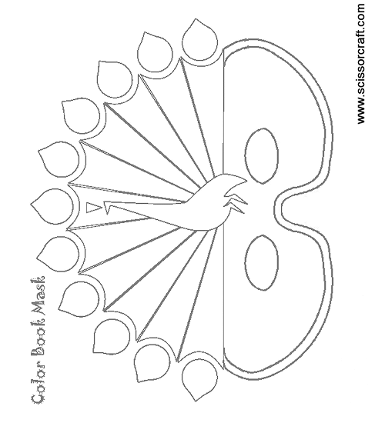

Sense Training: | Russell’s Photo Album

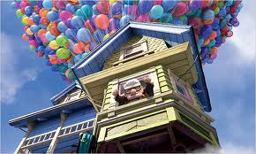 | 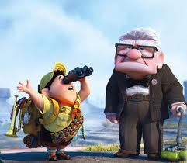 | 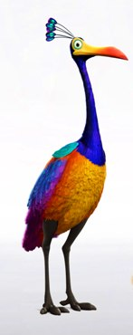
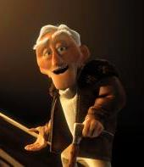 | 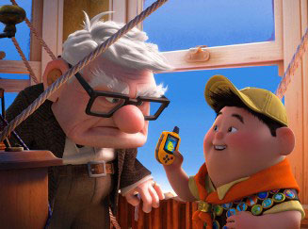 | 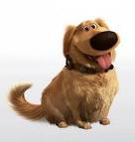
 | 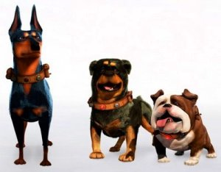 | 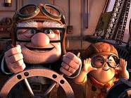

 | 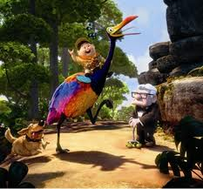 | 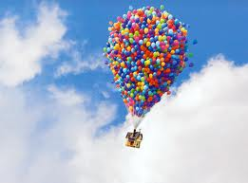
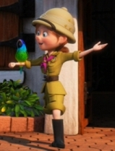 | 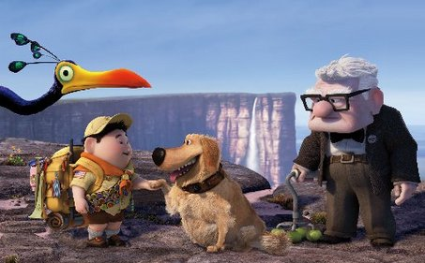 | 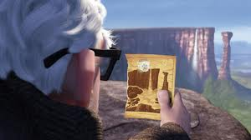

Please don’t forget to evaluate this programme:

