Steam Release: | Find the Map

Map of South Africa – enlarge and cut out and use as a puzzle for the game
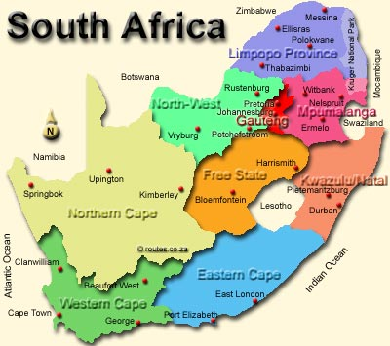

Handcraft: | Sand Art

What you are going to need:

Construction paper
White glue
Sand

Give each Cub a piece of construction paper, and allow them to draw a picture or write words with the white glue or similar. Make sure that they do not put globs of glue in any one spot. Before the glue dries take the picture over to the dry sand and with your hand pour sand onto the glue. Let it sit for a few minutes and then shake off the excess sand. Let it dry flat for about half an hour depending on how much glue was used.

Singing: | Five in the Bed

There were five in the bed and the little one said,
Roll over, roll over,
So they all rolled over and one fell out,
And bumped his head and gave a shout,
Please remember to tie a knot in your pyjamas,
Sleeping bags are only meant for one, two, three, four…

There were four in the bed ……..
There were three in the bed …….
There were two in the bed ……..
There was one in the bed and the little one said,
Good night, sleep tight.

Work Session: | Flags and Countries

Caracal | - Behave correctly during flag ceremonies and during the singing of national anthems.  - Colour in the South African flag correctly.
Cheetah | - Know all the parts of the flag.  - Learn the words of the national anthem and sing it together with other Cubs.  - Draw and colour the South African flag correctly.
Leopard | - Prepare, hoist, break and lower the flag correctly.  - Using a sheet bend join the flag to the halyard.
Lion | - Be able to recognize our five national symbols.

Sense Training: | Find the Gold bar



Please don’t forget to evaluate this programme:

