Yarn: | Where and When did it all begin?

In Ancient Greece they believed in honoring their gods usually by having festivals in the various temples. But a very special festival was held every four years when they all attended a great athletic meeting in Olympia. They believed that the gods enjoyed watching these meetings. So when summer started and it was time for the Games, messengers would go round from city to city calling out “Make your peace with your neighbor, for it is time for the Games of Olympia!” During the Games everyone lived in peace. In those days they were very strict about who could enter. Only young men of pure Greek descent, of good character and well-trained in athletics, were allowed to take part. They competed in running, wrestling, jumping, throwing the javelin and putting the shot. The prizes were crowns of wild olive branches cut from the holy trees on the slopes of Olympia with a golden knife. In Athens they considered it such an honour to win such a crown that an Olympic prize-winner could eat anywhere in the city without having to pay for his food. The Games were held for 400 years, but in 400 AD they were stopped. Around the turn of this century they started again but now they are held every four years in a different country, and, of course, sportsmen from all over the world take part.

Handcraft: | Snowboarder

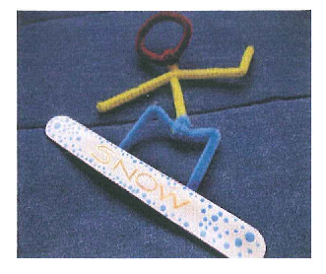 | 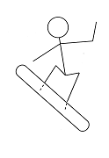
What you’ll need:

- 1 x jumbo craft stick or flat stick
- Paint and paintbrush or kokis or wax crayons
- Pipe cleaners or thin wire
- White craft glue

How to make it:

- Decorate the craft stick using kokis or crayons or paints.
- To make the man, use the pattern above as a guide. First cut a pipe cleaner in half. Cross them like a lower case letter “t” (yellow in picture) and twist together at the crossing point. Bend one arm up like it’s waving, point the other one downward. Cut about 4cm off of another pipe cleaner (blue in picture) and set aside. Bend the remaining pipe cleaner in half to find the center. Starting at the center, bend each side up, then back down to form an upper case letter “M” to make the legs.

- Twist the bottom of body (yellow) around the center of the leg section. Take the 4cm piece of pipe cleaner and wrap it around the intersection you just created.

- Bend another pipe cleaner (brown in picture) into a circle and twist it around the “neck” of the upper body (yellow). Trim off the excess and wrap any remaining around the neck.

- Write the word “SNOW” across the snowboard with marker or paint pen.

- Lay the chenille man on the table and add some white glue to the feet then place the snowboard on top of the feet.

Work Session: | Feats of Skill
Caracal | - Throw a ball to somebody else, and catch it again 8 times out of 10.  - Be able to hop around a figure of eight, each loop with a diameter of about 4 metres, changing feet at the start of the second loop.  - Sit, stand and walk correctly.
Cheetah | - Climb a tree or rope to a height of three metres.  - Do TWO of the following: headstand, handstand, cartwheel, star jumps, leapfrog over a Cub your own size.
Leopard | - Using a rope skip 15 forwards and 15 backwards.  - Throw a ball 15 metres OR dribble a soccer ball around a course drawn on the ground in the shape of a figure-of-eight measuring 12 metres long.
Lion | - Run Scout’s Pace over a 1km course in eight minutes.  - Swim 25m and then tread water for 60 seconds if in fresh water or 120 seconds in sea water OR do 35 sit-ups and 3 pull-ups.

Please don’t forget to evaluate this programme:

