Yarn: | Freddy to the Rescue

Freddy had always been afraid of heights and even at eleven, he still had the same problem. Walking to the shop for his mother one day he came across a fire. He saw the firemen in action; heard people yelling from an upstairs window; saw firemen putting up a ladder with a sort of cabin which they sent up with a fireman and brought people down. Nobody saw a little face at another window. A brown dog, looking very frightened. Everybody seemed too busy to notice the dog – they were treating the people who had been rescued. Freddy pointed him out to one of the firemen, who swung the ladder round and said he’d go up on the ladder himself. He started raising the ladder and when it was in position a falling beam hit him in the chest. There was no way out. Freddy decided to rush up the ladder himself, without thinking how frightened he was. Luckily the dog was calm, and small enough to fit under his arm. Only when he got down again did he realise what he had done. He no longer has a fear of heights.

Games: | Exercises and Partner Challenges

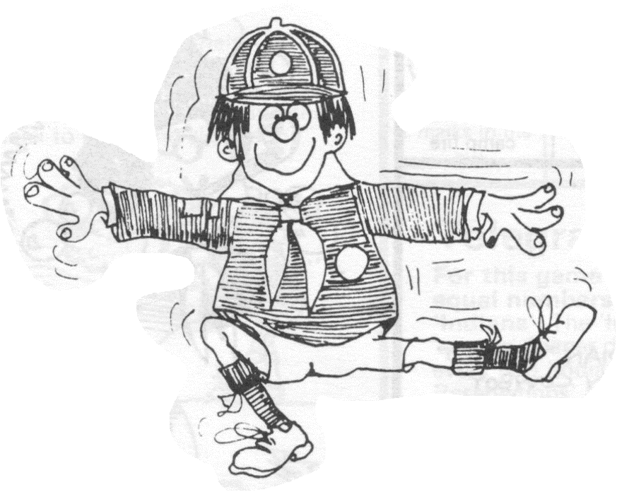 | TOE BALANCE  Try to balance on one foot with your other leg out at right angles to your body.
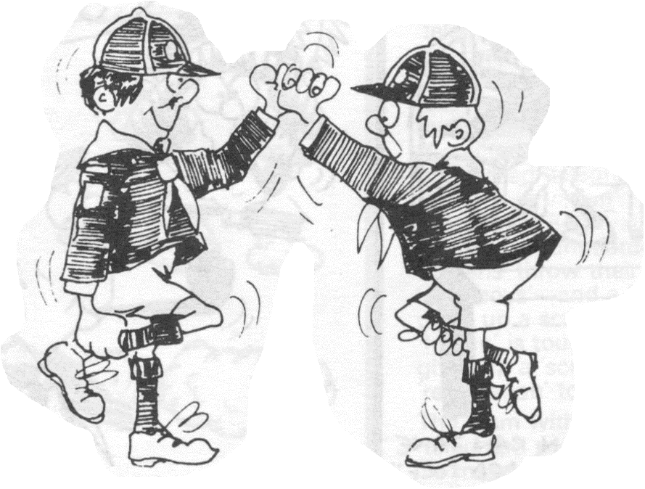 | ONE LEGGED HAND WRESTLE  Each Cub holds his/her own right leg with his/her right hand and clasps his/her partner’s left hand. The object is to try and make your opponent touch the floor with any part of his/her body or make him/her let go his/her leg.
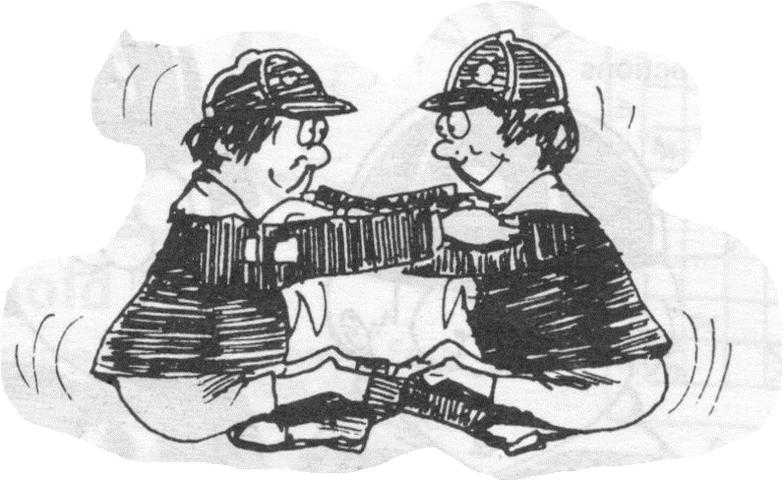 | FOOT LIFT CRAWL  Two Cubs sit facing each other – each sitting on the feet of the other. They hold each other’s shoulders and by rocking back and forth they move along the floor, each lifting the other with his/her feet as they go.
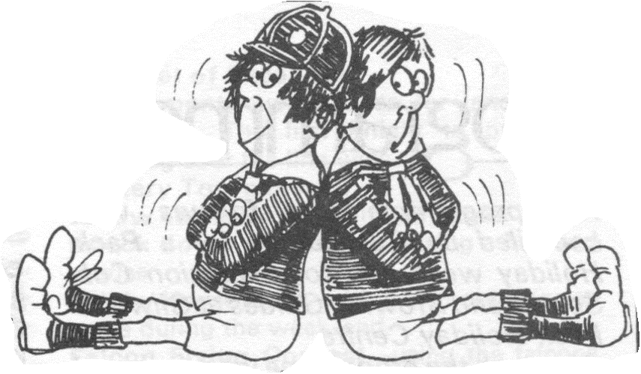 | STAND UP  Two Cubs sit back to back with their feet stretched out and arms folded. The idea is to stand up without using your hands.
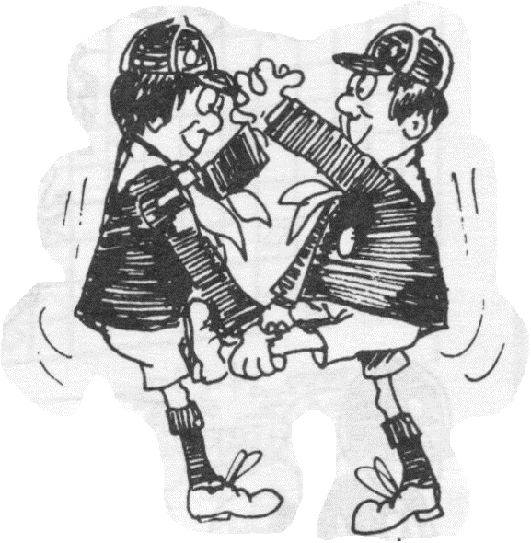 | HOPPING LEG PULL  Two Cubs facing each other. The first Cub holds his/her partner’s left leg with his/her right hand; they both clasp each other’s left hand. The first Cub tries to pull his/her partner along.

Singing: | Campfire’s Burning

Campfire’s burning,
Campfire’s burning,
Draw nearer,
Draw nearer,
In the gloaming,
In the gloaming
Sing and be merry,
Sing and be merry.
Variation:

Campfire’s burning,
Campfire’s burning,
Come and sing,
Come and sing,
All around the fire,
All around the fire,
Voices ring,
Voices ring.

Please don’t forget to evaluate this programme:

