Theme: | Compass and Mapping

Date: 23 October 2026 Duty Six: Black

Time | Min | Activity | Equipment | Scouter
17:30 | 05 | GRAND HOWL  Flag  Prayer  Register  Inspection  Break | Totem/skin/rock  Flag/flag pole  Prayer book  Register  Belts/socks/scarf/caps | Akela  CI
17:35 | 10 | Steam release – Compass Corner Dash  How to play  - Set up  Place four markers around the playing area: North, South, East and West. Use a compass to position them correctly.  - Play!  The Cubs stand in the middle. The Scouter calls out a direction, and everyone runs to the correct marker.  Make it trickier with commands such as:  “Face North!”  “Run to the opposite of East!”  “Stand facing South and point West!”  “Take 5 steps North, then turn East!”  “Face West, then turn 90° right!”  Anyone who gets it wrong does 3 jumping jacks and joins the next round. Nobody is eliminated!  - Final challenge  Call out a sequence: “North, East, South, West!”  The Cubs must move to each direction in the correct order. | Cones  Compass | CI’s
17:45 | 20 | Split Silver and Gold wolf  Gold Wolf:  - Show how to use and care for a compass  - Show how to use a street map by tracing a trail from the scout hall to Sunridge Primary School. On the same map circle and discuss 6 symbols used on the map.  Silver wolf:  - With a Scouter, go outdoors and point out where the sun rises, the path it travels and where it sets. (See resources)  - Show and explain the eight points of a compass. (See image) | Refer to reference below  Street maps  Compass | Akela  Darzee  Rafiki
18:05 | 20 | Split Silver and Gold wolf  Gold Wolf:  - Use a compass and one other method to find North in an outdoor environment. (See resources)  Silver Wolf:  - Draw a simple map of the Scout Hall showing the different rooms and doorways. | Compass  Paper  Crayons | Akela  Darzee  Rafiki
Traffic signs keep us safe on the roads, lets see how well you know them?
18:25 | 10 | Game: Ball Run  Give each Cub a piece of cardboard. Cubs have to stand in a line and start the ball rolling down the end of the line. Once the ball has gone through the first piece of cardboard that child runs to the other end of the line and joins with their cardboard. See how far around the hall it goes before the ball falls off the end. | Paper  Ball | CI
Now that we know more about being safe, lets get set up for closing

18:35 | 05 | Set up for closing | Totem/Skin/Flag | Duty Six
18:40 |  | NOTICES and BADGES
18:50 | 05 | GRAND HOWL  Flag  Prayer  Dismiss | Totem/skin/rock  Flag/flag pole  Prayer book | Akela / Duty Six

GOLD WOLF – FINDING NORTH WITHOUT A COMPASS

On 23 October 2026 at 18:15, the sun in Port Elizabeth (Gqeberha) will be sitting just under 7° above the horizon, preparing to set at 18:37.
At exactly 18:15, the sun will be positioned at an azimuth of 261°. This means it is tracking almost perfectly due West (which is 270°), sitting just 9° slightly to the left (South) of pure West.

Your 18:15 Navigation Alignment

Because 261° is virtually due West to the naked eye, you can safely use the sun as a direct compass marker:
1. Face the low sun directly: Turn your body until you are looking right at the sun hovering above the horizon. You are now facing West.
2. Extend your arms straight out: Hold your arms up straight to your sides to form a “T” shape with your body.
3. Find North: Look along your right arm. Because the sun sits just 9° left of perfect West, your right arm will point exactly True North. Your left arm will point directly South, and East will be directly behind you.

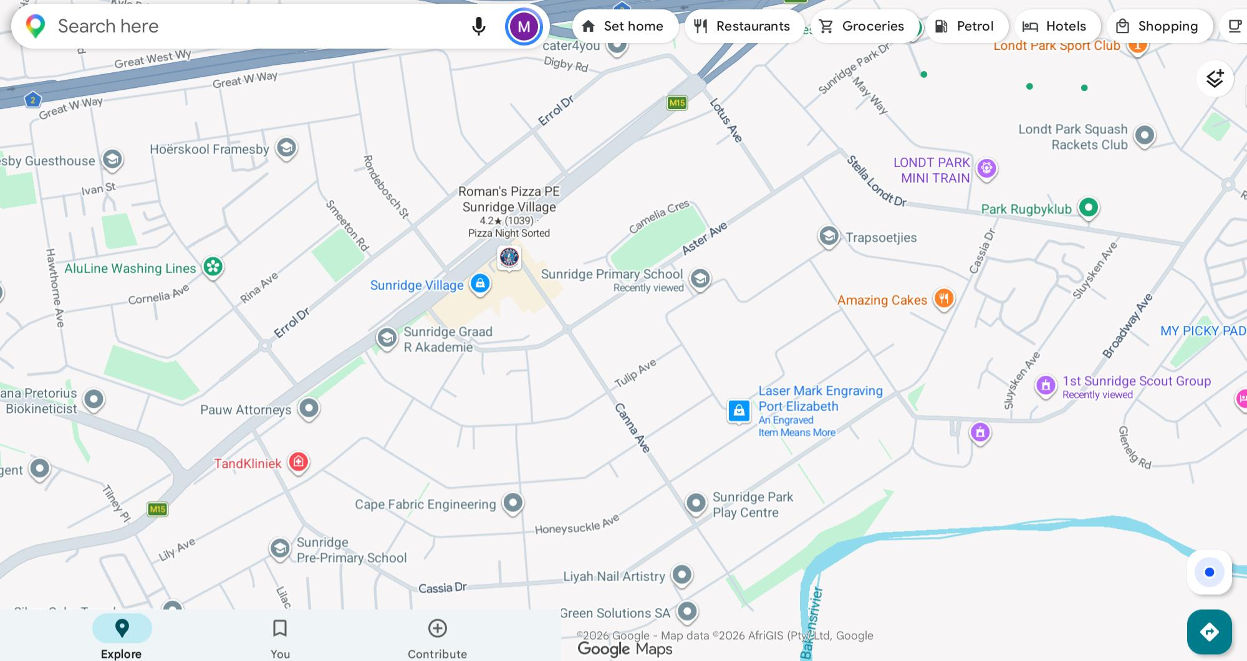

SILVER WOLF

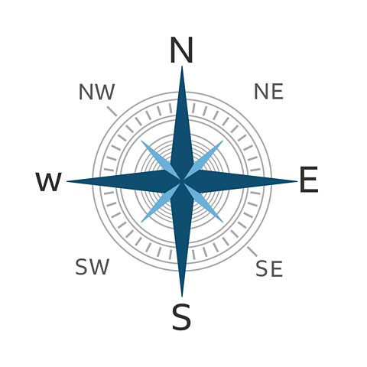
The Sunridge Park Guide to the Sun
1. Sunrise (East) — Towards the Baakens Valley & the Ocean
- What to tell them: "Point your left hand down towards the Baakens River Valley or Stella Londt Home side. That is East! If you kept walking that way, you'd end up at the beachfront. Every morning, the sun wakes up right over those trees and hills." 🌅
2. Midday (North) — Towards Sunridge Village & Cape Road
- What to tell them: "Turn and face straight towards Sunridge Village Shopping Centre or Cape Road. That is North. At lunchtime, the sun is high up in the sky right above the shops! Because the sun is shining from the shops' side, your shadow will stretch out long behind you towards the south." 🏢
3. Sunset (West) — Towards Framesby & the Mountains
- What to tell them: "Point your right hand towards Framesby High School or out towards the mountains. That is West. At the end of the day, the sun travels over there and goes down behind the houses and the far-away hills." 🌇

👣 The Sunridge Park Shadow Challenge
Since you'll be right there, have them try this quick physical trick:
- Have them stand facing Sunridge Village (North).
- Point their left arm out to the side (East / Sunrise).
- Point their right arm out to the side (West / Sunset).
- Now, tell them to look at the ground behind them. Their shadows are pointing straight away from the shops, down into the valley (South)!
Are you doing this with a specific group (like a sports team, scouts, or a birthday party), or would you like a quick game rules for a sun-tracking

