Programme: Friday 16 October 2026 Duty Six: Blue

Learning about cultural activity, compass points while knowing how to treat burns, scalds and stop bleeding and how to handle emergency situations all while doing our knots

Activity | Duration | Time | Equipment | Who
Grand Howl | 10 mins | 17h30 |  | All
Lets play our game and have some fun while doing it
Steam release
Play together Stay Together  Give each Cub a piece of cardboard. Cubs have to stand in a line and start the ball rolling down the end of the line. Once the ball has gone through the first piece of cardboard that child runs to the other end of the line and joins with their cardboard. See how far around the hall it goes before the ball falls off the end. | 15 mins | 17h40 | See video which was sent on Pack Scouters Group on 1 September 2026  Cardboard enough for each Cub  Small ball to roll through Cardboard tunnel. | Hathi  Cub Instructors
Now it’s time to practice our knots
Silver Wolf
Round turn & 2 half hitches | 10mins | 17h55 | Ropes | Jono  Cub Instructors
Gold Wolf
Bowline | 10mins | 17h55 | Ropes | Hathi
Now we are going to divide up into Silver, Gold and Leaping Wolf
Silver Wolf
Cultural Activity – 3 Bases  Divide Cubs up into 3 groups.  See below for details on the three bases | 8 mins x 3 = 25 mins | 18h05 | Zulu Necklace Base  Quiz Base  Dancing Base to a South African tune | Jono  Naomi  Jeanette
Gold Wolf
Burns, scalds and stop bleeding | 25 mins | 18h05 | Water, burn shield, makeup, gloves  Fake blood and medic kits including gloves  See below for additional information (for both Burns, scalds and stop bleeding) | Hathi  Cub Instructors
Let go and get some juice and biscuits before we continue
Juice and koeksisters | 5 mins | 18h25 |  | Parent helper for the night
Now its time to get back for some more fun.
Silver Wolf
Compass Points  Short demo on compass, sun rise direction, stars etc. Then use compasses to lay a trail for their partner (4 to 5 steps) and partner to follow it, then swap | 15 mins | 18h30 | Compasses, pen and paper | Jono  Naomi  Jeanette
Gold Wolf
Emergency situation | 15 mins | 18h30 | See below for information | Hathi  Cub Instructors
Now that we have had all our fun together. It is time to close the meeting.
Closing Howl  - Investment  - Badges  - Notices | 10 mins | 18h50 |  | All

Gold Wolf - First Aid: Know how to behave in an emergency situation

Although most of us know how to behave in emergency situations, when actually placed in one, do we know that we will do the correct things? The best way to try to ensure that the Cubs have absorbed the requirements is to put them in the role of dealing with an emergency, either by play-acting or by actually setting up a simple simulated emergency.

- Fire in the home could easily be the subject of a play-acting session. During this you can include revision for the younger Cubs in getting adult help in the case of any emergency.
- Role-play the situation where a Cub has fallen out of a tree and is lying on the ground. You can decide whether they are conscious or not, or make up some mock cuts and grazes and use this as revision for first aid as well as putting the Cubs into an emergency situation to see how they react.
- In recent years there have been a number of floods in our country, and a discussion around this topic, with the Cubs listing all the possible emergency procedures, could be a most valuable exercise. This would also bring in water purification, message carrying, general safety rules and differing aspects of first aid.

Gold Wolf - First Aid: Show how to stop bleeding by using direct pressure

- NEVER TOUCH a bleeding wound on anyone except yourself, unless you have your hand covered by plastic gloves or a plastic bag.
- Remember to wash your hands before treating a cut on yourself.
- With a cloth or handkerchief folded, apply pressure on the wound with your fingers flat together.
- Check if the bleeding has stopped. If not, apply pressure again.
- Cover the wound with a clean cloth, or a dressing if you have a first aid kit handy, and tie gently around the injured part, using a reef knot to tie the ends.
- If the person needs to go to hospital, an adult will take over.
- Remember when removing your glove or plastic bag to take if off in a way that it is inside out, leaving the blood inside the glove or bag.

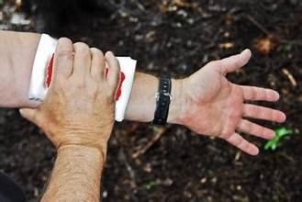

Gold Wolf – Burns and Scalds

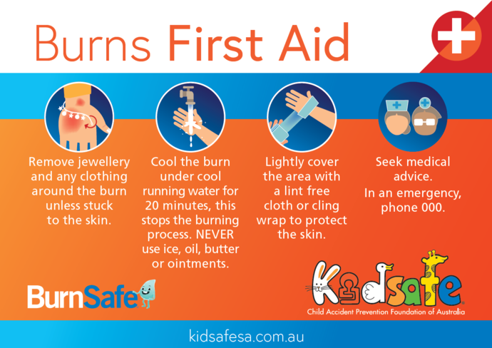

Silver Wolf: Cultural Activity:-

Base 1: Zulu Necklace Base

Make a Zulu necklace
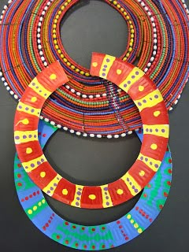

Base 2: Quiz Base
Name That South African Food! 🍲 Done with Bean Bags and the Corn hole

Question | Answer
I am a sausage cooked on a braai? | Boerewors
Bunny chow is served in hollowed out bread (True or False) | True
I am made from maize meal. I can be soft and porridge-like or firm enough to eat with your hands? | Pap
Biltong is a type of sweet cake (True or False) | False
I am a spicy relish made with tomatoes, onions and chilles? | Chakalaka
Melktart is often flavoured with cinnamon (True or False) | True
I am a sweet twisted pastry covered in syrup | Koeksister
Boerewors is a type of ice cream (True or False) | False
I am a curry served inside a hollowed-out loaf of bread? | Bunny chow
A baked spiced minced-meat dish with an egg-based topping? | Bobotie
I am a pudding made with milk often sprinkled with cinnamon? | Melktart
I am dried seasoned meat that people enjoy as a snack | Biltong
A soft sweet pudding often served with custard or cream | Malva pudding
I am a traditional fried dough treat, often eaten plain or with a filling? | Vetkoek

Base 3: Dancing Base

Use the song “Special Star” by Mango Groove. The Cubs need to come up with a 20 second dance as a group to show you

