Theme: Knots
Date: 5 September 2026
Advancements: Outdoor Challenge
Duty Six: Brown
Time | Activity | Person in charge | Equipment
2:30 pm  10 min | Opening  Flag, Prayer, Cub promise  Inspection: Nails, handkerchiefs, badges and uniform | All Pack Scouters
2:40 pm  10 min | Activity 1: Steam Release – Statues  On the word go, cubs to run around, when the leader shouts “stop” cubs to freeze. | Meena
2:50 pm  30 minutes | Activity 2: Knots  New cubs  Reef Knot  Thumb Knot  Figure of eight  Older cubs  Sheep Shank  Bowline  Sheet Bend | Prakashini  Meena  Prakashini  Pia
3:20 pm  10 min | Activity 3: Turtle Soccer  Everyone stands in a circle facing inward with their feet spread wide. The outside of each player's foot must touch the outside of their neighbor's foot to form a continuous ring. Players pass and block a ball using only their feet while staying in position. If the ball passes through, the player looses a hand, then the 2nd hand, third time, they are out. | Prakashini
3:30 pm  10 min | Activity 4: Construction Model  Work in their sixes. Each six to build the tallest tower in 10 minutes | Pia
3.40 pm  10 min | Activity 5: Human Knot  First attempt in their sixes, then in 2 teams and final the whole pack.  Ask everyone to raise their right hand and reach into the center of the circle. Grab the hand of someone standing across or opposite from you. You cannot grab the hand of the person directly next to you  Ask everyone to raise their left hand, reach into the center, and grab the hand of a different person  Ensure every single person is holding hands with two different people, and that no one is holding hands with their immediate neighbors  Work together to untangle the human knot and form one large, unbroken circle of people holding hands. | Meena
3:50 pm  10 min | Activity 6: Beat the clock  To be played in their sixes. Each six to be given 10 chairs.  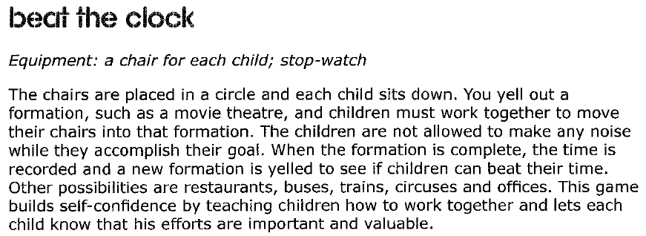 | Prakashini
4:00 pm  10 minutes | Activity 7: Tower of Buttons – Relay Game  A bucket of buttons is placed at the end of the hall. In their sixes each cub will have a turn to collect 5 buttons and take them back to their six. Aim is to build the tallest tower within a set time, without toppling it over. | Pia
4:10 pm  10 min | Activity 8: Mushroom Ball Throw  Cubs stand in a circle with the leader in the middle. The leader throws the ball to a cub who passes it back to the leader. If the cub misses, he must stand on one leg. On the 2nd miss he goes onto his knees and on the 3rd miss he is out and must sit down. If the leader misses, the leader goes into the circle. | Meena
4.20 pm  10 min | Closing  Flag, Prayer  Law and Promise, Notices and reminders  Badges | All pack scouters
4:30 pm | Dismiss | APS

Other games:
- Pass the button
- Balance the paper, across the hall (Meena)


