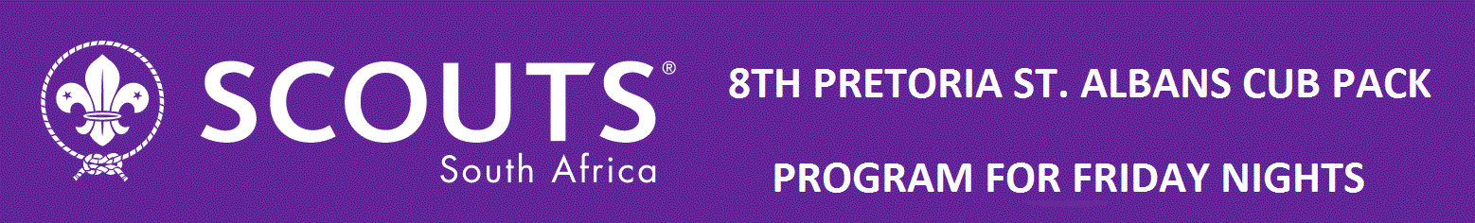
Theme: Knotting, Trail signs
1st Camps Bay Cub Pack
TIME |  | MIN | 6 August 2026  ACTIVITY | EQUIPMENT | SCOUTER
17:00 |  | 15min | GRAND HOWL  Investiture: Max, Stefan, Adrian  Flag break: Blue Six  Recruit:  Inspection: uniform and ropes | Flag and Totem | Akela
What can you remember from the First Aid last weekend Amelia and Jonas?…
First game is about a Jungle character Shere Khan for our new cubs
17:15 |  | 10 min | Steam Release: Shere Khan’s hunt.  All the cubs lie down asleep and Shere Khan roars, cubs jump up and run away. Any cub tagged by Shere joins in the next hunt. Points for last 5 cubs not caught. |  | Akela
The yarn today is about finding your way in the jungle, when you know your knots and trail signs
17:20 |  | 5 min | Yarn: |  | Jean-Claude
Now time to revise knots, and GW to help new cubs especially, how to tie knots
SW:
- Make and use the following knots:
  - Reef knot
  - Slip reef
  - Round turn and two half hitches
  - Figure of eight
- Know how to hank a short rope.
- Successfully take part in three separate games and/or activities which involve using knots.
GW: complete the knotting board
- Make and use the following knots:
  - Sheet bend
  - Fisherman's knot
  - Bowline
  - Sheepshank
Compass and Mapping  - With a Scouter, go outdoors and point out where the sun rises, the path it travels and where it sets.  - Know the eight main points of the compass.  - Identify a simple object viewed from the side and top to illustrate the difference in shape.  - Draw a simple map of your home or meeting place showing the different rooms and doorways.  - Compass and Mapping  - Show how to use and care for a compass.  - Use a compass and one other method to find North in an outdoor environment.  - Using a compass follow a compass trail of six to ten moves.  - Show how to use a street map.  - On a street map explain and recognise six to ten map symbols. | 20 min |  | GW lay a trail of 20 trail signs  SW learn the trail signs |  | Akela
Time for another game.
18:05 |  | 15 min | Cubs get into sixes and put tight hand into circle and hold hands, then left hand into circle to hold hands to make a big knot, then twist and turn to get unknotted |  | All
 |  | 5 min | Time for Stalk | n/a
18:10 |  | 10 | GRAND HOWL  Flag break: Blue Six  Interest Badges: Jonas, Amelia (First Aid), Ben (Food for life) | Flag and Totem | Akela

A little bit about the History of the Reef Knot

The Reef Knot, also known as the square knot or the Hercules knot, traces back centuries & finds its origins in maritime and practical applications.

Believed to have been used by sailors as early as ancient Egypt, this knot's simple yet effective design made it an essential tool for securing sails, rigging, and other nautical tasks.

While it might appear as just a simple method of joining two ropes together, the history of the reef knot is interwoven with the changes of maritime practices, technological advancements, and everyday applications that have spanned centuries.

Its primary appeal lay in its simplicity; it could be tied and untied quickly, an essential quality for sailors dealing with ever-changing weather conditions and the dynamic nature of the sea.

The reef knot's ability to hold tightly under tension, yet still be easily undone when needed, made it an invaluable tool. During the era of tall ships and intricate rigging, the knot's reliability was tested as it played a pivotal role in keeping vessels afloat and functioning in the treacherous waters of the high seas.

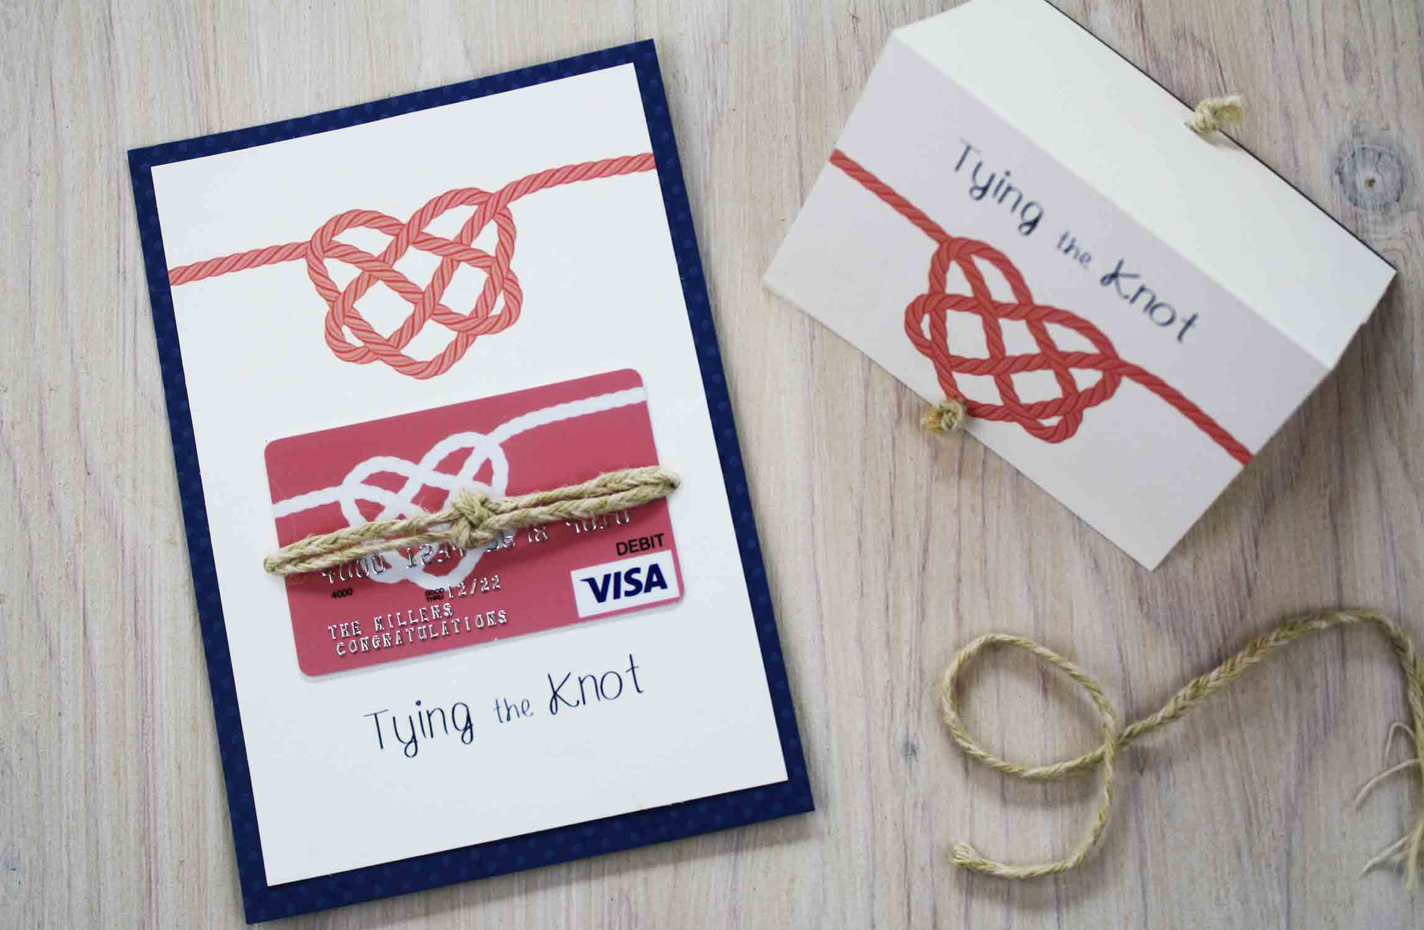

Once upon a time in the heart of a dense forest, there lived a group of curious cub scouts. One sunny afternoon, their leader, Wise Owl, gathered them around a campfire and began to share a tale about the power of knots.
"Scouts," Wise Owl began, "let me tell you the story of Knotley, the humble knot. Knotley was once just a simple piece of rope, overlooked and underestimated by all. But as time passed, Knotley learned that its strength lied not in its appearance, but in its ability to hold things together."
The scouts listened intently as Wise Owl continued, "One day, a great storm swept through the forest, tearing branches from trees and causing chaos everywhere. In the midst of the storm, Knotley found itself tangled up with other ropes and branches. Instead of giving in to despair, Knotley remembered its purpose – to hold things together."
"With determination and perseverance, Knotley began to weave itself around the other ropes and branches, creating strong knots that held everything in place. While other ropes broke under the pressure of the storm, Knotley's knots remained firm and steadfast."
Wise Owl paused, allowing the significance of the story to sink in. "Scouts," he said, "just like Knotley, each of you holds the power to be a source of strength and support, even in the face of life's storms. Remember, it's not about how flashy or impressive you may appear, but about the strength of your character and your willingness to hold things together when it matters most."
As the campfire crackled and the stars twinkled above, the cub scouts reflected on Wise Owl's words. From that day forward, they embraced the lesson of Knotley, knowing that with every knot they tied, they were not just securing ropes, but also building resilience and unity within their pack.



