
Theme: finding direction
1st Camps Bay Cub Pack
TIME |  | MIN | 13 August 2026  ACTIVITY | EQUIPMENT | SCOUTER
17:00 |  | 5min | GRAND HOWL  Flag break: red Six  Investiture of Adrian and Liya  Inspection: uniform and ropes | Flag and Totem | Akela
We are all so lucky to be at cubs. "Tonight we are going to do some path finding
17:05 |  | 10 min | Steam Release  Compass points on the field |  | Kaa
The yarn today is about what to do if you get lost …
17:15 |  | 15 min | Each time the wrong thing to do (underlined sentence) cubs must jump up and sprint to touch a tree/playhouse…
. WE split into GW and SW now
 | 10 min |  | SW: With a Scouter, go outdoors and point out where the sun rises, the path it travels and where it sets.  Know the eight main points of the compass.  Identify a simple object viewed from the side and top to illustrate the difference in shape.  Draw a simple map of your home or meeting place showing the different rooms and doorways.  GW: Show how to use and care for a compass.  Use a compass and one other method to find North in an outdoor environment.  Using a compass follow a compass trail of six to ten moves. |  | Kaa  Rikki  Baloo  Akela  Kylie
Time for another game. This time the rescue will be by boat
17:40 |  | 15 min | Lifeboat relay using the direction |  | All
 |  |  | The compass wedding
18:00 |  | 10 | GRAND HOWL  Flag break: Six  Interest Badges:  Notices: | Flag and Totem | Akela

Lifeboat Relay – "Abandon Ship!"
Story
"There's a huge storm at sea! Your ship has hit rocks and is sinking. Your whole crew must get safely to the island, but you only have one lifeboat. Can your crew work together to save everyone before the ship disappears?"

Equipment
- One hula hoop (or a large rope tied into a circle) per Six – this is the lifeboat.
- Two cones about 30 metres apart.
- Optional: beanbags or a teddy to represent "supplies" or an injured sailor.

Set Up
- One cone is the sinking ship.
- The other cone is the safe island.
- Each Six stands behind the starting cone with their lifeboat.

How to Play
The lifeboat can only carry two Cubs at a time.
- The first two Cubs stand inside the hula hoop (or hold the rope circle around them).
- They walk or jog together to the island, keeping the lifeboat around them.
- One Cub stays safely on the island.
- The other Cub returns with the lifeboat to collect another sailor.
- Continue until the whole Six has been rescued.
The first team with everyone safely on the island wins.

Challenge Rules
To make it more exciting:
- The lifeboat must stay touching both sailors.
- No running.
- If the lifeboat falls off or someone steps out, they must return to where they started.
- Cubs must encourage one another—good teamwork earns bonus points.

Harder Version (Perfect for Gold Wolves)
Halfway through the rescue, shout:
"A storm is coming!"
Now the lifeboat must carry:
- a beanbag (food supplies),
- or a teddy (an injured sailor),
- without dropping it.
This suddenly forces the Cubs to slow down and cooperate even more.

Be prepared, and do your best not to get lost in the first place!

These are things you can do before you head out:

Don’t tell anyone where you’re going.

Before you leave, tell someone where you are going.

Always tell someone where you are going and when you will be back. Make sure that when you do get back you let them know so that they don't call out the cavalry.

Never take water with you on a hike.

Be prepared

Even if you are only going for a day walk, always take a map and a small emergency kit: first aid, torch (to signal rescuers), matches (to light a signal fire), food and water, warm clothing, a small mirror for signalling rescuers.

You don’t need to plan your trip. Just use Google.

Plan your expedition

You are much less likely to get lost if you plan your route, study the map before you start, and know how long it will take. Also check the weather forecast before you go.

You don’t need to keep checking your map. Everything will probably work out if you keep walking.

Keep track of where you are

Along the way, keep checking the map and taking a mental note of landmarks that you pass. Keep an eye on the time, and on any changes in the weather.

Split up, so you can cover more ground.

Stick together

Use the buddy system. Don't get separated from the rest of the group. Work as a team.

If you get lost, don't panic - be resourceful!

Stop - don't push on into the unknown

As soon as you know that you are lost, stop. You are safer staying on a rocky ledge than trying to find a way down a dangerous cliff. If it is getting dark, it is far better to set up a camp in the remaining light rather than to stumble on in the dark.

Run around like a headless chicken!

Stay calm, and think!

Don't panic! You are much safer if you stay calm and think clearly.

Find a windy, cold place to stand.

Take shelter

Find shelter or build a shelter to protect you from the elements - wind, cold, rain, heat. Try to build a fire to keep you warm.

Leave your car, because if it’s not working it can’t help you.

Stay with your vehicle

If you break down in a vehicle, stay with it. It is much easier for a rescuer to find a car than a person who has wandered away! A vehicle can help in many ways, even if it can't drive.

Sit on your hands and do nothing.

Signal for help

Build a signal fire with lots of damp leaves to ensure that the fire produces a lot of smoke. Make ground-to-air signals in a clear spot. Shout and blow a whistle when a rescuer is near.

Put spread mud on your face and make sure nobody can spot you.

Be visible As soon as the sun comes up, try to find an open place where you could be seen from the air.

Stream beds are excellent for this if you are in thick vegetation. Search helicopters generally traverse waterways first of all when looking for missing people.

Eat all your food, because the extra energy will help you think better.

Make your supplies last Ration your food and water. Try to make it last as long as you can. If you are low on water, find a source of water.

Be impatient.

Be patient

If someone knows that you are missing, help is on the way.

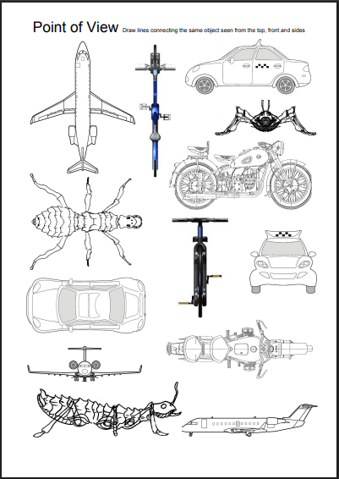

The Compass Wedding

Each Cub brings a chair into the circle. Divide the circle into the 8 points of the compass. Leave a clearly defined space between each point. When each section is called, for instance, NORTH, the Cubs in that section stand up, turn around and then sit down. Each section does the same thing when their compass point is mentioned. When the story teller says WORLD, each player moves one chair to their left (clockwise). Each player should note which section they are now occupying. (You can use more than one circle depending on the number of Cubs in your pack.)

The Compass Wedding

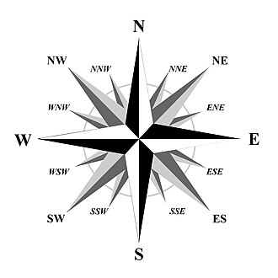

A big important wedding is being held this year. The daughter of King NORTH is being married to the son of King SOUTH. It is going to be a very grand affair with guests from all parts of the WORLD: from the land of the rising sun, the Emperor of the EAST and his wife, the Empress, and from the other side of the WORLD, King and Queen WEST with the little Prince NORTHEAST and the Princess SOUTHWEST.

The bridegroom, son of King SOUTH, has invited his cousin SOUTHEAST to be the best man. The bride, daughter of King NORTH, has asked her best friend, NORTHEAST, who is also a cousin of SOUTHEAST, to be Maid of Honor. The Queen of the NORTH was very busy trying to find places for the visitors from all over the WORLD to stay.

The Emperor EAST and his wife the Empress EAST had brought so many servants to wait on them, that the little town was beginning to be very overcrowded. To add to the confusion, King and Queen WEST had brought so much luggage that it took 3 wagons to haul it to the NORTH palace. Queen NORTH looked quite worried; where in the WORLD was she to put it all? In the last wagon, Prince NORTHWEST and Princess SOUTHWEST had put all their pets which they couldn't bear to leave behind. Four SOUTHWEST cats, four big dogs (which came from the 3 other side of the WORLD), and a cow and a goat from the EAST. The cousins SOUTHEAST and NORTHEAST thought they were very odd things to bring halfway across the WORLD to a wedding.

At last the great day dawned, beautiful and sunny. The procession started to go to the NORTH Cathedral from NORTH Palace, and people from all over the WORLD cheered. After the ceremony in NORTH Cathedral, the procession returned to the NORTH Palace for the wedding breakfast. First came King NORTH, with Queen SOUTH on his arm. Next came King SOUTH with Queen NORTH. Following then came King and Queen WEST, with Prince NORTHWEST and Princess SOUTHWEST.

Looking very grand in their silk robes were the Emperor of the EAST and the Empress of the EAST. The guests from this part of the WORLD came next. Cousins SOUTHEAST and NORTHEAST then appeared. Then came the moment the whole WORLD had been waiting for. The beautiful bride, daughter of king NORTH, and the handsome bridegroom, son of King SOUTH, were standing in the doorway. Guests from all over the WORLD threw confetti and rice as they ran down the steps to the famous NORTH glass coach.

After the wedding breakfast at NORTH Palace, the bride and groom left on their honeymoon around the WORLD. Prince NORTHWEST had tied and old boot on the back of the car, and Princess SOUTHWEST had printed "Just Married" on the front. The whole WORLD laughed and cheered and waved good-bye and good luck, along with Prince NORTHWEST, Princess SOUTHWEST, Cousins NORTHEAST and SOUTHEAST, Emperor and Empress EAST, King and Queen SOUTH, and finally King and Queen NORTH.

So ends a happy and exhausting day!





