BUSH HILL CUBS – Program
29.05.2026 | Theme: A Rumble In the Jungle | Bagheera
TIME | ACTIVITY | LEADER / EQUIP
2.40  10 min | Opening: Grand Howl  Register  Inspection – Names in Caps  Welcome to the Jungle cubs:  For today each six is going to be a different character from the jungle:  RED : Hathi (Elephant)  BLUE : Kaa (Snake)  GREEN :Baloo (Bear)  WHITE : Bagheera (Black panther)  YELLOW : Chil (Kite bird)  PURPLE : Raksha (Wolf)  Give each six the opportunity to make their animal sounds and movement. | Bagheera
“Cubs, today we are leaving the safety of the den and stepping deep into the wild jungle where exciting adventures and challenges await us!”
2.50  10 min | ACTIVE GAME: Relay/Memory game  Match the picture to the name.  Eight Jungle Book Characters  Flip the cards over if you get a match keep them face up. If not turn them over and let the next cub go. First six to make all the matches wins beans.  -SW Task 55 Eight Jungle Book Characters  -SW Task 13 Memory Game | Chil  Dani/Gabi  Jordan  Picture  Chairs
“As we enter the jungle, the animals are waking up around us. To survive in the jungle, we must learn to move just like them!”
3:00  15 mins | Craft : Binoculars  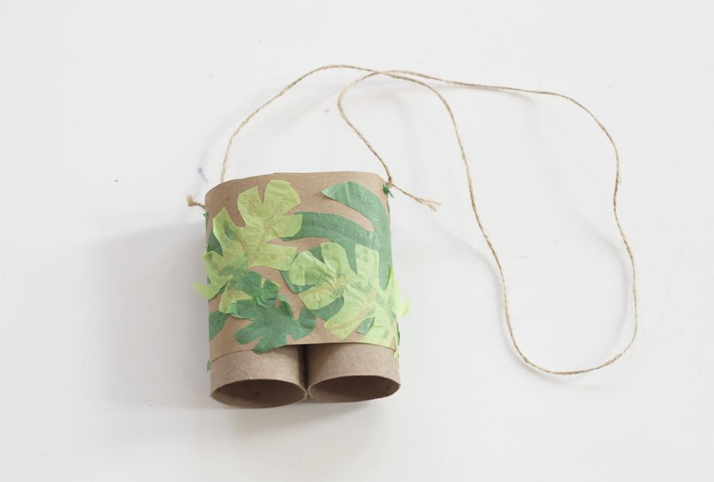  SW Task 16 | Toilet Paper Roll  2 per cub  Pens  String  Pritt  Stapler  Tape board clear tape  Leaves  Markers
3.15  10 min | Steam Release:  Find the banana and bring back to a leader  Work in pairs and find 1 banana | CI – Hide Banans all over the hall and outside
Break Time: “Our jungle explorers have travelled far already. Before the next adventure, we need to rest, drink water, and prepare for the trail ahead.”
3.25  5 min | Juice & Biscuits | PH
“Deep in the jungle, explorers leave secret signs behind to guide others safely through the wilderness. Now it is your turn to follow the jungle trail!”
3.30  30 min | INSTRUCTION:  NEW CUBS:  SW: Nature rumble (Split into 2 groups)  GW: Lay 20 wood trail  SW: TO FOLLOW TRAIL LAYED OUT AND GW TO DO NATURE RUMBLE | Bagheera  Chil\Dani/Raksha  Hathi /Jordan  Lay a simple trail through the area using:  - Arrows made from sticks  - Piles of stones  - Broken twigs  - Leaf markers
“As the sun sets over the jungle, the animals grow quiet and the explorers gather around the campfire to share stories and songs.”
4:00  15 min | Pretend Camp Fire:  Lets sing a campfire song  Raksha will read us a story while we sit around the campfire.  Kim Story SW Task 11  Let Sing another Camp song  What’s you favourite camp song? | Hathi  Raksha  Chil
“Deep in the jungle, a brave Cub pack followed mysterious tracks through the trees…”
Back inside the hall for a special cermony.
4:15  10 min | Investiture :Azania | Hathi  Badges,Cap and Scarf
“Our jungle adventure is coming to an end, but before we leave the jungle, we will celebrate together one last time!” Each six to make the sounds and movements of the animal they were assigned.
4.20  10 min | Closing Prayer  Raffle Winner  Helping Hand  Badges Announcements | Bagheera  All

BEANS:

RED | BLUE | WHITE | GREEN | PURPLE | YELLOW

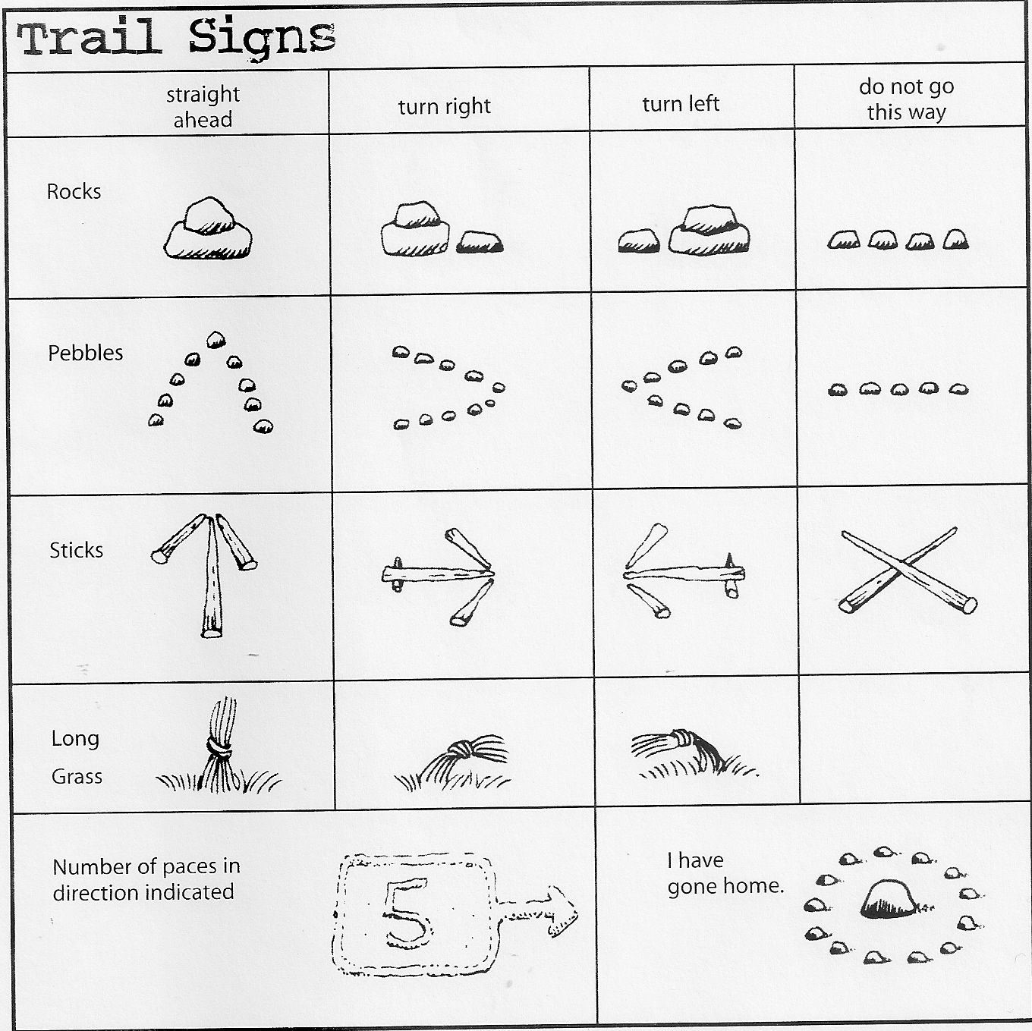

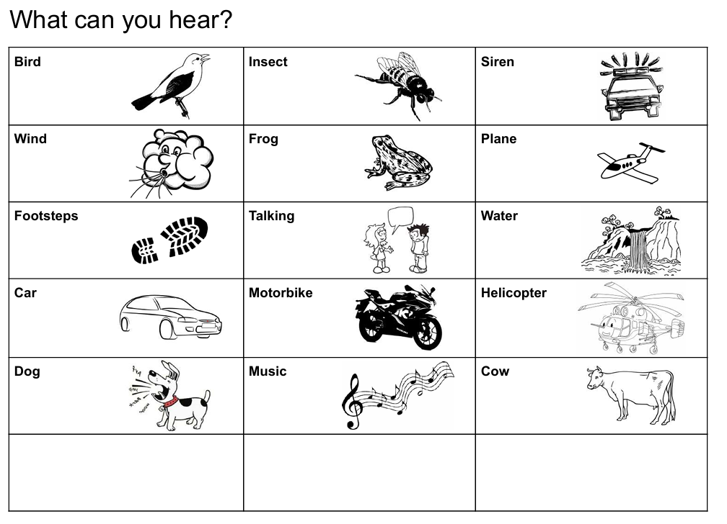

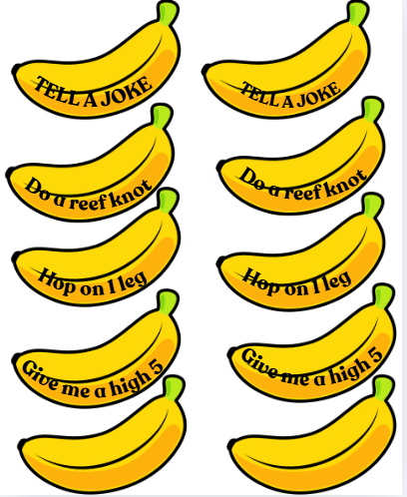
X3 copies

