Cub Swimming Programme – 16 Oct 2026 – at Pinelands North School swimming pool
Scouters: Joey Lugt, Ghalied Geduldt, Naseema Ishmail, Jude Conradie
Cub National Challenge 2026 – Be Water Safe
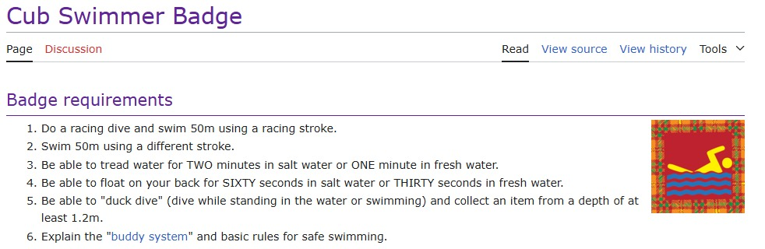

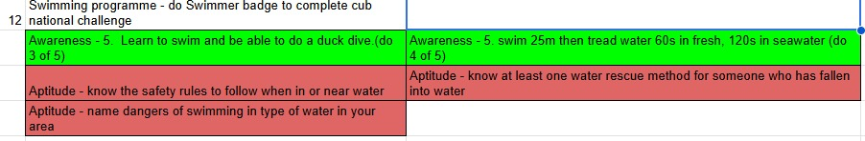
Activity | Leader | materials
Kick off base: (10 min)  Safety rules to follow when in or near water (Joey)  Dangers of swimming in type of water in our area (Joey)  Buddy system and basic rules for safe swimming | Joey | none
Base rotation: (40 min – 9min per base 1min to change bases)

- Racing Dive and swim 50m (2 lengths) using a racing stroke | Monique | None
- Tread water for 1min and float on back for 30 seconds | Ghalied | Timer
- Swim 50m (2 lengths) using a different stroke | Joey | None
- “duck dive” (dive while standing in the water or swimming) and collect an item from bottom of pool in deep section | Naseema | Sinking objects
Closing base: (14min)  Rescue method for someone who has fallen in the water  Two methods  – pass a stave and pull the person to safety  - Throw out a rope with floater (plastic bottle tied to it) |  | Staves, rope, empty 2L plastic bottles

Dimensions and depth of pool Positions for bases 1 - 4


