Period 1 (1491 – 1607) Chapter 1 of the Textbook

Review Sheet

R

E

A

D

T

H

I

S

F

I

R

S

T

Welcome to Period 1! This period accounts for roughly **5%** of the exam. Although you will not see a Long Essay or DBQ based solely on this time period, you could see a topic that incorporates this period as part of a larger idea.

**Why were these years chosen for this period?**

1491 marks one year prior to the arrival of Columbus and Europeans in large numbers to the Americas. Additionally, 1607 is the year that the first permanent English settlement was established in Jamestown, Virginia. Period 1 focuses significantly on Native American life **PRIOR** to the arrival of Europeans. Furthermore impacts of the **Columbian Exchange** on **Africans**, **Native Americans**, and **Europeans** are important to know.

**Key vocabulary terms to know for this time period:**

***Autonomy*** - to have self-government, or independence. Native Americans and Africans sought to preserve autonomy in the face of contact with Europeans.

***Subjugation*** - to take control of a person or group of people by force. Native Americans and Africans were subjugated by Europeans, often in the form of slavery.

***Maize*** - corn, grown in present-day Mexico and spread to the Southwest portion of the present-day United States. Native Americans built societies around maize. Once it was introduced to Europe (Columbian Exchange), it helped lead to a drastic increase in population.

***Columbian Exchange*** - Spread of goods, ideas, people, and diseases between Africa, Europe, and the Americas.

***Encomienda System*** - Spanish system of granting land to colonists in the New World. This system exploited Native Americans and resources. Eventually, Native American labor was replaced with African slave labor.

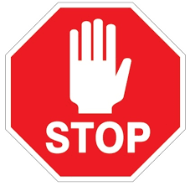

|  |
| --- |
| Watch [this](https://www.youtube.com/watch?v=_p_dNOpqdj0) video on Period 1 before you proceed. (Less than 7 minutes) |

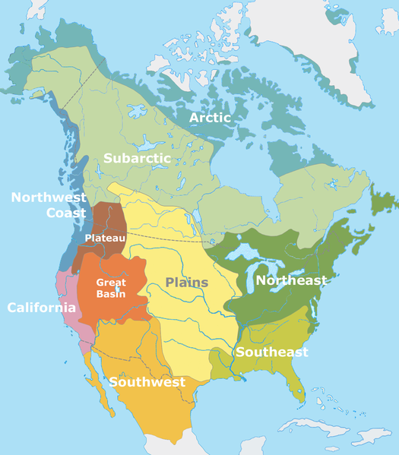

1. For each region listed below based on the map, describe what Native American life was like.

* Great Plains/Great Basin:
* 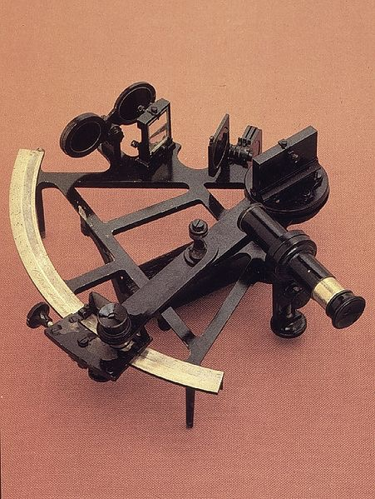Southwest:
* Northeast:

2. What technological improvements allowed for European Exploration?

3. What is the Columbian Exchange?

4. What impact did the Exchange have on Europe?

5. What impact did the Exchange have on Natives?

6. What impact did the Exchange have on Africans?

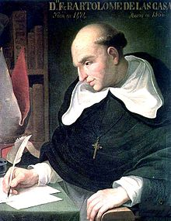

7. How did the Encomienda System impact Natives? Check out [this video](https://www.youtube.com/watch?v=Zh_syCs0Pz8) on the Encomienda System for a quick review if you need it.

8. What replaced the Encomienda System?

9. How did Europeans often view Natives?

10. In what ways did Africans preserve autonomy in the Western Hemisphere?

Document Analysis

“The Spanish have a perfect right to rule these barbarians of the New World and the adjacent islands, who in prudence, skill, virtues, and humanity are as inferior to the Spanish as children to adults……”

- Juan De Sepulveda (1547)

Need help with this document? Check out [**THIS**](https://www.youtube.com/watch?v=zEMgDJpXXu8)quick video.

1. What is Sepulveda’s Point of View towards Natives?

2. How does this contrast with Bartolomé de Las Casas?

Next page for one more document!

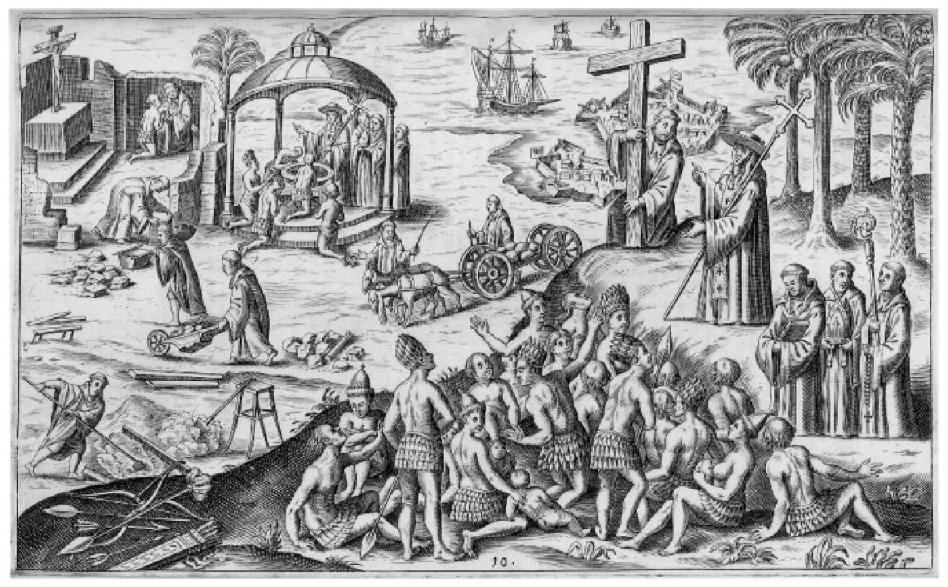

Need help with this document? Check out [**THIS**](https://www.youtube.com/watch?v=PtTnmXWxSns) quick video.

1. What is the Point of View of Spanish Colonization according to the illustration?

2. What is the Purpose of the above illustration?