DATA 202, Homework 1
Measurements, Sampling, and Graphical Summaries

Part A: Conceptual Questions (20 Points)
- Explain the difference between mean, median, and mode. Which measure is usually more appropriate for highly skewed income or housing-price data? Why?
Ans: Mean: It is the Average of given Values ($SumofValues÷Count$). Uses all the data points but deviates a lot due to extreme value
Median: The Middle Value when data is sorted or the average of two middle values when count is even. Splits the data into two halves and does not deviate due to extreme values
Mode: Most frequently occurring value used for categorizing data or identifying common values.
For Highly Skewed Data most appropriate measure is Median, the distribution in income/ housing prices may have some samples of extreme values which may cause the mean to deviate towards that end (either high or low). Thus, Median which does not get affected by outliers is the best measure.

- Classify each variable as nominal, ordinal, discrete, or continuous: blood type, number of website visits, satisfaction level from 1 to 5, and customer waiting time.
Ans:
Variable | Classification | Reasoning
Blood Type | Nominal | Categories (A, B, O, AB)
Number of Website visits | Discreet | Countable Numbers
Satisfaction Level (1-5) | Ordinal | Ranked categories
Customer Waiting time | Continuous | Can take any value (e.g. 2:21 mins)

- A company surveys only users who clicked on an email link. Explain one possible sampling bias and how it could affect a dashboard metric.
Ans: Surveying only the people who clicked the link causes a self- selection bias. The people who click through the link for the survey are different from the full customer base. These surveys are from people who are more engaged or have stronger feelings (positive or negative) towards the brand than the majority who did not click on the survey.
Effect on Dashboard: If a satisfaction score is calculated from these specific groups of responders, it will not represent the true customer base. For example, if only the happy customers click on the link the customer satisfaction score would be higher. And if only unhappy customers click on the link to report issues, then the customer satisfaction score would be lower. In both scenarios the dashboard depicts a biased estimates leading to bad business decisions.

Part B: Computational Problems (35 Points)
- For the dataset [ 12, 14, 15, 15, 16, 18, 90 ] compute the mean, median, and mode. Then state which measure best represents a typical value and explain why.
Ans:
Dataset = X= [12,14,15,15,16,18,90]
N = 7
Mean = $\sum{X} ÷ N$
= $\frac{\left(12+14+15+15+16+18+90\right)}{7} =\frac{180}{7}=25.71$
Median: (N = 7 is odd so middle term of the sorted list)
Median is 4th term in this list = 15
Mode: (Values appearing the most often)
Mode = 15
Best representative measure: The Median is the best representative measure as we also have an extreme value (outlier) towards the end of the list, which is 90 which deviates the mean value higher. And Mode is good only for categorizing the data.

- For the dataset [ 4, 6, 8, 10, 12] compute the range, population variance, and population standard deviation. Show all major calculation steps.
Ans:
Dataset: [4,6,8,10,12]
N = 5
$Mean=\frac{4+6+8+10+12}{5}$ $=\frac{40}{5}= 8$
$$Range = max - min = 12 - 4 = 8$$
$$Population variance =\frac{\sum{{\left(x_{i}- mean\right)}^{2}} }{N}$$
$$x$$ | $$x- mean$$ | $${(x-mean)}^{2}$$
4 | -4 | 16
6 | -2 | 4
8 | 0 | 0
10 | 2 | 4
12 | 4 | 16
Sum of Squared Deviations = 40
$$Population variance =\frac{40}{5}= 8$$
$$Population Standard Deviation = \sqrt{8}=2.83$$

- For the sorted dataset [ 3, 7, 8, 12, 14, 18, 21, 23, 27, 30, 50] find the minimum, Q1, median, Q3, maximum, and IQR. Determine whether 50 is an outlier using the 1.5 × IQR rule.
Ans:
Sorted Dataset: [3,7,8,12,14,18,21,23,7,30,50]
N = 11
Minimum = 3
Maximum = 50
Median = 18 (6th value i.e. middle value out of 11 values)
Q1 = 8 (Median of lower half)
Q3 = 27 (Median of upper half)
$$IQR = Q3 - Q1 = 27 - 8 = 19$$
Outlier check:
$$Upper limit = Q3 + 1.5 * IQR = 27 + 1.5(19) = 27 + 28.5 = 55.5$$
Since 50 < 55.5, 50 is not an outlier by this rule.

Part C: Programming Exercise (20 points)
- Use Python and NumPy for the values [ 42, 45, 47, 50, 210] Submit code and output for the mean, median, sample standard deviation, Q1, Q3, and IQR. In one sentence, explain how the outlier changes the mean compared with the median.
Ans: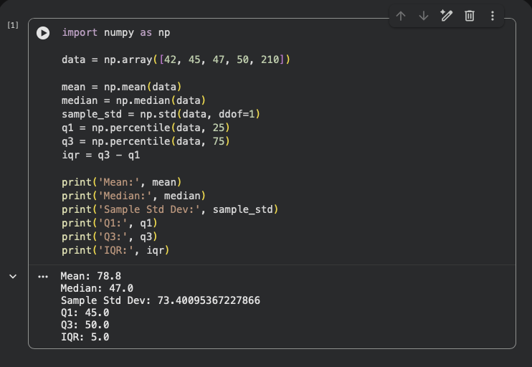

Explanation: The Outlier (210) deviates the mean up to 78.8, well above every other value in the set while the median stays at 47. This shows that the median is far better measure than the mean in cases of outliers.

Part D: Real Data Practical Application (25 Points)
- The table below shows weekly customer-support resolution times in hours.
Ticket | 1 | 2 | 3 | 4 | 5 | 6 | 7 | 8
Hours | 2 | 3 | 3 | 4 | 4 | 5 | 6 | 20

Compute the mean, median, range, and IQR. Which measure would you report to describe a typical ticket resolution time? Explain briefly.
Ans:
Ticket resolution hours: [2, 3, 3, 4, 4, 5, 6, 20]
N = 8
$$Mean =\frac{2+3+3+4+4+5+6+20}{8}=\frac{47}{8}=5.875\text{ hours}$$
Median: Since N is even, average of 4th and 5th values (4 and 4)
$$\text{Median}=\frac{4+4}{2}=4\text{ hours}$$
Range:
$$\text{Range}=20-2=18\text{ hours}$$
IQR:
- $Q1 =\frac{3+3}{2}= 3$
- $Q3 =\frac{5+6}{2}= 5.5$
$$\text{IQR}=5.5-3=2.5\text{ hours}$$
Which measure to report: The median best describes a typical resolution time. The mean is skewed upward by the single 20 hour outlier ticket, which doesn't represent how quickly a normal ticket gets resolved. The median, along with the small IQR, gives a much more honest picture that most tickets resolve quickly (2–6 hours), with one unusual delay dragging the average up.

