HOMEWORK 1

Student ID: P76087081 Name: Tran Thi Ai

**Description of your circuit:**

(Please describe the function and dataflow of the circuit.)

This circuit is a multiply circuit. Multiplies signed two numbers 6-bit. The output is result 12-bit. Inside, negative numbers are expressed in two’s complement.

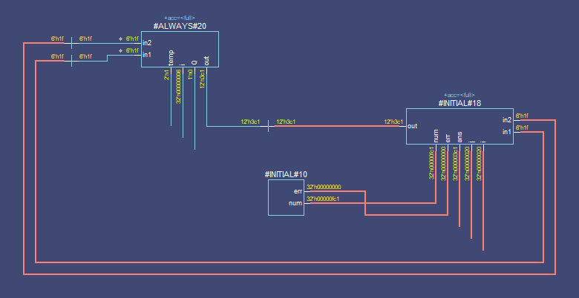

This is dataflow.

Step 1:

Decide which operand will be the multiplier and which will be the multiplicand.

Initialize the remaining registers to ‘0’ and initialize Count Register with the number of multiplicand bits.

Use the LSB (least significant bit) and the previous LSB to determine the arithmetic action.

If it is the first pass, use 0 as the previous LSB.

Step 2:

Possible arithmetic actions:

00 or 11 => no arithmetic operation.

1. => add multiplicand to left half of product.
2. => subtract multiplicand from left half of product.

Step 3:

Perform an arithmetic right shift on the entire product.

Step 4:

When Count register is not ‘0’ then continue the multiplication.

If Count register is ‘width’ then end.

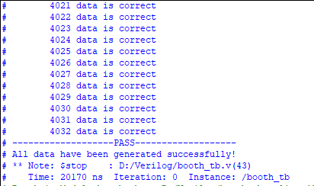

This is the result.

**Lesson learn**

(Please write down the experience of completing this assignment, what you learned, and the points of difficulty.)

Though this homework, I learned what is booth algorithm what I didn’t know before. Especial, I already know how to use ModelSim software. And I can learn more commands, it helps me understand than about command and use testbench better.

I am still not proficient in using commands. Therefore, I had many difficulties in implementing it.