HOMEWORK 3

Student ID: P76087081 Name: Tran Thi Ai

**Block design Screenshot:**

(Please attach a screenshot and describe the block design function.)

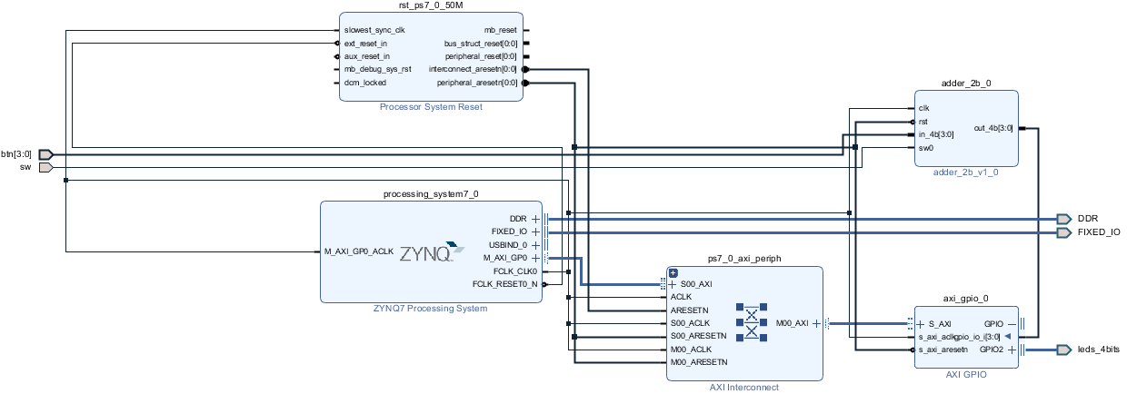

This is the block design.

ZYNQ is an ARM processor that can be designed with its internal software. ZYNQ's DDR and FIXED_IO connect, and the software terminal operate normally for memory.

AXI GPIO converts GPIO digital signals into AXI BUS signals.

The adder_2b_0 block will receive the value from button. If the switch is equal 1, the output will equal {2’b0, in_4b[3:2]} + {2’b0, in_4b[1:0]}. On the other hand, If the switch is equal 1, the output will equal {2’b0, in_4b[3:2]} - {2’b0, in_4b[1:0]}.The leds_4bits will light through AXI_GPIO with width is 4.

The GPIO signal (hardware) is passed to the ARM core via the AXI bus.

**Jupyter python code:**

(Please describe the function and execution flow of the jupyter python code.)

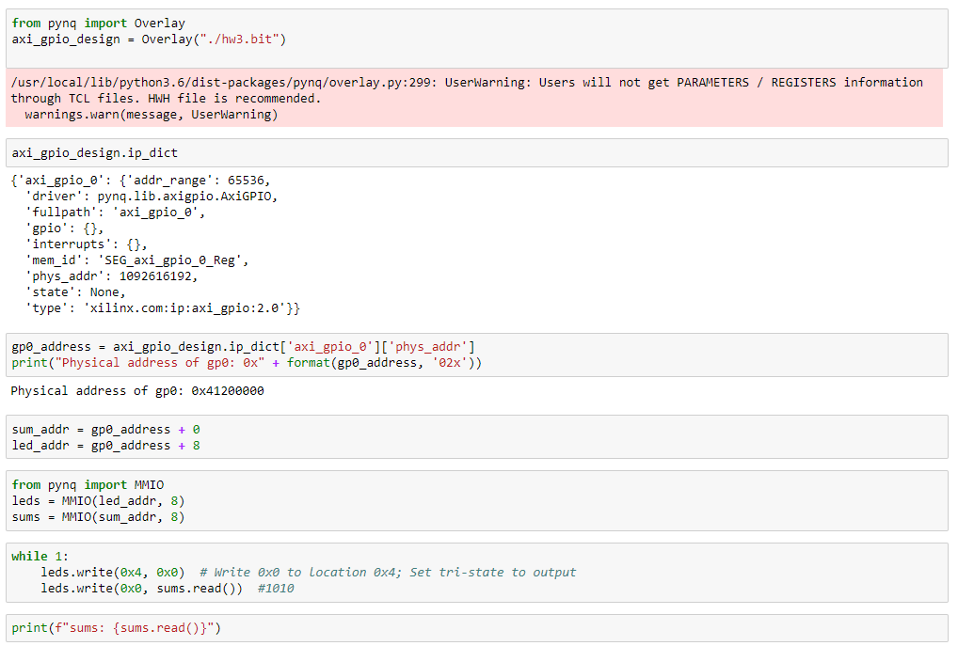

First of all, the hw3.bit bitstream implicitly downloaded to PL. The ip_dict contains a list of IPs in the overlay and can be used to determine the IP driver, physical address, version, if GPIO or interrupts are connected to the IP. Next, the gp0_address value is a dictionary mapping the physical address. The operation physical address of axi_gpio_0 is 0x41200000. Then, calculate the operation address of the led_addr and sum_addr. After imported MMIO, the leds and sums become IO variables that can operate the address; “8” is the length in bytes of the address range. Next, the leds.write change the state of leds which is on or off.

Finally, print out the status of the bottom right buttons if it pressed or released.

**Lesson learn**

(Please write down the experience of completing this assignment, what you learned, and the points of difficulty.)

Through this homework, I learned how to use the Vivado and Jupyter notebook. I have written a program using Python language, so I learned more about the command and its structure and it helped me to write the program easier than the C or C++ language. Regarding the Vivado, I learned how to create and add IP blocks.

The difficulty point I encountered was that it took a long time to understand the sample Python code.