HOMEWORK 1

Student ID: P76087081 Name: Tran Thi Ai

A High Performance VLSI Implementation of Local Binary Convolutional Neural Network.

1. 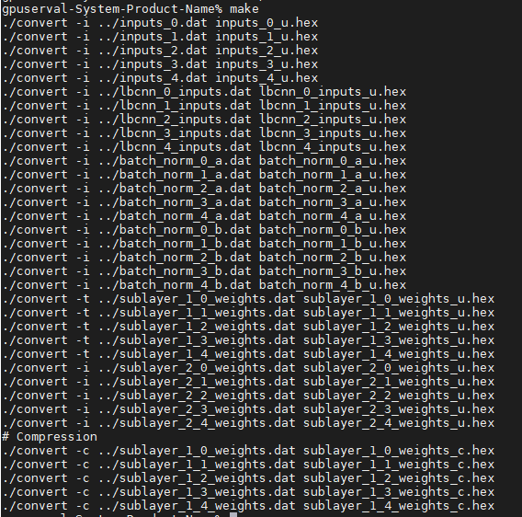There are the values of the fixed point and it’s also the result of weight preprocessing.
2. This is the result of Pre_sim Configuration.

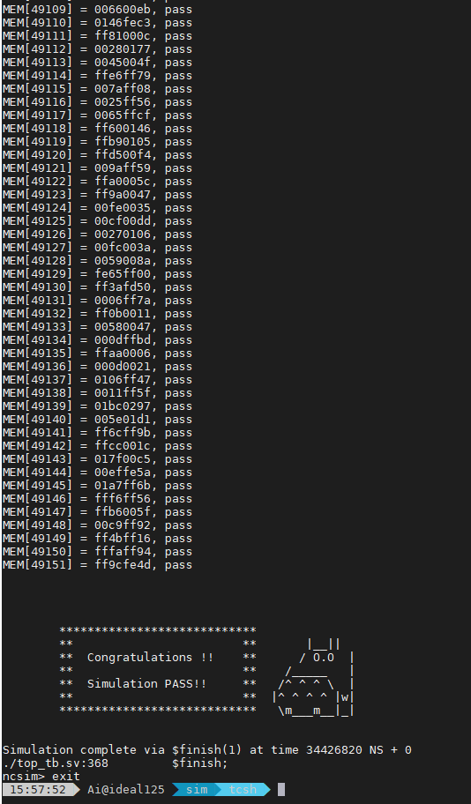

1. This is the result of Post_sim Configuration.

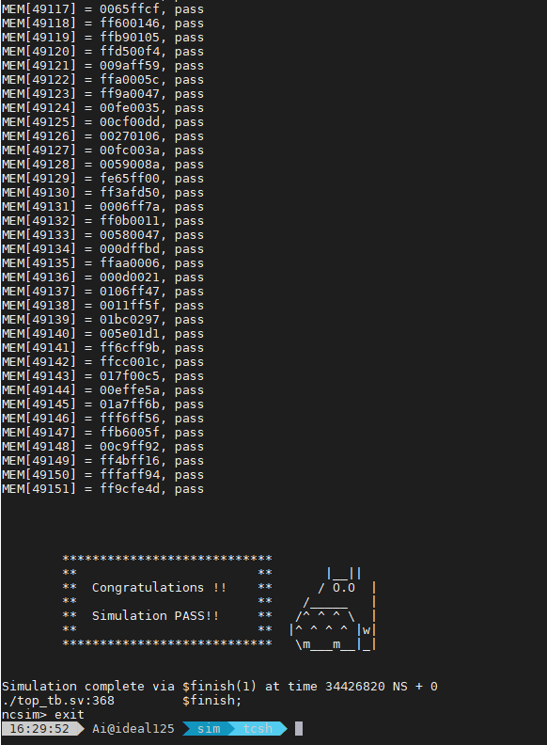

1. This is the result of Jupyter_Notebook.

