**Homework 2**

Name: Tran Thi Ai Student ID: P76087081

[ROAD: Improving Reliability of Multi-core System via Asymmetric Aging](https://moodle.ncku.edu.tw/mod/resource/view.php?id=871253)

Hspice_experiment experimental steps

First enter hspice_experiment directory



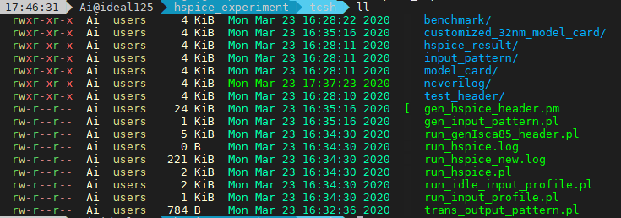

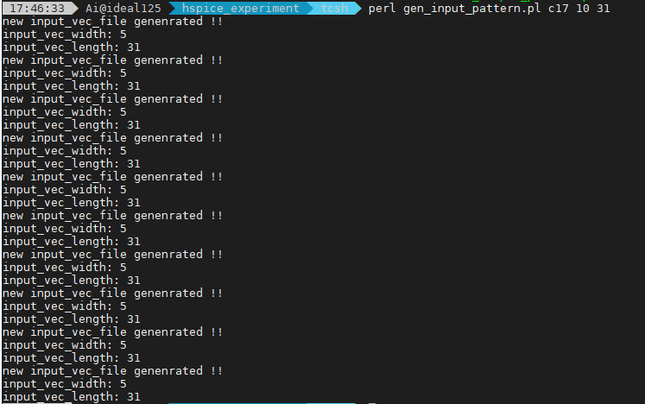

The circuit input pattern randomly generated after the step is stored in the input pattern directory.

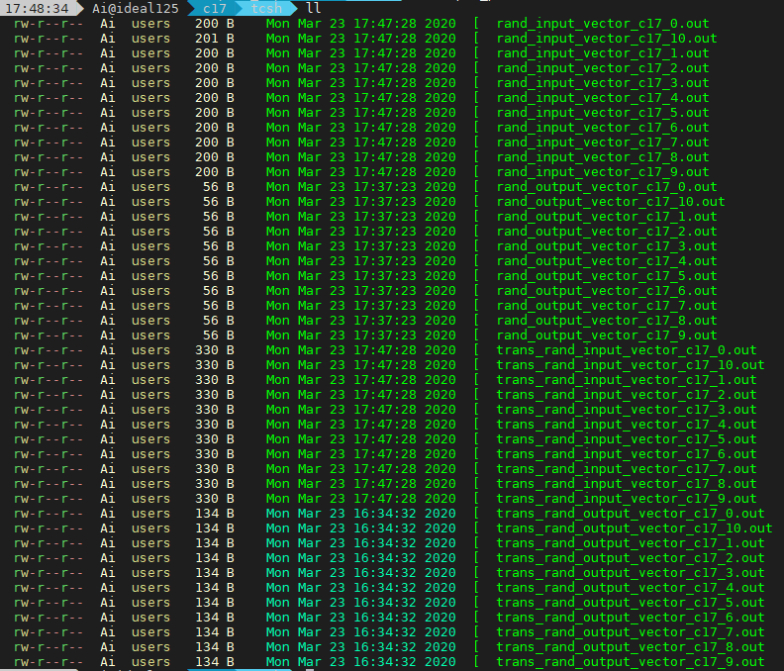

Each numbered .out file corresponds to an input pattern set. In the next step we will produce the output pattern set corresponding to the input pattern set.

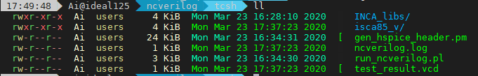

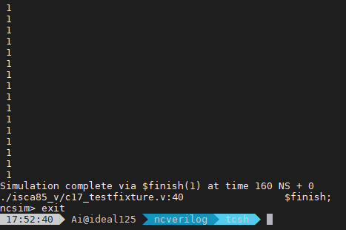

We will find that there are more files related to output pattern in the input pattern's records. These files are used to verify whether the simulation results of hspice are consistent with the results of ncverilog

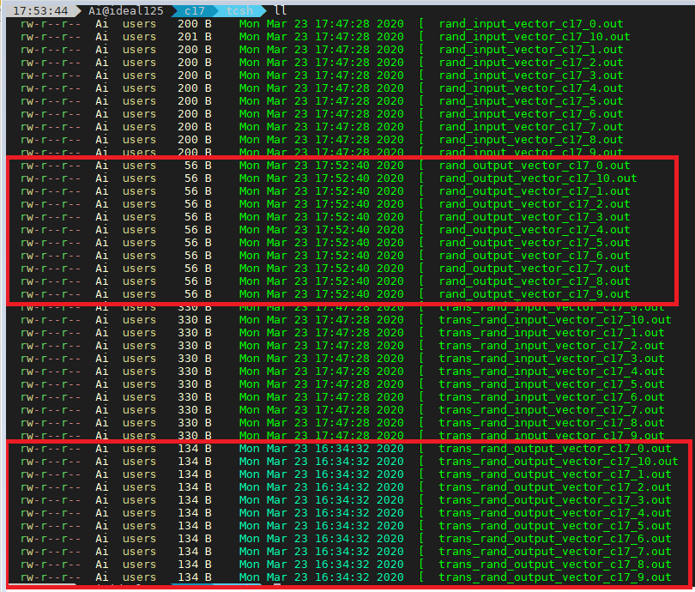

If hspice unfortunately fails to execute or gets stuck in the process, we first open this run_hspice_new.log file. Normally, if hspice successfully executes a case, the following prompt will appear

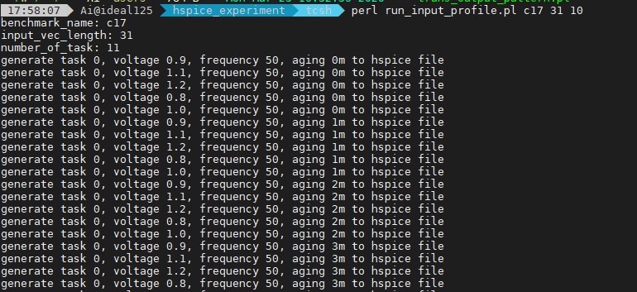

Multicore_experimentexperimental steps

