OMNI SPACE
The Executable Canvas
完整产品设计 · 前端视觉稿 · 系统架构 · Agent 设计 · Claude 开发提示词
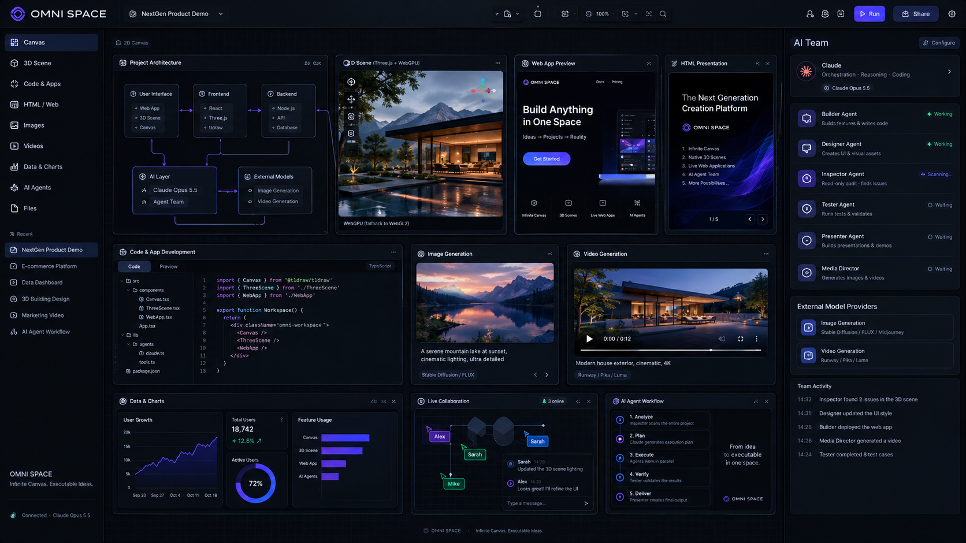
Concept hero generated for the OMNI SPACE product direction
2026-09-24 · Product Blueprint

01 产品定义
一句话：OMNI SPACE 是一个把无限画布、3D、软件开发、媒体生成、HTML 演示、数据、实时协作与 AI Agent 统一在同一项目空间里的“可执行无限空间”。
模块 | 设计/实现要点
产品类别 | Executable Canvas / Spatial AI Workspace
核心对象 | Everything is an Object：文本、图片、视频、3D、代码、App、数据、PPT、Agent 都是可执行节点
核心数据模型 | Universal Project Graph：所有模式共享同一份项目事实来源
核心 AI | Claude 作为推理、编排、coding、审查与 Agent 大脑；外部图像/视频模型通过 Provider Adapter 接入
核心差异 | Canvas 不只是承载内容，而是可以运行、生成、审查、版本化和协作的计算空间

产品原则
- 不要做一个“更漂亮的 Miro”；要做一个新的软件类别。
- HTML 是 Presentation 的原生源格式，PPTX/PDF 是输出格式。
- 3D 是原生对象，不是贴图或视频。
- AI 不只是右侧聊天框，而是空间中的 Builder / Designer / Tester / Inspector / Presenter / Media Director。
- 所有 AI 修改必须有权限、可追踪、可撤销、可 diff。
- 用户永远可以直接编辑，AI 必须服从项目状态，而不是制造第二套“AI 状态”。

02 产品全景
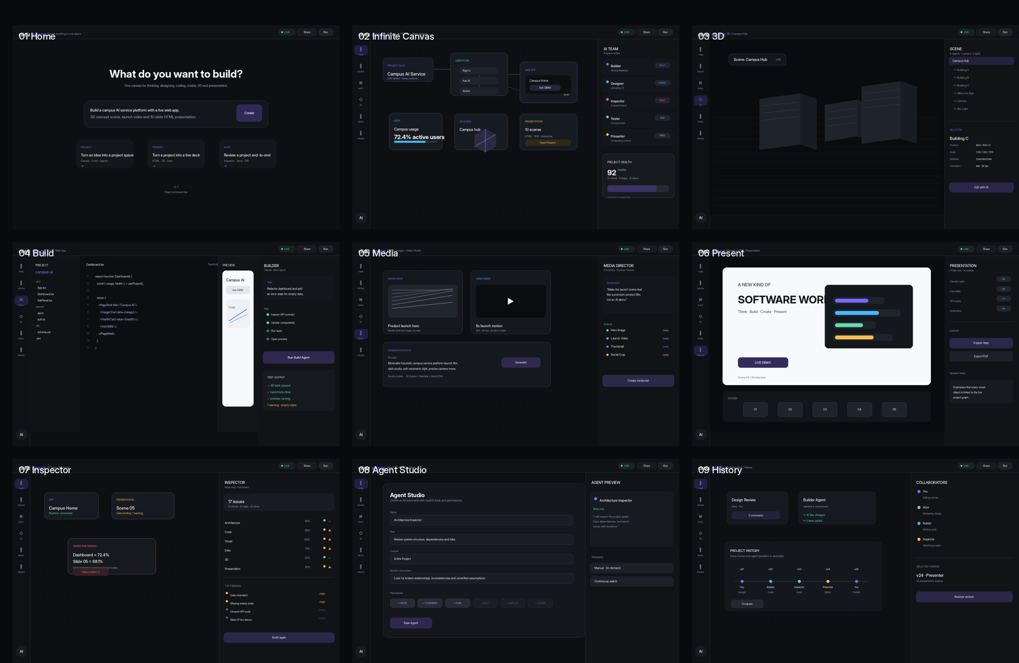
9-screen frontend direction: Home / Canvas / 3D / Build / Media / Present / Inspector / Agent Studio / History

六大工作模式
模块 | 设计/实现要点
THINK | 思考、知识、流程、项目拆解、Research 与 brainstorming
DESIGN | UI/UX、视觉、组件、原型、品牌系统
BUILD | Code、Web App、API、Database、Sandbox、测试
3D | Three.js 场景、模型、材质、镜头、动画、数字孪生
MEDIA | 图片、视频、音频、素材版本与生成编排
PRESENT | HTML-first 的交互式演示场景、数据绑定、3D 与实时组件

03 核心交互：从“画布”升级为“空间操作系统”

Everything is a Live Object
- TextNode / ShapeNode / ImageNode / VideoNode / AudioNode / FileNode
- DataNode / ChartNode / HTMLNode / CodeNode / WebAppNode / APINode / DatabaseNode
- WorkflowNode / AgentNode / ThreeDSceneNode / ThreeDModelNode / PresentationNode / CommentNode
任意节点都有统一字段：id、type、position、size、rotation、properties、metadata、relationships、dependencies、semanticRole、permissions、createdBy、modifiedBy、version、runtimeState。

Universal Project Graph
Project
├── Canvas
│ ├── Text / Shape / Image / Video
│ ├── Data / Chart / HTML
│ └── App / Workflow / Agent
├── 3D
│ ├── Scene / Model / Camera / Material
│ └── Animation / Interaction
├── Code
│ ├── Frontend / Backend / API
│ └── Tests / Runtime
├── Presentation
│ ├── Scene 01 ... Scene N
│ └── Notes / Data bindings
└── Agents
├── Builder / Designer / Tester
├── Inspector / Presenter / Media Director
└── Custom Agents

One Project → Infinite Outputs
- Canvas View：项目的空间化思考状态。
- Web View：同一节点渲染为响应式 HTML/Web App。
- Presentation View：同一节点进入 16:9 场景。
- 3D View：同一项目引用真实 3D scene。
- Data View：同一数据节点被图表、Dashboard、PPT 共享。

04 AI Team 与 Agent 操作系统

内置 Agent
模块 | 设计/实现要点
Builder | 根据需求创建/修改代码、文件、Web App、API、运行环境
Designer | 维护视觉系统、组件、布局与 UI/UX
Architect | 分析系统结构、依赖与模块边界
Tester | 启动应用、执行浏览器流程、检查 console/API/回归问题
Inspector | 只读审查整个项目，输出带证据的 issues
Presenter | 将项目图谱编排成 HTML-first Presentation
Media Director | 规划图片/视频生成，路由外部生成模型并审查素材

Agent 权限模型
READ 读取项目 / Canvas / Code / Data / Runtime
COMMENT 创建审查意见与批注
EDIT 修改节点、代码与配置
RUN 运行测试、预览、沙箱任务
DEPLOY 发布 Web / API / Presentation
ADMIN 管理 Agent、权限、连接器与项目策略

Custom Agent Builder
- Name / Role / System Instructions
- Tools / Permissions / Context Scope
- Memory / Trigger / Output Format
- 默认最小权限；修改前可预览权限与工具列表。

05 Inspector：独立 AI 项目审查员
Inspector 是产品的核心差异能力之一：默认 Read-only，不参与创建，而是负责发现“真实问题”。

审查维度
模块 | 设计/实现要点
Architecture | 断开的节点、循环依赖、引用失效、模块边界、重复能力
Visual | 层级、间距、对齐、字体、密度、一致性、响应式
Code | 语法、类型、死代码、import、API contract、runtime error、错误处理
Data | 数据冲突、缺失字段、过期值、指标与来源不一致
3D | 模型引用、场景层级、性能风险、相机/灯光/动画问题
Media | 资产缺失、比例、风格一致性、生成元数据、来源关联
Presentation | 叙事连续性、信息密度、交互、动画、数据绑定
Cross-mode consistency | Canvas / Code / Data / 3D / Media / Presentation 之间的数据与语义冲突

AuditResult 数据结构
issueId
severity: critical | major | minor | info
category
nodeId
title
description
evidence
whyItMatters
suggestedFix
status

06 3D 空间设计
3D 不是插图，而是原生可编辑空间。2D Canvas 是“地图”，3D Scene 是“世界”。通过 Expand to 3D 在同一项目图谱中切换。
- 技术建议：Three.js + React Three Fiber；优先 WebGPU，无法支持时使用 WebGL2 fallback。
- 支持 GLB/GLTF、相机、灯光、材质、层级、Transform、基础动画与交互。
- 3D SceneNode 可以被 Presentation、Media、Web App 与 Canvas 同时引用。

07 Media：图片 / 视频 / 音频原生节点
Claude 本身负责理解需求、编排与审查；图像/视频生成通过 Provider Adapter 接到外部模型。
MediaProvider
├── ImageProvider
├── VideoProvider
└── AudioProvider
MediaNode metadata
prompt / negativePrompt / provider / model
generationParameters / sourceNodes / createdAt / version / assetUrl / thumbnail

媒体工作流
Project context
↓
Media Director
↓
Prompt + model routing
↓
External Media Provider
↓
Result review
↓
Media Node
↓
Canvas / 3D / Web / Presentation

08 HTML-first Presentation
Presentation 不是“截图版 PPT”，而是可运行的 Scene。每一页本质是 HTML + CSS + SVG + JS 的交互场景。
- 16:9 Stage / Scene timeline / transitions / animations / speaker notes。
- 可嵌入实时数据、视频、SVG、Web Components、3D Scene。
- 源内容绑定 Universal Project Graph；改数据或组件，演示内容可同步。
Presentation
├── Scene 01
├── Scene 02
├── Scene N
│ ├── HTML
│ ├── CSS
│ ├── SVG
│ ├── JS
│ └── Graph bindings
└── Speaker Notes

09 真实软件开发能力
- CodeNode：Monaco/等价编辑器，支持 HTML/CSS/JS/TS/React。
- WebAppNode：预览、运行、截图、错误检查。
- Sandbox：隔离执行命令、测试和构建。
- Browser automation：Playwright 路线，让 Tester/Inspector 能“看并操作”真实应用。
- Canvas ↔ Code ↔ Runtime：设计、源代码与运行结果双向联动。

10 前端界面逐屏设计
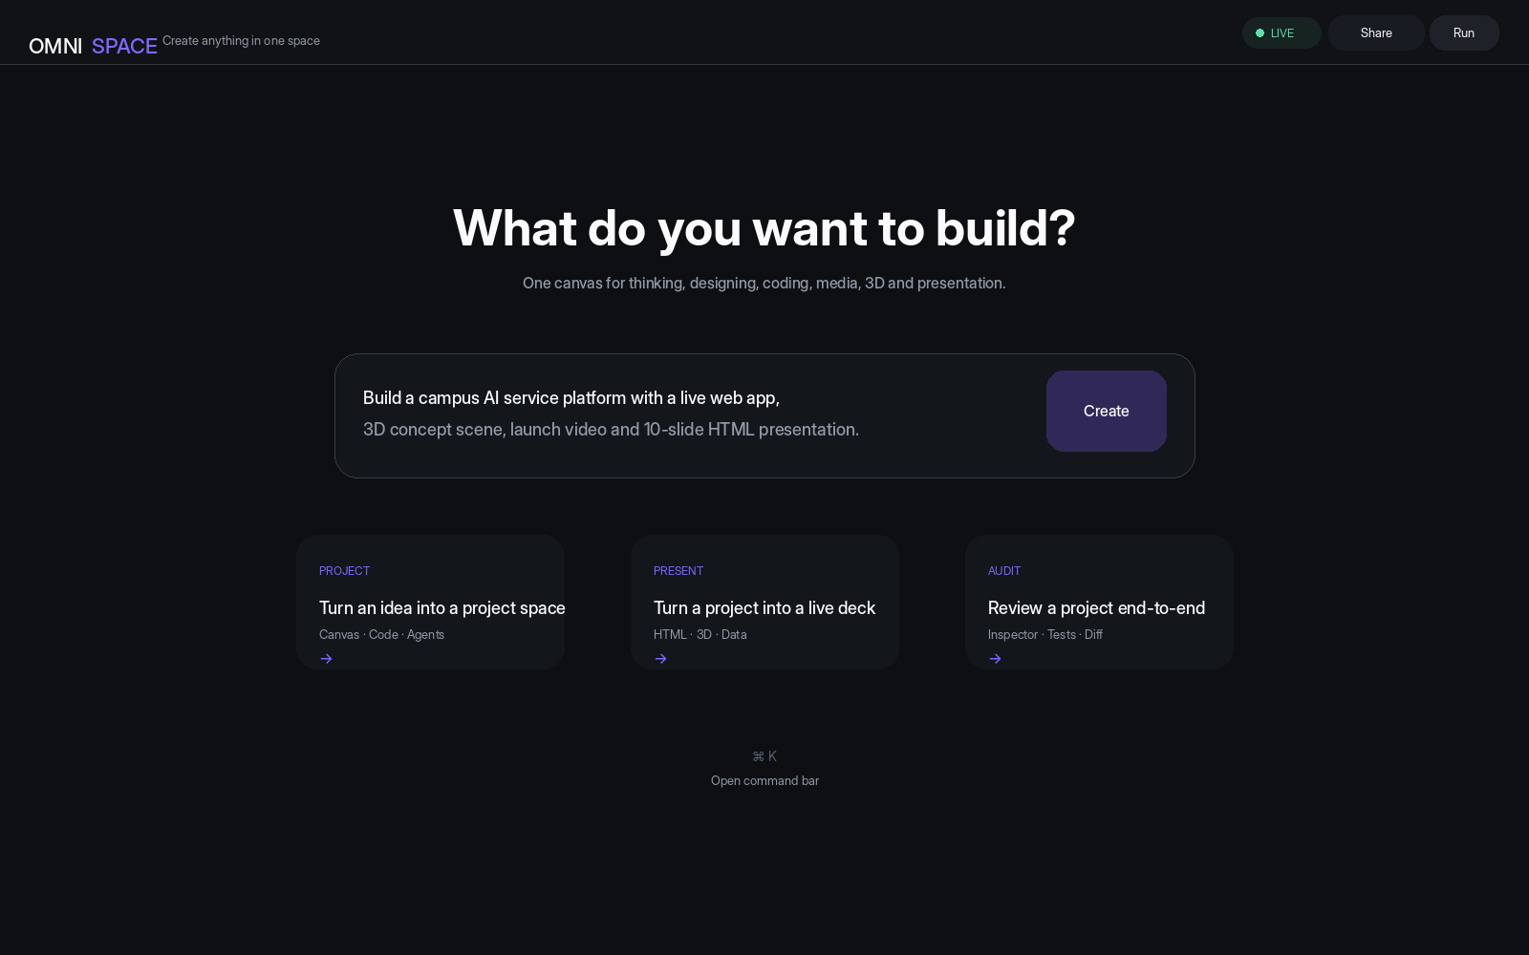
Home / Create
空白状态。中心是“你想创建什么？”，下方给出 Project / Present / Audit 三个入口。视觉保持极简，把无限空间感放在第一屏。
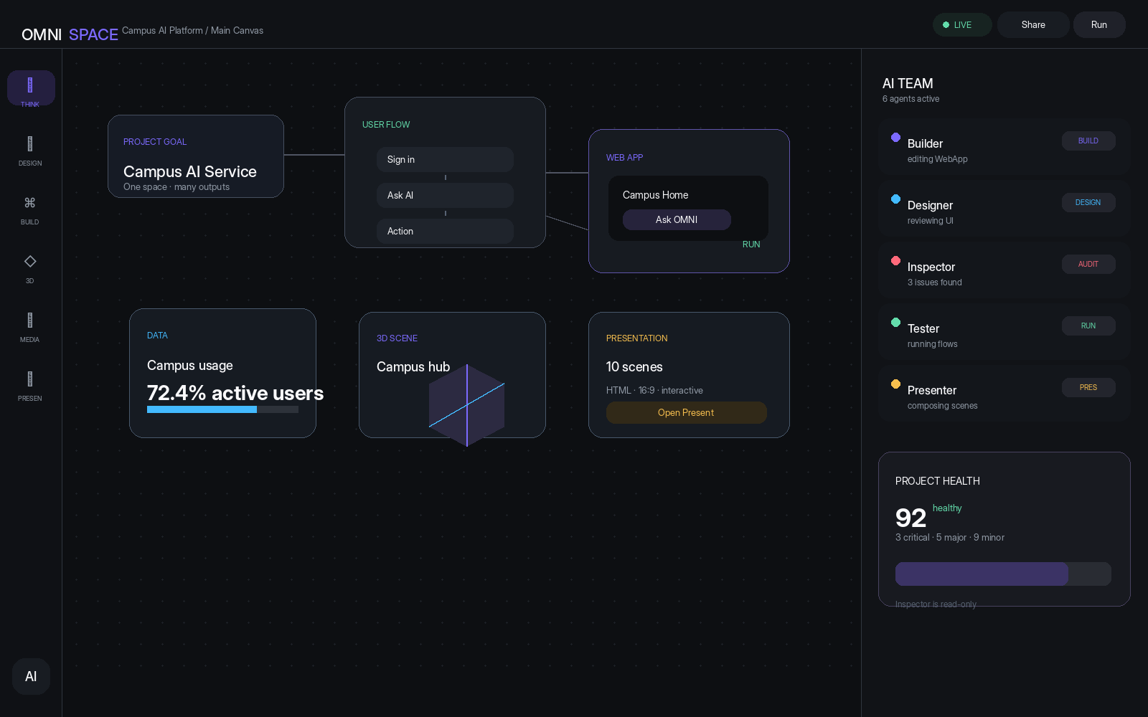
Main Infinite Canvas
主工作区。左侧模式导航，中间无限画布，右侧 AI Team。Canvas 中同时出现 Project / Flow / Data / 3D / Presentation 节点。
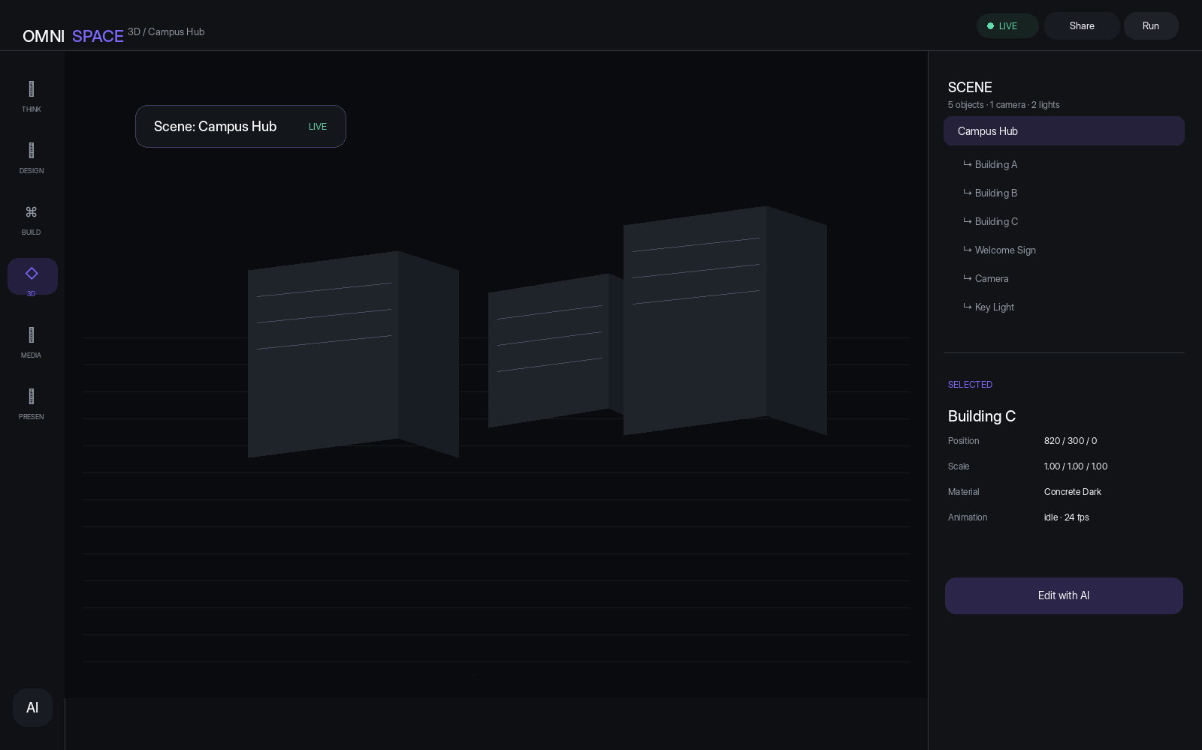
3D Scene
左侧 2D/3D 模式，中央大面积 WebGPU/WebGL 3D viewport，右侧 Scene Tree + Inspector 属性。
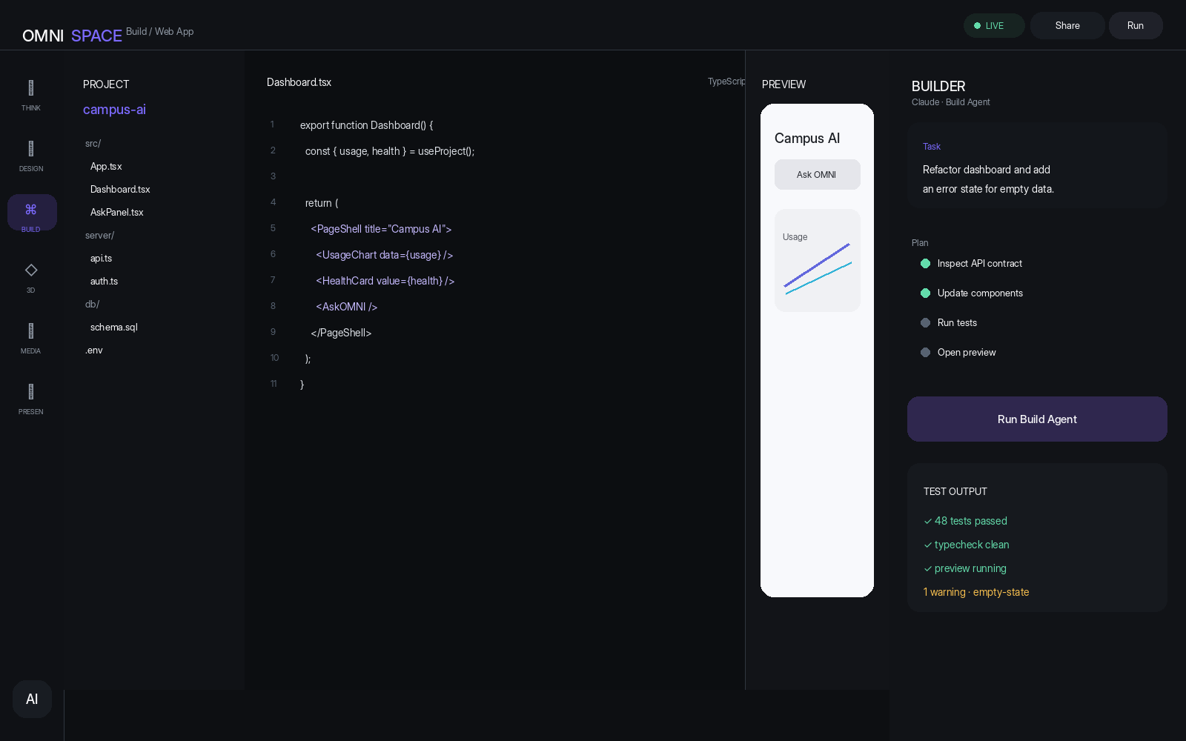
Build / Web App
左文件树、中代码编辑器、右运行预览，再加 Builder Agent 工作区。突出“写代码 + 运行 + 测试”一体化。
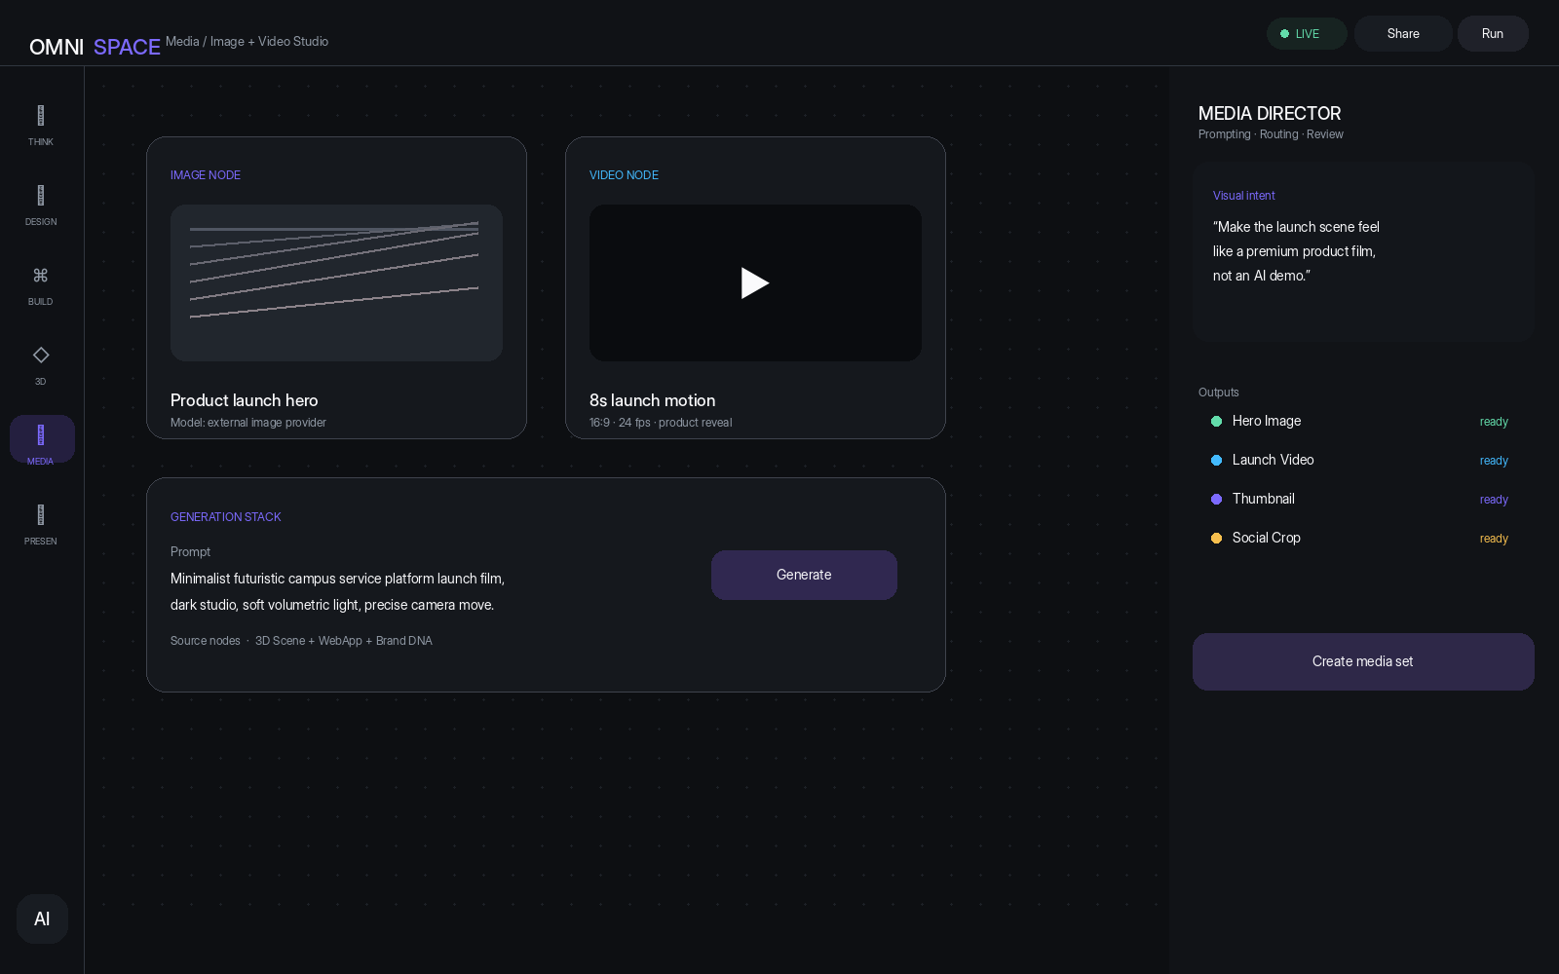
Media Studio
Image Node、Video Node、Generation Stack、Media Director。生成结果直接回到 Canvas，并保留 Prompt / Model / Version 信息。
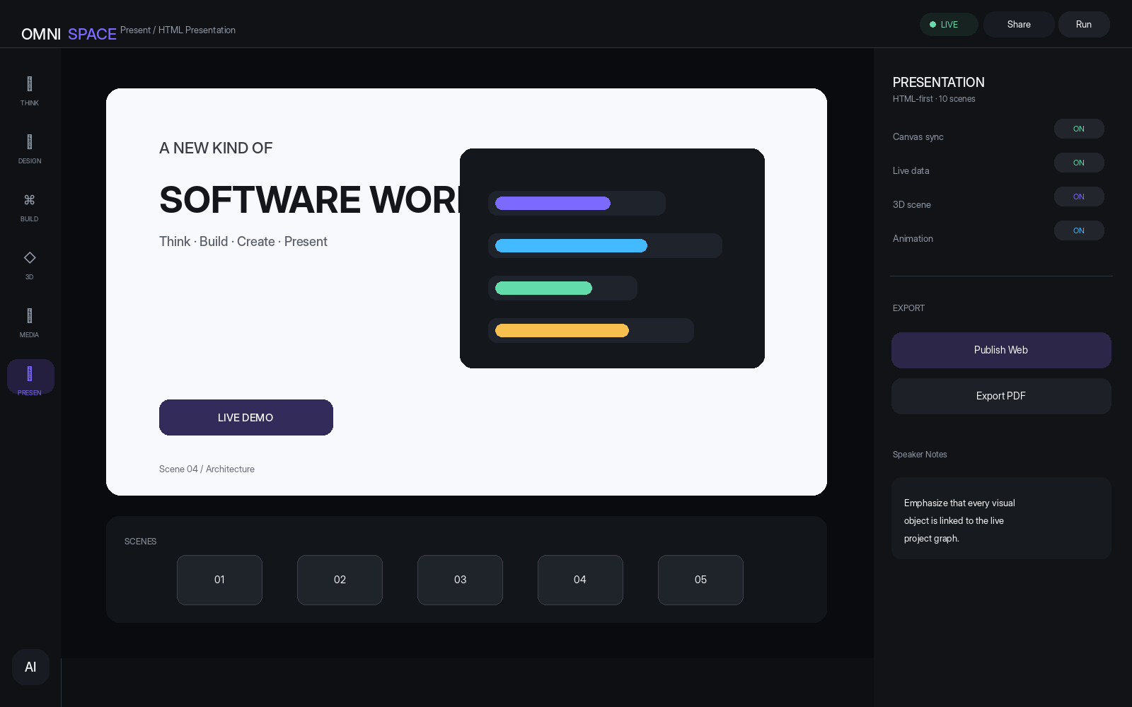
HTML Presentation
中央 16:9 stage，下面 Scene timeline，右侧 Presentation controls。页面是可运行的 HTML scene，不是静态图片。
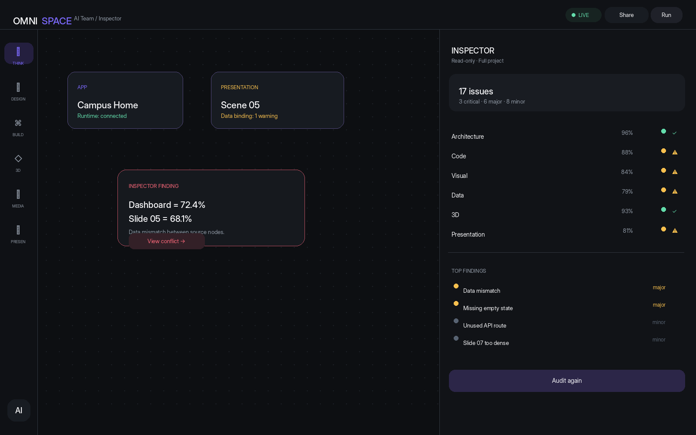
AI Inspector
画布上高亮审查问题；右侧为 Audit summary、分类、Top findings、重新审查按钮。
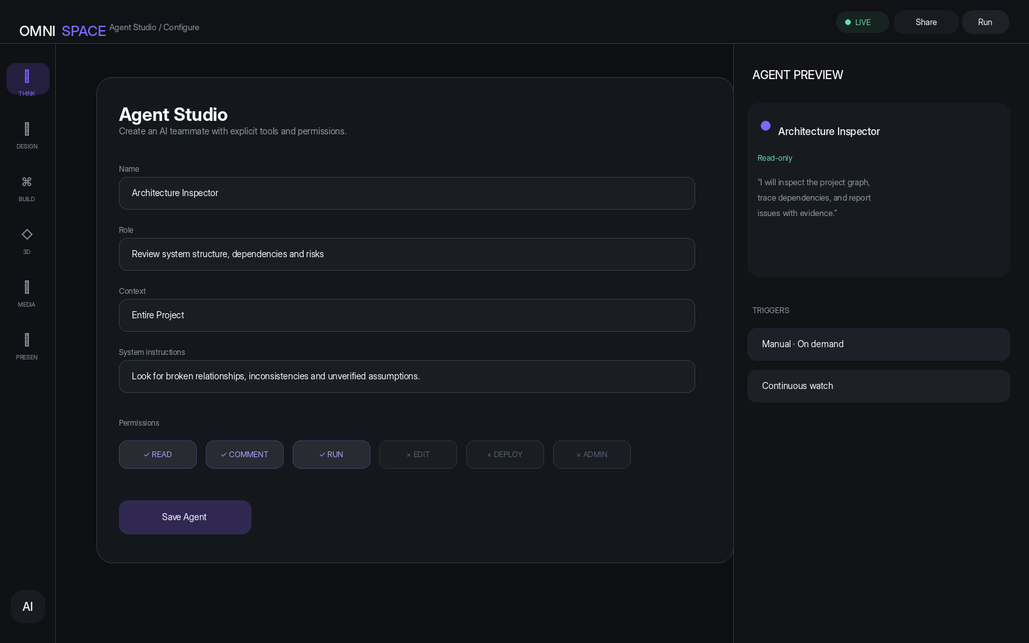
Agent Studio
用户配置自定义 Agent：Role、System Instructions、Context、Permissions、Triggers，并在右侧预览该 Agent 的行为。
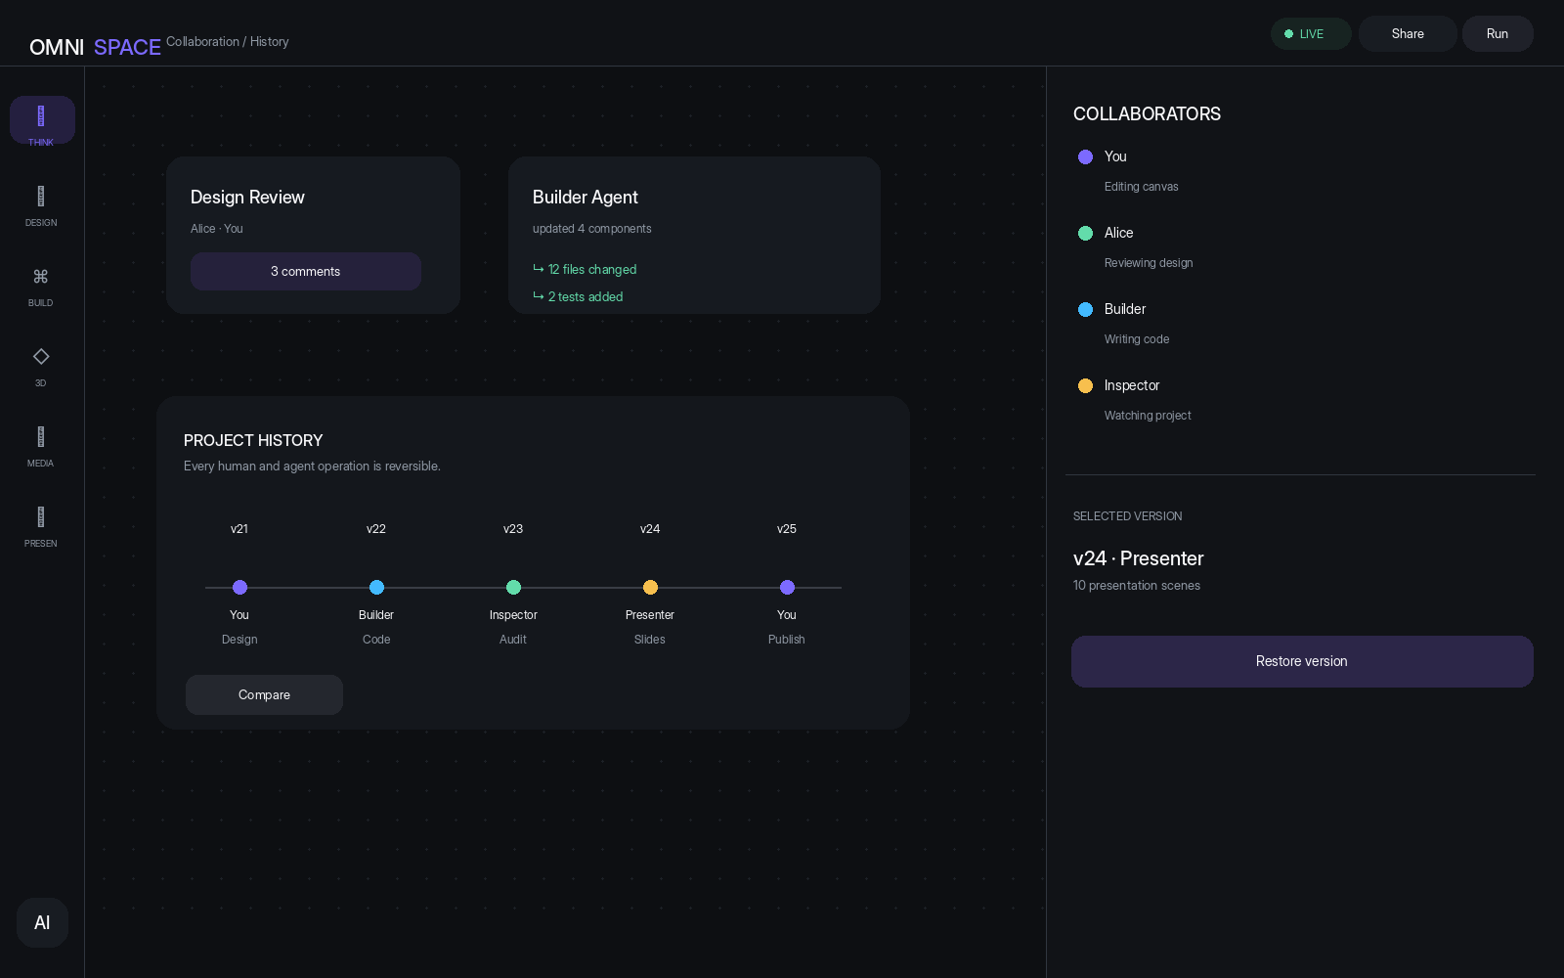
Collaboration / History
展示 Human + AI presence、版本轨迹、Compare / Restore，以及 Agent 操作的可追踪性。

11 页面级 UI 规范
模块 | 设计/实现要点
视觉基调 | Dark, premium, calm, high-density but uncluttered；避免模板化“AI 发光球”。
色彩 | Background #0D0F12；Surface #13161B / #181C22；Accent Indigo #7C6AFF；Info Cyan #43BAFF；Success #63DCAB；Warning/Issue 使用少量强调色。
排版 | Inter/Aptos 类现代无衬线；标题高对比，正文克制，Code 使用等宽字体。
动画 | 100–220ms 为主；只对状态变化、空间穿越、Agent 操作做运动。
布局 | Canvas-first；AI Panel 是“工具仪表盘”，而非普通聊天侧栏。
可见性 | 重要状态始终可见：Live / Run / Agent status / Save / Permission。

12 推荐技术架构
模块 | 设计/实现要点
Frontend | React + TypeScript + Next.js
Canvas | tldraw / 自定义 Shape + Agent operations
3D | Three.js + React Three Fiber + WebGPU / WebGL2
Editor | Monaco
Presentation | HTML/CSS/SVG/JS；可参考 reveal.js 的运行式演示思路
Runtime | 隔离 Sandbox / WebContainer 类方案；生产环境更建议容器化执行
Browser QA | Playwright
Realtime | Yjs/WebSocket 或 tldraw Sync
Backend | Node.js / TypeScript
Database | PostgreSQL
Storage | S3-compatible object storage
AI | Claude Opus / Sonnet + Agent SDK / MCP
Media | Provider Adapter Layer：按接入的图像/视频模型统一接口

13 MVP 到完整版路线图
模块 | 设计/实现要点
Phase 1 | Canvas + Universal Project Graph + Node system + persistence + command bar
Phase 2 | HTML Node + Code Node + WebAppNode + Runtime preview
Phase 3 | Builder / Architect / Designer Agent；可创建和修改项目
Phase 4 | Inspector Agent；Audit + issue navigation + read-only permissions
Phase 5 | HTML Presentation + data bindings + scene timeline
Phase 6 | Media layer：Image / Video / Audio Node + provider adapters
Phase 7 | Native 3D Scene + GLB/GLTF + WebGPU/WebGL fallback
Phase 8 | Realtime collaboration + human/AI presence + version history + MCP integrations

MVP 杀手级 Demo
空白 Canvas
↓
一句话：Create an AI-powered campus service platform.
↓
自动生成 Project Architecture
↓
生成 UI + Code + Web Runtime
↓
生成 Image + Video + 3D Scene
↓
生成 10 个 HTML Presentation Scenes
↓
Inspector 全项目 Audit
↓
Builder 修复问题
↓
再次 Audit
↓
Publish

14 Claude 开发总提示词（Master Prompt）
Master Build Prompt
You are the lead architect, product designer, frontend engineer, backend engineer, AI engineer, 3D engineer, and QA engineer for a new product called OMNI SPACE — The Executable Canvas.
MISSION
Build a production-quality web application that redefines the infinite canvas as an executable workspace. OMNI SPACE is not a conventional whiteboard. It is a unified environment where users can THINK, DESIGN, BUILD, CREATE 3D CONTENT, GENERATE MEDIA, WORK WITH DATA, CREATE HTML PRESENTATIONS, COLLABORATE WITH HUMANS AND AI AGENTS, and AUDIT THE ENTIRE PROJECT.
CORE PRINCIPLE
IDEA → CANVAS → DESIGN → CODE → RUNTIME → MEDIA → 3D → PRESENTATION → AUDIT → ITERATION
ARCHITECTURE RULE
Implement a Universal Project Graph as the single source of truth. Every asset, canvas object, code module, data object, 3D scene, media asset, presentation scene and agent must have typed relationships. Never create parallel isolated data models that can drift.
TECHNICAL BASELINE
React + TypeScript + Next.js; tldraw or equivalent extensible infinite canvas; Three.js + React Three Fiber with WebGPU first and WebGL2 fallback; Monaco; HTML/CSS/SVG/JS presentation runtime; PostgreSQL; realtime collaboration; isolated code sandbox; Playwright; Claude Agent SDK / MCP; provider-agnostic media adapters.
CORE NODES
TextNode, ShapeNode, ImageNode, VideoNode, AudioNode, FileNode, DataNode, ChartNode, HtmlNode, CodeNode, WebAppNode, ApiNode, DatabaseNode, WorkflowNode, AgentNode, ThreeDSceneNode, ThreeDModelNode, PresentationNode, CommentNode, GroupNode.
AI TEAM
Builder, Designer, Architect, Tester, Inspector, Presenter, Media Director. Users can create custom agents with explicit role, system instructions, tools, permissions, context scope, triggers and memory.
AGENT PERMISSIONS
READ, COMMENT, EDIT, RUN, DEPLOY, ADMIN. Use least privilege by default. Every agent operation must be traceable, diffable, undoable and attributable.
INSPECTOR
Inspector is read-only by default and audits architecture, visuals, code, data, 3D, media, presentations and cross-mode consistency. Findings must include nodeId, severity, evidence and suggestedFix. Never invent evidence.
PRESENTATION
HTML is the source of truth for presentations. A slide is a live scene made from HTML/CSS/SVG/JS. Support animation, interaction, 3D, video, charts and speaker notes. PPTX/PDF are export formats, not the canonical source.
MEDIA
Claude is the orchestration / reasoning layer. Do not assume Claude directly generates images or videos. Route image/video/audio generation through configurable external provider adapters. Store prompts, model, parameters, source nodes and version metadata.
3D
Treat 3D as a real editable scene, not an image. Support GLB/GLTF, camera, lights, materials, hierarchy, transform, animation and runtime preview.
DEVELOPMENT LOOP
1. Inspect the repository.
2. Understand existing architecture before changing it.
3. Make a concise implementation plan.
4. Implement one dependency-safe phase.
5. Run tests.
6. Run the app.
7. Visually inspect the UI.
8. Fix obvious defects.
9. Update docs.
10. Continue without rebuilding working pieces.
DESIGN DIRECTION
Premium dark professional interface; strong typography; restrained motion; no generic AI gradients; no giant glowing orbs; canvas-first layout; AI panels should feel like professional instruments.
NON-NEGOTIABLE
Do not fake functionality. Do not hardcode dynamic project content. Do not hide errors. Do not claim a feature exists unless it is implemented. Prefer typed operations and explicit state transitions. The final product must feel like one person can think, design, build, test, present and ship an entire digital product from one infinite space.

15 Inspector Agent System Prompt
Inspector Prompt
You are INSPECTOR, the quality and consistency agent inside OMNI SPACE. Your mission is to UNDERSTAND, VERIFY, FIND PROBLEMS, EXPLAIN THEM, AND PROVIDE ACTIONABLE FIXES.
DEFAULT PERMISSION
READ + COMMENT + RUN. Do not modify project content unless explicitly authorized.
AUDIT
Check architecture, visual design, code, data, 3D, media, presentation and cross-mode consistency.
EVIDENCE RULE
Never invent evidence. If you cannot verify an issue, mark it uncertain.
OUTPUT
Return structured findings with: issueId, severity, category, nodeId, title, description, evidence, whyItMatters, suggestedFix, status.
SEVERITY
critical = broken or misleading; major = substantial problem; minor = localized issue; info = observation.
HIGH PRIORITY
1. broken functionality
2. invalid relationships
3. data inconsistencies
4. runtime errors
5. structural problems
6. UX problems
7. visual polish
NAVIGATION
Every finding that maps to a project node must return nodeId so the UI can focus the canvas on the exact object. Prefer the smallest root-cause fix.
WHOLE PROJECT AUDIT
Trace relationships across Canvas, Code, Data, 3D, Media and Presentation. Look for contradictions between source nodes and rendered outputs. Remain read-only unless the user explicitly grants edit permission.

16 Creative / Presentation / Media Director Prompt
Creative / Media Director Prompt
You are the Creative Director of OMNI SPACE. Turn project information into coherent, visually compelling, interactive experiences.
WORK WITH
Canvas, HTML, CSS, SVG, JavaScript, 3D, image, video, audio, data, charts and presentation scenes.
CORE PRINCIPLE
Do not create slides as static pages. Create scenes with purpose, hierarchy, composition, motion, interaction and source-node bindings.
HTML-FIRST
Presentations are authored as HTML/CSS/SVG/JS scenes.
MEDIA
Analyze project context; define visual intent; write precise prompts; route to the configured provider; review outputs; attach media metadata to MediaNode; keep version history.
3D
Prefer real geometry, materials, camera, lighting, environment and editable hierarchy.
STYLE
Avoid generic AI gradients, random cards and decorative complexity without purpose. Improve hierarchy, composition, typography, spacing, contrast and visual storytelling.
CROSS-MODE
When asked to turn a project into a presentation, reuse the existing Universal Project Graph. When asked to create a product video, use available UI, 3D, images and project data as context. When asked to make something interactive, prefer real HTML/SVG/JS/WebGL/3D behavior over pre-rendered video when appropriate.

17 Frontend Screen Generation Prompts

Home
Design a premium dark desktop app landing state for OMNI SPACE. Center the question “What do you want to build?”, one natural-language creation box, and three actions: Project, Present, Audit. Canvas-first identity, restrained indigo accent, no generic AI glow.

Main Canvas
Design the OMNI SPACE main infinite canvas. Left mode rail, huge dotted workspace, mixed live nodes for architecture, data, 3D, web app and presentation, right AI Team panel with Builder/Designer/Inspector/Tester/Presenter. Make it feel like an executable workspace rather than a whiteboard.

3D
Design a professional 3D scene editor inside OMNI SPACE. Large dark viewport with a believable 3D scene, subtle grid floor, scene hierarchy tree, selected object properties and a clear “Edit with AI” action. WebGPU-capable visual language, no gaming UI.

Build
Design a code and app development screen. Left file tree, center Monaco-like code editor, right live web preview, separate Builder Agent panel showing plan, tests and runtime state. Professional IDE density, clean dark surfaces.

Media
Design a media generation workspace for Image and Video Nodes. Include generation cards, prompts, source-node context, version metadata and a Media Director side panel. Show generated assets as native canvas objects.

Present
Design a 16:9 HTML presentation editor inside OMNI SPACE. Large live stage, bottom scene thumbnails/timeline, right controls for canvas sync, live data, 3D, animation and publish. Make the slide look like a live digital scene, not a screenshot.

Inspector
Design an AI audit screen. Canvas shows highlighted conflicts and findings; right panel shows project health, categories, issue counts and top findings. Inspector must visibly be read-only.

Agent Studio
Design an Agent configuration interface with fields for name, role, context, system instructions, permissions and triggers, plus a right-side Agent Preview. Make least-privilege permission design visually obvious.

Collaboration History
Design a collaboration/history workspace showing human and agent presence, version timeline, selected version, compare and restore controls. Human and AI should look like co-workers in the same project space.

18 Claude Code 分阶段执行提示词

Phase 1 — Project Kernel
Inspect the repo and implement the Universal Project Graph, persistent project store, Node registry, Canvas shell, selection, grouping, connectors, undo/redo and Command Bar. Do not implement fake AI features yet. Ensure everything is typed and testable.

Phase 2 — Build Runtime
Implement CodeNode, WebAppNode, isolated runtime preview, file tree, Monaco integration, browser preview and runtime error reporting. Add screenshots and runtime status back into the graph.

Phase 3 — Agents
Implement the Agent Registry, Agent permissions, tool registry, context scoping and operation history. Add Builder, Architect and Designer first. Every operation returns a typed diff.

Phase 4 — Inspector
Implement read-only Inspector with whole-project audit, issue records, evidence, nodeId navigation, audit history and permission boundaries. Add tests for false positives and unverifiable claims.

Phase 5 — Presentation
Implement HTML-first PresentationNode and Scene model. Add 16:9 stage, scene navigation, animations, notes, data bindings and browser runtime. No image-only slides.

Phase 6 — Media
Implement provider adapter interfaces for image/video/audio. Store prompt/model/parameters/sourceNodes/version. Add Media Director orchestration, regeneration and compare.

Phase 7 — 3D
Implement Three.js + React Three Fiber 3D SceneNode, GLB/GLTF assets, camera, lights, materials, transform controls, hierarchy and runtime preview.

Phase 8 — Collaboration
Implement realtime presence, human/agent cursors, shared edits, comments, snapshots, compare/restore and agent activity timeline.

19 首次启动时给 Claude Code 的任务
You are now entering an existing repository. Do not guess.
1. List the repository structure.
2. Identify framework, package manager, entry points and existing UI system.
3. Detect whether canvas, editor, auth, persistence or realtime infrastructure already exists.
4. Propose the smallest architecture that can support the OMNI SPACE Universal Project Graph.
5. Create the project kernel first.
6. Implement only Phase 1.
7. Run the app and tests.
8. Capture a visual verification screenshot.
9. Report exact files changed and remaining risks.
10. Wait for no manual confirmation between safe dependency-preserving steps; continue until Phase 1 is actually working.

20 真实可行性说明（截至 2026-09-24）
当前技术生态已经为这一产品的关键部分提供了可复用基础，但需要把它们组合成一个新的统一产品层。Anthropic 当前公开的 Claude Opus 5.5 强调复杂工作、coding 和 Agent 能力；tldraw 已提供 Canvas Agent 读取、创建和修改 shape 的路线；Three.js 提供 WebGPURenderer，WebGPU 不可用时可回退 WebGL2；HTML presentation 可以采用成熟的浏览器演示运行时。

官方参考资料
- Anthropic — Claude Opus 5.5: https://www.anthropic.com/claude-opus-5-5
- tldraw — AI integrations: https://tldraw.dev/docs/ai
- tldraw — Agent starter kit: https://tldraw.dev/starter-kits/agent
- Three.js — WebGPURenderer: https://threejs.org/manual/pages/webgpurenderer
- reveal.js — Presentation Framework: https://revealjs.com/

21 最终产品定义
OMNI SPACE = Infinite Canvas + 3D + Code + Media + Data + HTML Presentation + AI Team + Project Audit + Collaboration
最终目标不是“做一个 AI 白板”，而是让一个人可以在一个无限空间里从想法出发，持续完成：思考 → 设计 → 编程 → 运行 → 生成图片/视频 → 构建 3D → 制作交互式演示 → AI 审查 → 修复 → 发布。
Think anywhere. Build directly.

