DocuXray Sobha Reconciliation POC Proposal
1. Problem Statement
In Sobha finance operations today, customer receipt posting into Dynamics 365 depends on manual, repetitive handoffs. Pre-posted payment batches land in DocuXray, and finance users must open D365, recreate customer payment journals line by line, and re-enter account, amount, offset, dimensions, and voucher details — because there is no practical way to push validated batch data into D365 at scale.
Finance staff work across DocuXray and D365 with limited time between batches. The result is receipt journals that are posted late, inconsistently, and without a reliable link back to the source batch — and teams spend hours each day converting DocuXray payment records into usable D365 customer receipt journals.
2. Proposed Solution
Sobha Reconciliation replaces the manual D365 journal entry loop with a dedicated desktop workspace. Finance users review pre-posted payment batches from DocuXray, validate transactions with search and batch controls, and publish accurate customer payment journals to D365 through guided browser automation. If a batch contains multiple sub-batches or transaction chunks, the system processes them in controlled steps — the user does not need to rebuild each journal line by hand.
2.1 How It Works
- Finance user opens Sobha Reconciliation on their workstation.
- Signs in with their Microsoft D365 account (session stored locally).
- The app syncs pre-posted payment batches from Sobha DocuXray in real time.
- The user selects a batch, validates transactions, and starts guided automation — the system fills D365 customer receipt journal lines (account, credit, offset, dimensions) and posts them in controlled chunks.
- Posted receipts are patched back to DocuXray so source batches stay in sync with D365.
2.2 Desktop Workspace
The desktop workspace is the finance-side console where pre-posted receipt batches are reviewed, validated, and published to D365, and where session, journal, and automation controls are configured.
Features
- Batch queue for all pre-posted DocuXray payment batches, filterable by search and batch/sub-batch.
- Review and select transactions before automation runs.
- Config management — D365 URL, journal name, clipboard column mapping, and bulk-paste mode.
- Batch integrity checks — validates transaction fields before journal generation.
- Microsoft sign-in with local session storage for reuse across runs.
- Can export/clipboard-map journal columns for D365 bulk paste.
- Can keep the browser session open for audit and recovery when a post needs review.
2.3 Automation Engine
The automation engine that drives Dynamics 365 customer receipt journal creation from validated DocuXray batches — available as a portable desktop app (Windows EXE / MSI, macOS app).
Features
- Guided D365 automation — journal lines are filled and posted without retyping each field.
- Multi-batch / sub-batch capture — one selected batch can cover multiple sub-batches; the system processes them in sequence.
- Bulk paste mode — paste controlled chunks of journal lines for faster posting.
- Resumable D365 sessions — a user who already signed in can continue without a full re-login.
- Available as a portable desktop package or MSI install — login session and config stay with the user machine.
2.4 DocuXray Sync
The integration channel that brings pre-posted payment batches from DocuXray into the desktop workspace — used to sync source transactions and patch posted receipts back, not to replace D365 posting itself.
Features
- Live batch sync from Sobha DocuXray transaction APIs.
- No change to the D365 posting model — journals still post inside the customer’s Dynamics 365.
- Post-success receipt patch back to DocuXray for batch completion tracking.
- Familiar, low-friction entry point into the existing finance workflow.
2.5 Screenshots
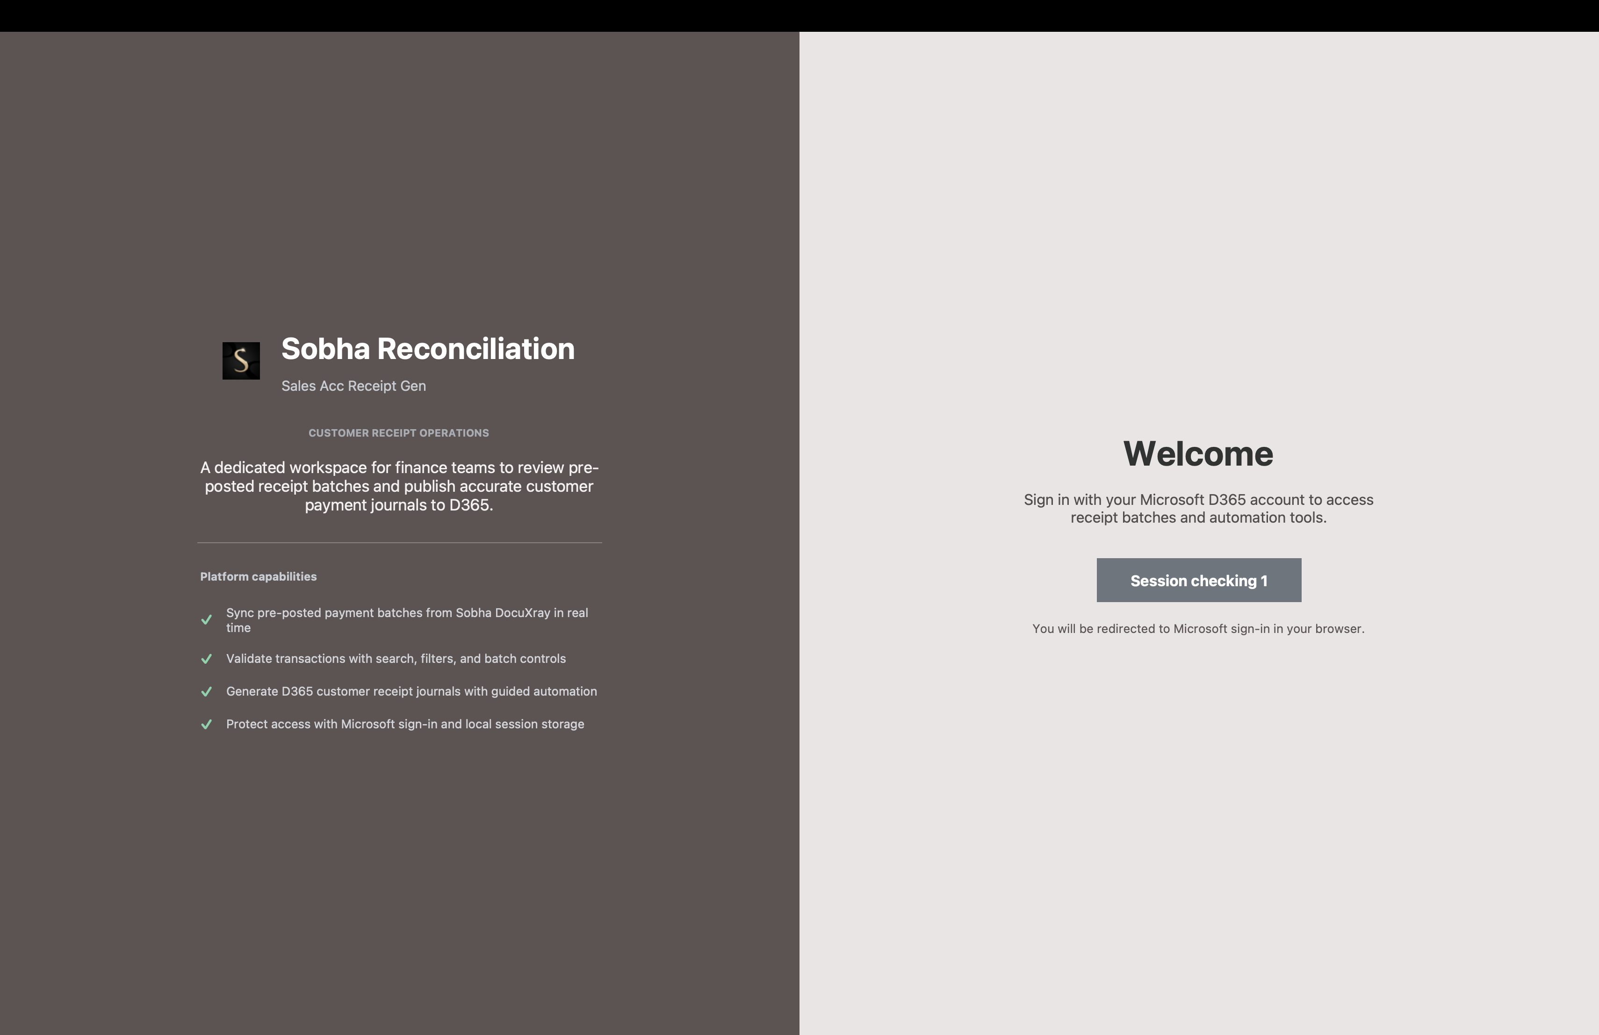
Fig. 1 — Welcome / login screen: Microsoft D365 sign-in and session status.
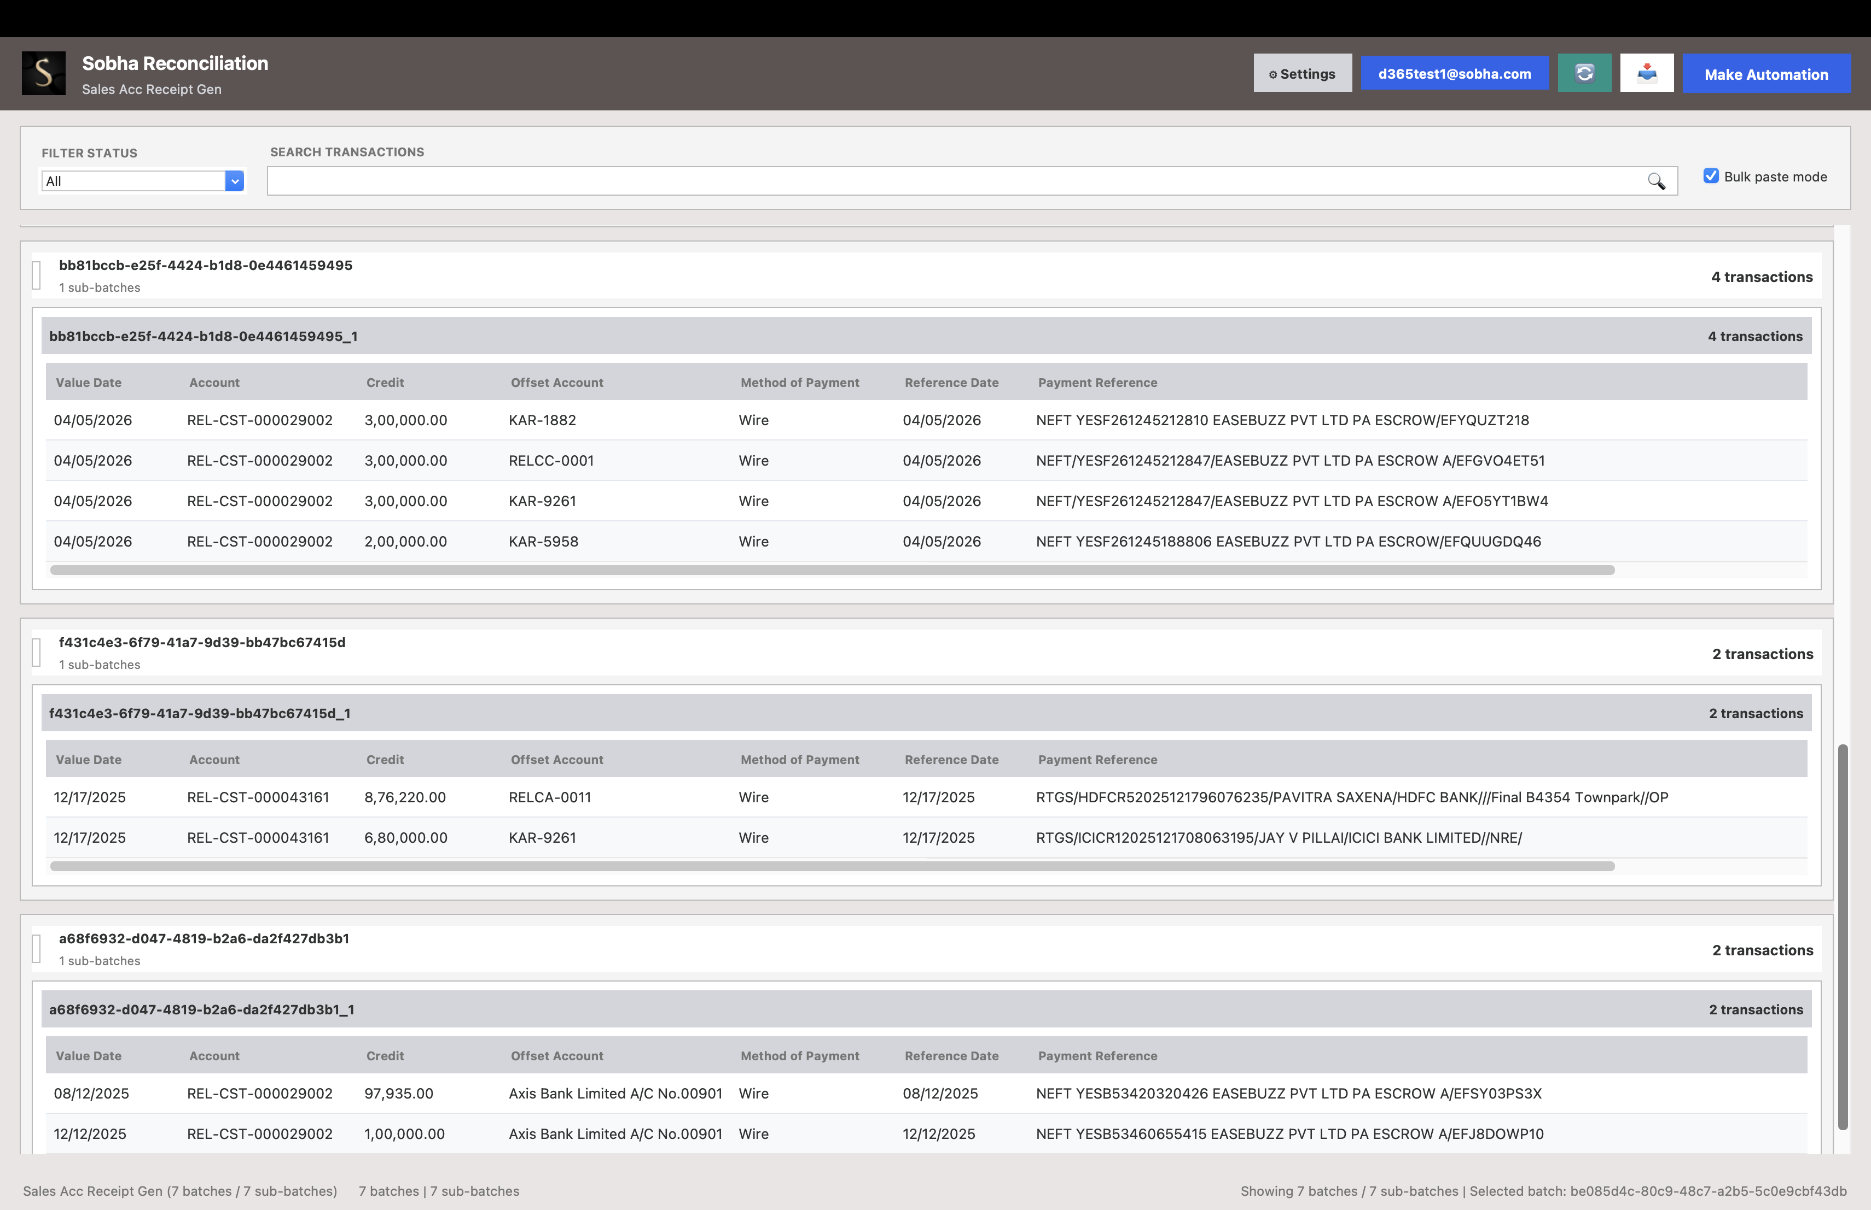
Fig. 2 — Batch workspace: pre-posted receipt batches queued for review and automation.
3. Scope
- Scope: one finance environment — the pilot runs on that tenant’s real customer receipt posting workflow, with its own DocuXray batches, D365 journal, and finance users.
- Duration: 4 weeks.
- Hosting: the POC desktop app is packaged and delivered by DocuXray; DocuXray APIs remain on DocuXray infrastructure — no server setup requirement on the client side beyond existing D365 access.
- Automation budget: capped at the agreed volume of automated journal postings / batch runs for the full 4-week pilot.
- POC-only configuration change: bulk-paste chunk size and keep-browser-open recovery options can be relaxed for the pilot so finance users can run multiple training, demo, and test postings in a day. Production controls are restored before rollout.

  - 4. Usage
  - – Up to the agreed volume of automated D365 receipt journal runs will be provided as part of the Proof of Concept (POC) for demonstrations, pilot usage, validation, and testing during the engagement.
5. Timeline (4 Weeks)
Week | Focus | Key Activities
Week 1 | Setup & Onboarding | Configure D365 URL, journal name, clipboard mapping, and DocuXray API access. Onboard finance users. Test login + one end-to-end receipt journal post. Brief the finance team.
Week 2 | Live Pilot — Phase 1 | Users process real pre-posted batches. Monitor fill accuracy, post success, and session stability. Track exceptions and offset/dimension edge cases.
Week 3 | Live Pilot — Phase 2 & Refinement | Continue live posting. Tune bulk-paste chunking, column mapping, and recovery behaviour from Week 2 findings. Cross-check DocuXray batch status against D365 journals.
Week 4 | Review & Sign-off | Compile accuracy, adoption, and turnaround-time results. Final stakeholder review and production rollout plan.

6. Commercials & Pricing

