 | CISC 886 Cloud Computing  Queen's University  Lab 8: Automating Multi-Container Deployment with CI/CD
Name | Aya Abdallah Abdelmonaem
Student ID | 20596345
Group | 25

Task 1 – Add a Database Service to the Repository
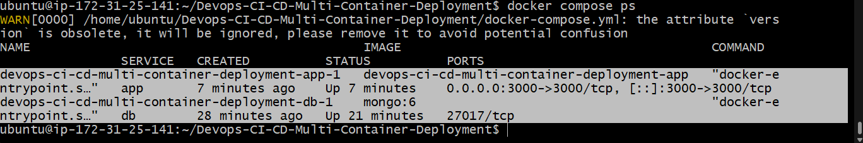

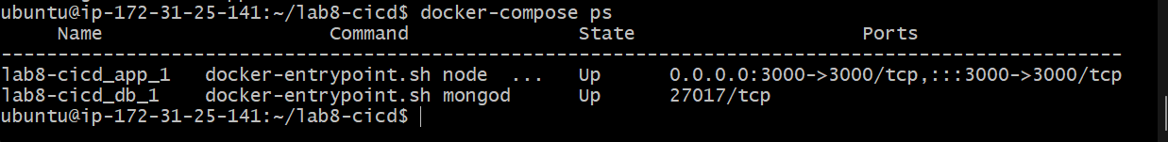

Write-up 1: I chose MongoDB. The app uses db as the hostname because Docker Compose creates an internal DNS network where each service is reachable by its service name — localhost would refer to the app container itself, not MongoDB.

Task 2 – Update the Pipeline to Deploy the Compose Stack
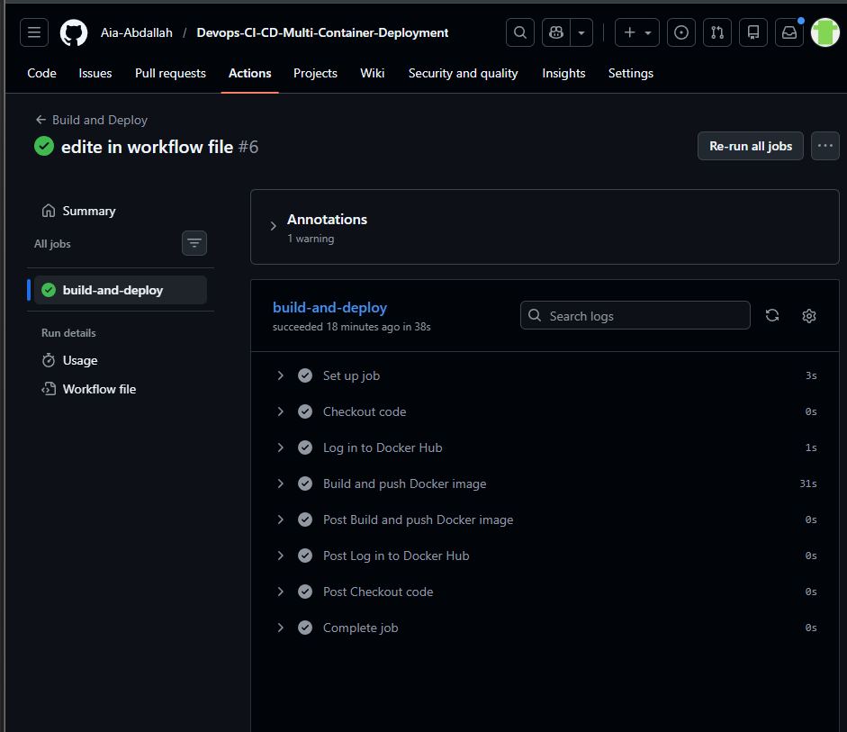
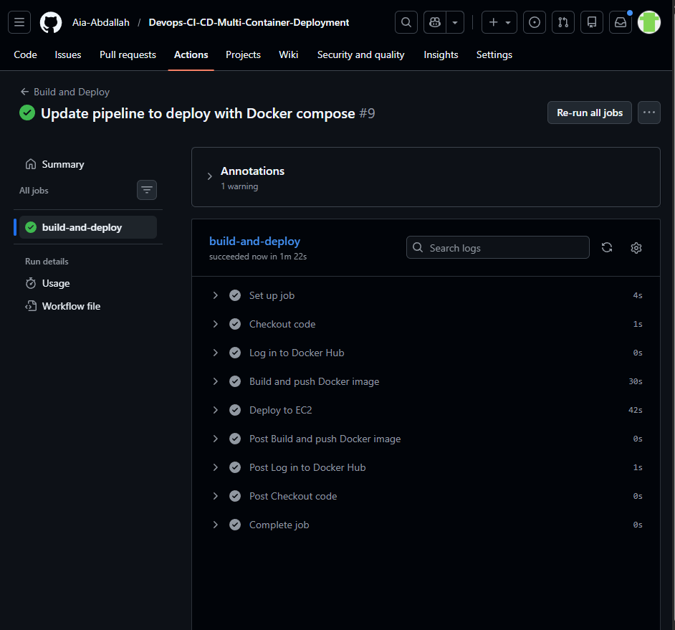

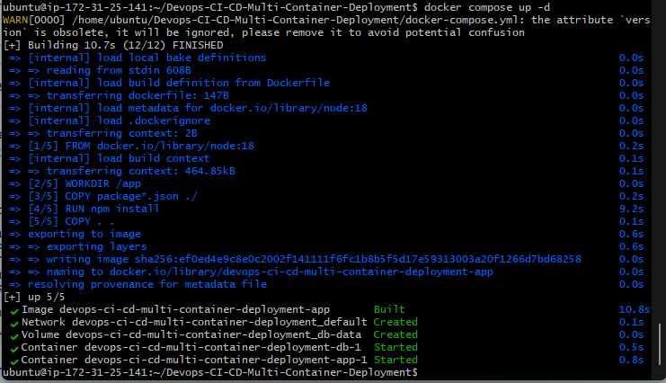

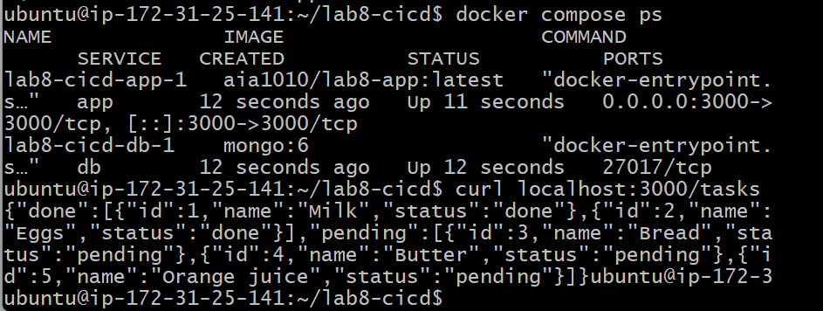

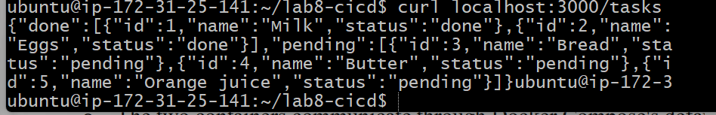

write-up 2: The two containers communicate via Docker Compose's default internal network — they share a private bridge network and reach each other by service name, so MongoDB port 27017 never needs to be exposed publicly.
Task 3 – Trigger a Full Round-Trip Change
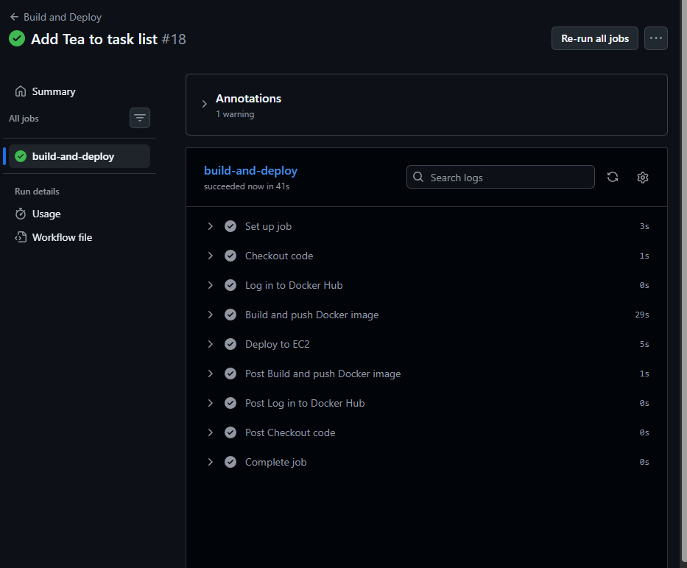

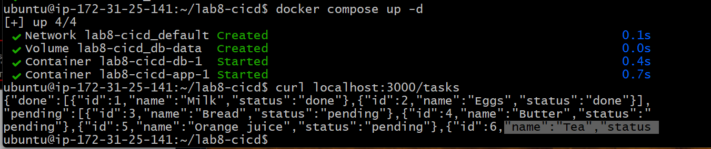
Write-up 3: Docker Hub acts as the intermediary at the "Build and push" step — the GitHub Actions runner pushes the image to Docker Hub, then EC2 pulls it from there. This matters because EC2 cannot directly connect to the GitHub Actions runner, but both can independently reach Docker Hub.

