AP CSP 0.1 note

# Unit0 Intro

## History of computer & Turing machine

### course Overview

Unit0 Intro

1. History of computer
2. Computer in modern day
3. How computer work (hardware/software/Program language)
4. Use computer to solve problems

Unit1 Computer as tools

1. Image, Audio and Video
2. hypertext/webpage
3. Game
4. VR, AR and MR

Unit2 Data and Abstracting

Unit3 Algorithms

Unit4 Programming and Engineering

Unit5 Internet and Data communication

Unit6 Social Impact

Unit7 AI

**Grading :**

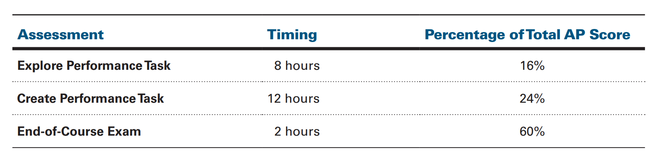

### Early Stage

1642-1645 Pascaline, Pascal’s device was one of the world’s **first mechanical adding machines**.

1673 **Leibniz wheel**,can be used in the calculating engine of a class of [mechanical calculators](https://en.wikipedia.org/wiki/Mechanical_calculator)

# 1822 Babbage designs a mechanical computer.

# Ada language

### Defined Computer

1936 **Turing machine**

A **tape** divided into cells, one next to the other. Each cell contains a symbol from some finite alphabet.

A **head** that can read and write symbols on the tape and move the tape left and right one (and only one) cell at a time.

A **state register** that stores the state of the Turing machine, one of finitely many. With a special **start state.**

A finite **table** of instructions that, given the **state**(qi) the machine is currently in *and* the *symbol*(aj) it is reading on the tape (symbol currently under the head), tells the machine to do the following *in sequence* (for the 5-tuple models):

1. Either erase or write a symbol (replacing aj with aj1).
2. Move the head (which is described by dk and can have values: 'L' for one step left *or* 'R' for one step right *or* 'N' for staying in the same place).
3. Assume the same or a *new state* as prescribed (go to state qi1).

A system of data-manipulation rules (such as a computer's [instruction set](https://en.wikipedia.org/wiki/Instruction_set)(ISA), a [programming language](https://en.wikipedia.org/wiki/Programming_language)) is said to be **Turing complete** or **computationally universal** if it can be used to simulate any [Turing machine](https://en.wikipedia.org/wiki/Turing_machine).

The **Turing test**, developed by [Alan Turing](https://en.wikipedia.org/wiki/Alan_Turing) in 1950, is a test of a machine's ability to [exhibit intelligent behavior](https://en.wikipedia.org/wiki/Artificial_intelligence) equivalent to, or indistinguishable from, that of a human. Turing proposed that a human evaluator would [judge natural language conversations](https://en.wikipedia.org/wiki/Natural_language_understanding) between a human and a machine designed to generate human-like responses.

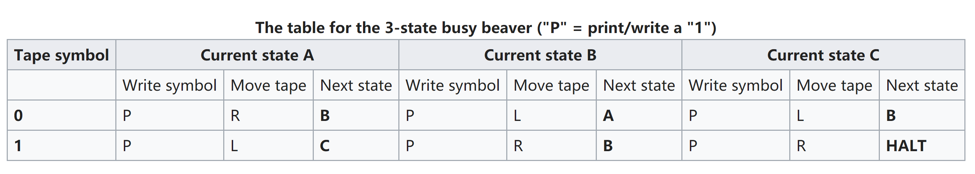

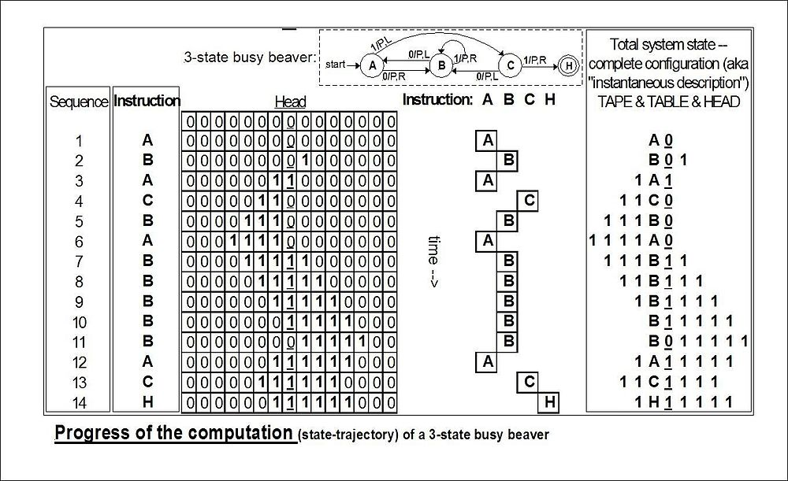

general-purpose [computer](https://en.wikipedia.org/wiki/Computer)

1941 **Atanasoff–Berry computer** (**ABC**) was the first automatic electronic digital computer, it was neither [programmable](https://en.wikipedia.org/wiki/Computer_program), nor [Turing-complete](https://en.wikipedia.org/wiki/Turing-complete). It was designed only to solve systems of [linear equations](https://en.wikipedia.org/wiki/Linear_equation) and was successfully tested in 1942.

1945 **Electronic Numerical Integrator and Computer(ENIAC),**  was the first electronic general-purpose [computer](https://en.wikipedia.org/wiki/Computer). It was [Turing-complete](https://en.wikipedia.org/wiki/Turing_completeness), digital and able to solve "a large class of numerical problems" through reprogramming.

ENIAC was formally dedicated at the [University of Pennsylvania](https://en.wikipedia.org/wiki/University_of_Pennsylvania) on February 15, 1946

The combination of speed and programmability allowed for thousands more calculations for problems, as ENIAC calculated a trajectory in 30 seconds that took a human 20 hours (allowing one ENIAC hour to displace 2,400 human hours). (5000 addition or 400 multiplication per second)

Problem of ENIAC:

No storage device.

Using [ten's complement](https://en.wikipedia.org/wiki/Ten%27s_complement)

**von Neumann architecture**

1. A [processing unit](https://en.wikipedia.org/wiki/Central_processing_unit) that contains an [arithmetic logic unit](https://en.wikipedia.org/wiki/Arithmetic_logic_unit) and [processor registers](https://en.wikipedia.org/wiki/Processor_register)
2. A [control unit](https://en.wikipedia.org/wiki/Control_unit) that contains an [instruction register](https://en.wikipedia.org/wiki/Instruction_register) and [program counter](https://en.wikipedia.org/wiki/Program_counter)
3. [Memory](https://en.wikipedia.org/wiki/Computer_memory) that stores [data](https://en.wikipedia.org/wiki/Data_(computing)) and [instructions](https://en.wikipedia.org/wiki/Instruction_set)
4. External [mass storage](https://en.wikipedia.org/wiki/Mass_storage)
5. [Input and output](https://en.wikipedia.org/wiki/Input_and_output) mechanisms

Code as Data