AP CSP 0.1 note

# Unit0 Intro

Computer in modern day

Von Neumann architecture

1. A [processing unit](https://en.wikipedia.org/wiki/Central_processing_unit) that contains an [arithmetic logic unit](https://en.wikipedia.org/wiki/Arithmetic_logic_unit) and [processor registers](https://en.wikipedia.org/wiki/Processor_register)
2. A [control unit](https://en.wikipedia.org/wiki/Control_unit) that contains an [instruction register](https://en.wikipedia.org/wiki/Instruction_register) and [program counter](https://en.wikipedia.org/wiki/Program_counter)
3. [Memory](https://en.wikipedia.org/wiki/Computer_memory) that stores [data](https://en.wikipedia.org/wiki/Data_(computing)) and [instructions](https://en.wikipedia.org/wiki/Instruction_set)
4. External [mass storage](https://en.wikipedia.org/wiki/Mass_storage)
5. [Input and output](https://en.wikipedia.org/wiki/Input_and_output) mechanisms

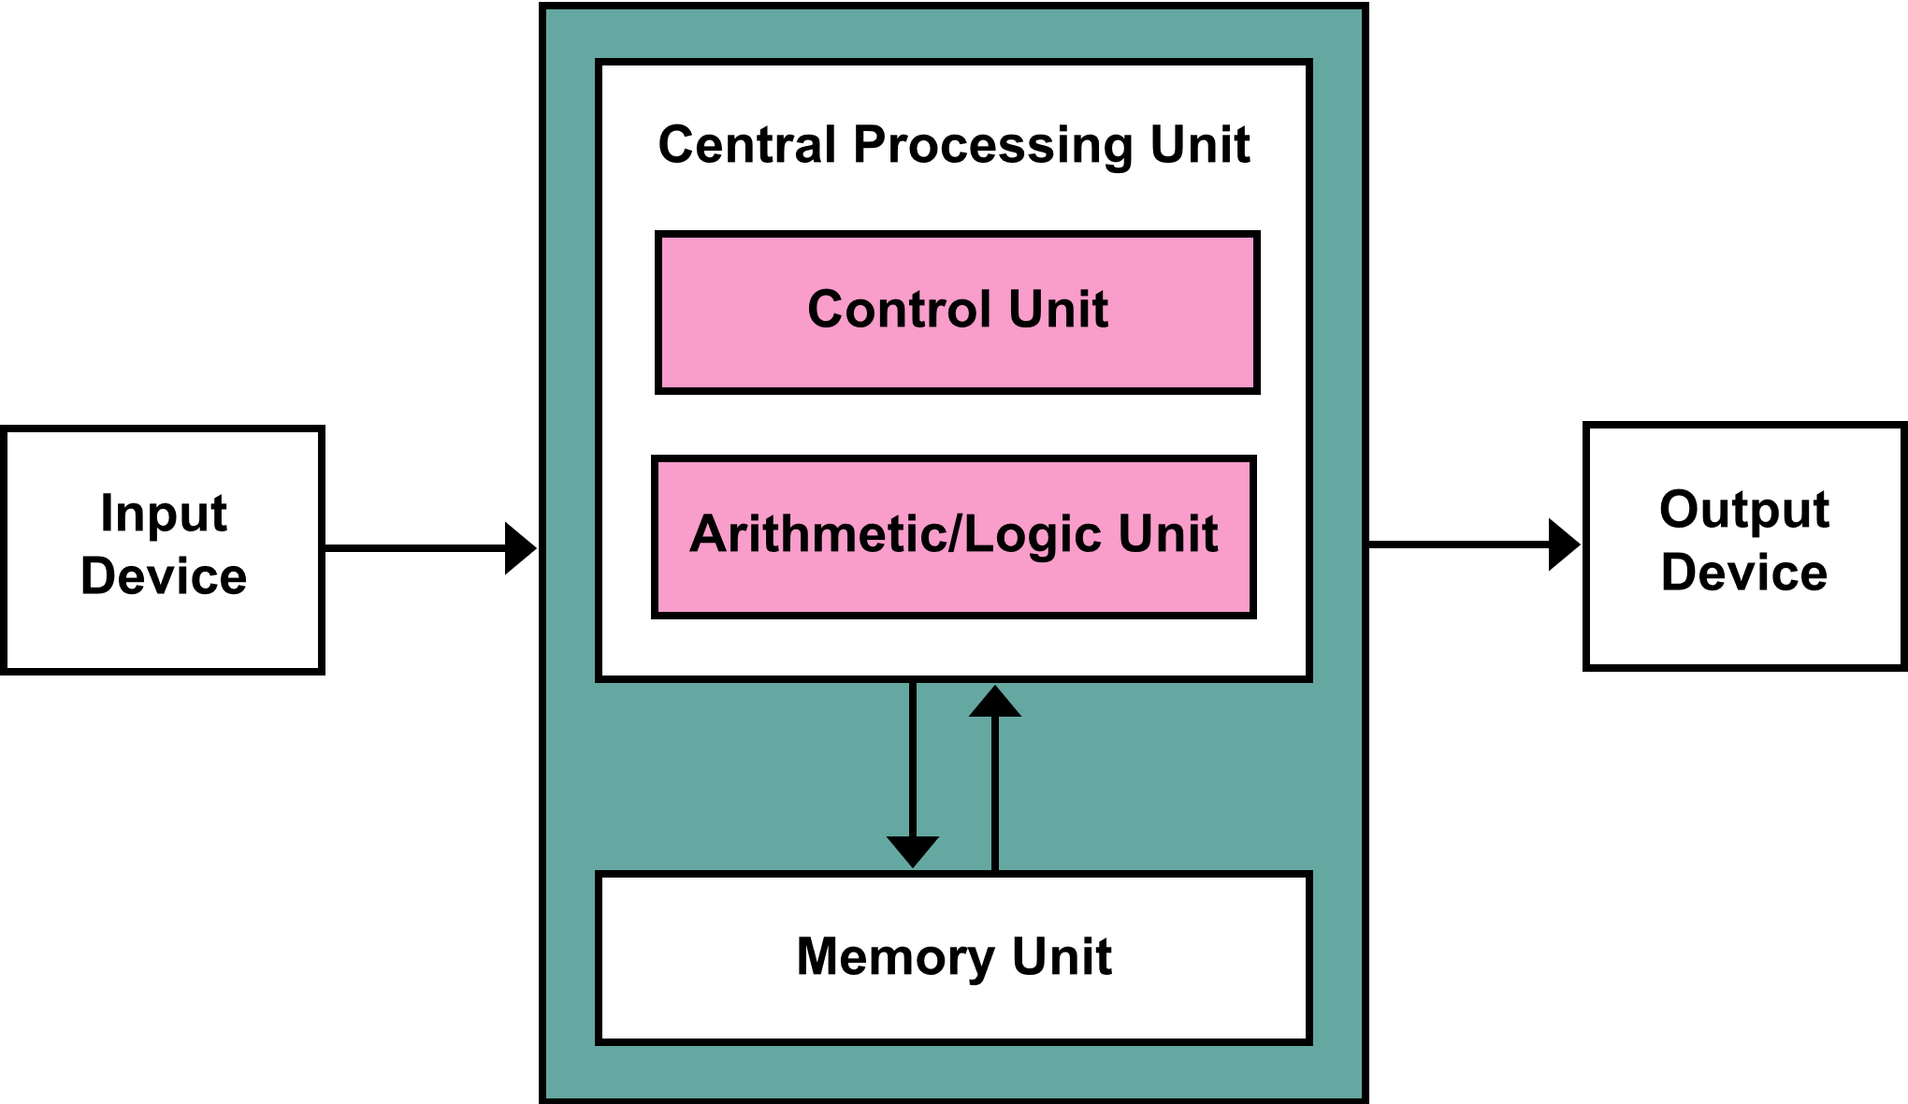

**Stored-program computer**： computer with a von Neumann architecture stores program data and instruction data in the same memory. **Therefore, code is data.**

**Self-modifying code ：** Code can change itself at run time. Why is this useful/harmful?

**Von Neumann bottlenecks**

The shared bus between the program memory and data memory leads to the von Neumann bottleneck, the limited throughput (data transfer rate) between the central processing unit (CPU) and memory compared to the amount of memory.

Binary system

Start with Von Neumann architecture, computer start using binary system.

**The traditional decimal system is based on power of ten.**

**The Binary system is based on power of two.**

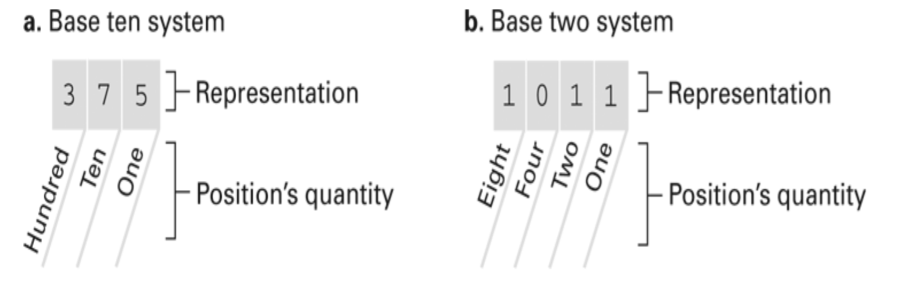

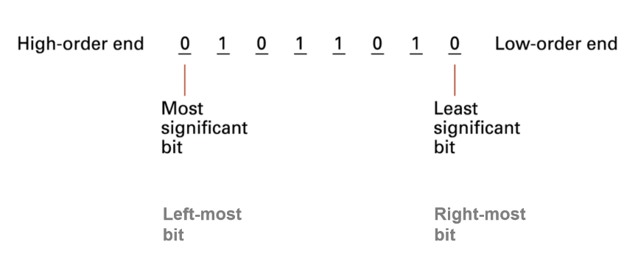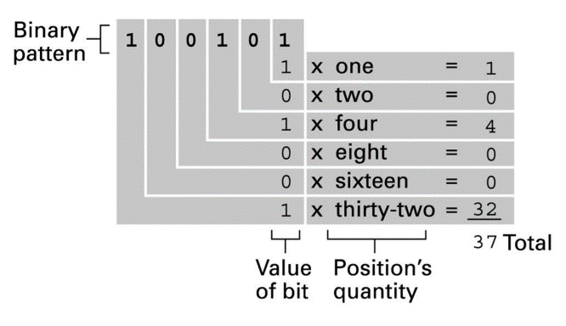

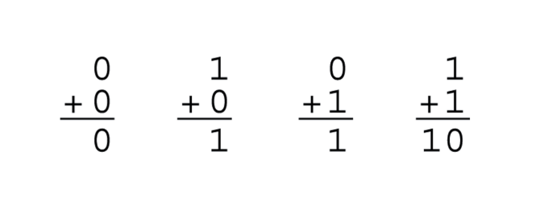

**The binary addition**

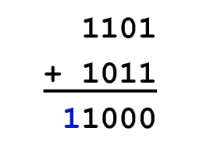**Overflow:** an overflow occurs in computer when there are not enough bits to hold an arithmetic result

**How do we do subtraction on binary?**

We can’t (sort of)

$$A – B = A + (-A)$$

**But how do we representation negative binary number?**

**TWO’s complement notation**

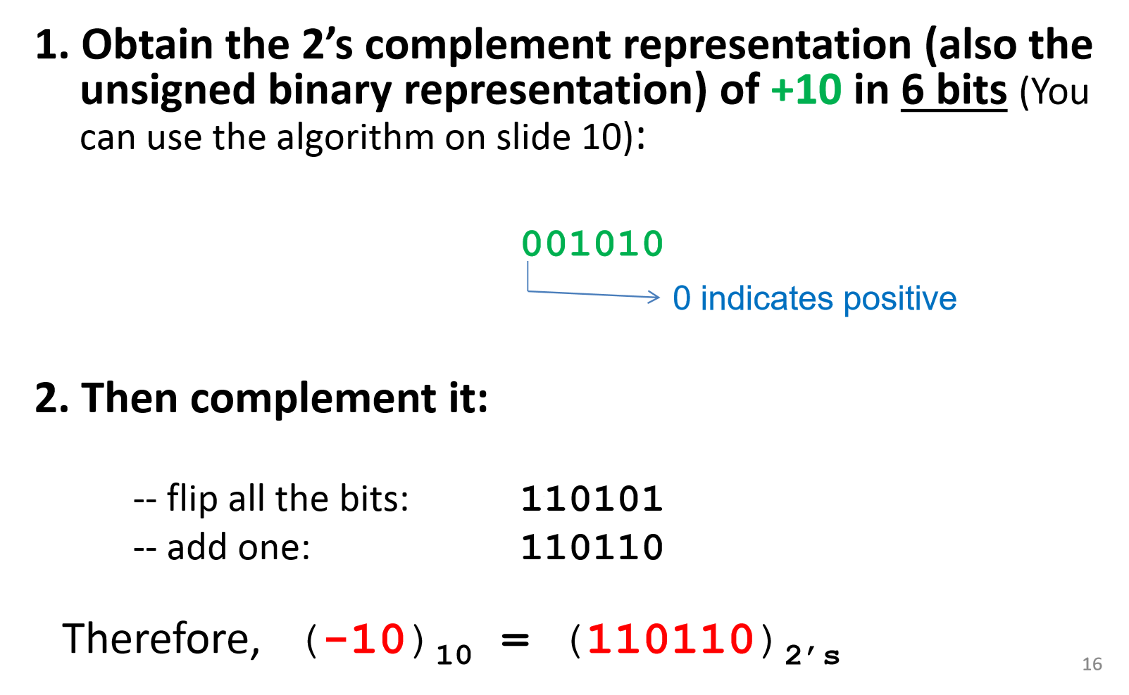



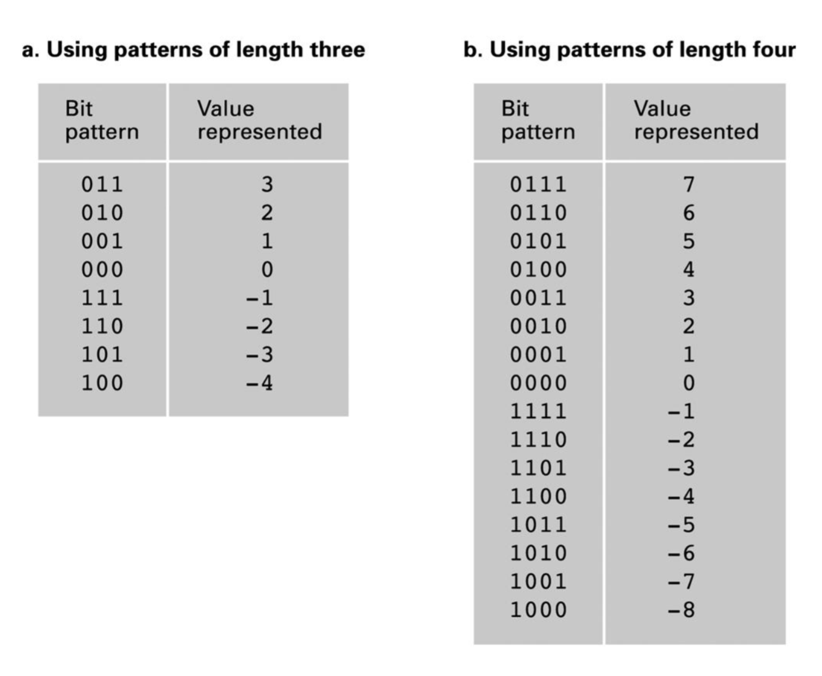

$\left[-2^{n-1},+2^{n-1}-1\right]$

The number can be represante by TWO’s complement notation in length $n$ bits.

