AP CSP 2.0 homework

1. Write a function that take a number $n$ and return $n!$

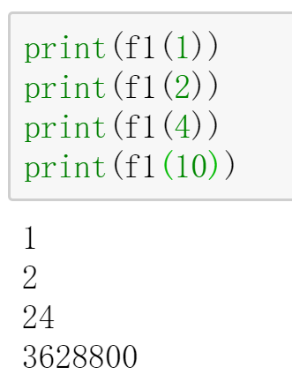

1. Write a function that ask user age and print user born year.

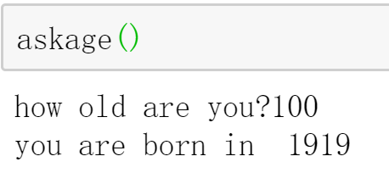

1. Support you are creating a program to model a bingo game that you can play on computer.

2a. What are some object in game that you will likely want to simulate?

2b. What are some important action in a card game?

2c. What are some hypotheses you could use the game to test?

1. Encoding “Hello, Python!” to binary data by ASCII, then write it in hexadecimal.