AP CSP 2.0 note

# Unit2 Data and Abstraction

Abstraction

Abstraction reduces information and detail to facilitate focus on relevant concepts.

Abstraction on Data

**#**Digital data is represented by abstractions at **different level**.

**#**At the **lowest level**, all digital data are represented by bits (a series of 0 or 1).

**#**At a **higher level**, bits are grouped to represent abstractions, including but not limited to **numbers**, **characters**, and **color**.

“

binary number: 65 66 67

or color **gray** in RGB [65,66,67]

or three characters “A B C”

**#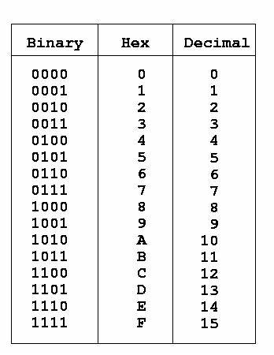Number bases**, including binary (base 2), decimal (base 10), and hexadecimal (base 16), are used to represent and investigate digital data.

**#Hexadecimal** (base 16) is used to represent digital data because hexadecimal representation uses fewer digits than binary.

**#**Numbers can be converted from any base to **any** other base.

**Characters** in computer arerepresent by some kind of encoding system.

Most stranded one is **American Standard Code for Information Interchange (ASCII).**

In computing, **floating-point** arithmetic (FP) is arithmetic using formulaic representation of real numbers as an approximation to support a trade-off between range and **precision**.

Since all floating-point are approximation, there are not precise. Be careful when using comparison with floating-point.

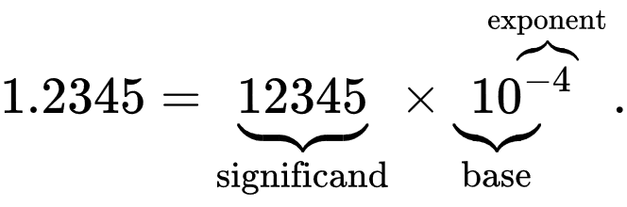

**#**The **interpretation** of a binary sequence depends on how it is used.

**#**A sequence of bits may represent **instructions(code)** or **data**.

**#**A sequence of bits may represent different types of data in different **contexts**.

Models and simulations

Models and simulations use abstraction to generate new understanding and knowledge.

A basic modeling includes Object and Action.

Ex:

In a card game, you have card and a deck (cloud be a list of card object) as Object. You can deal card, know you are win/lost as action.

1. The program may be written to model an actual situation. Ex: we need schedule timetable of different course, so that every student has a conflict free schedule.
2. The program may contain object designed to represent an actual object in real world. Ex: In animation studio, we want to make fire in movie look real.
3. The program may be written to test a hypothesis that cannot be tested or simulated in real life. Ex: We can test different way to build road and highway to test how to improve traffic.

**#**Models and simulations are simplified representations of more **complex** objects or phenomena.

**#**Models often **omit unnecessary features** of the objects or phenomena that are being modeled.

**#**Simulations mimic real-world events **without the cost or danger** of building and testing the phenomena in the real world.

A **hypothesis** is a proposed explanation for a phenomenon.

Ex: In flipping coin, with coin as Object, flipping as Action. A hypothesis can be If a flipping coin 100 times I will get 50 heads and 50 tails.

**#**Models and simulations facilitate the formulation and refinement of hypotheses related to the objects or phenomena under consideration.

**#**Hypotheses are formulated to **explain** the objects or phenomena being modeled.

**#**The results of simulations may **generate new knowledge and new hypotheses** related to the phenomena being modeled.

**#**Simulations allow hypotheses to be **tested without the constraints of the real world**.

**#**Simulations can facilitate **extensive and rapid testing** of models.

**#**The **time** required for simulations is impacted by the **level of detail** and **quality of the models** and the software and hardware used for the simulation.

**#**Rapid and extensive testing allows models to be **changed** to accurately reflect the objects or phenomena being modeled.

ASCII table

