Login Page
Access: Navigate to the Login Page by entering the platform's web address in your browser “122.54.164.177 is the web address.
Credentials: Enter your assigned username and password in the designated fields.
Secure Sign-In: Click the "Login" button to securely authenticate your credentials.
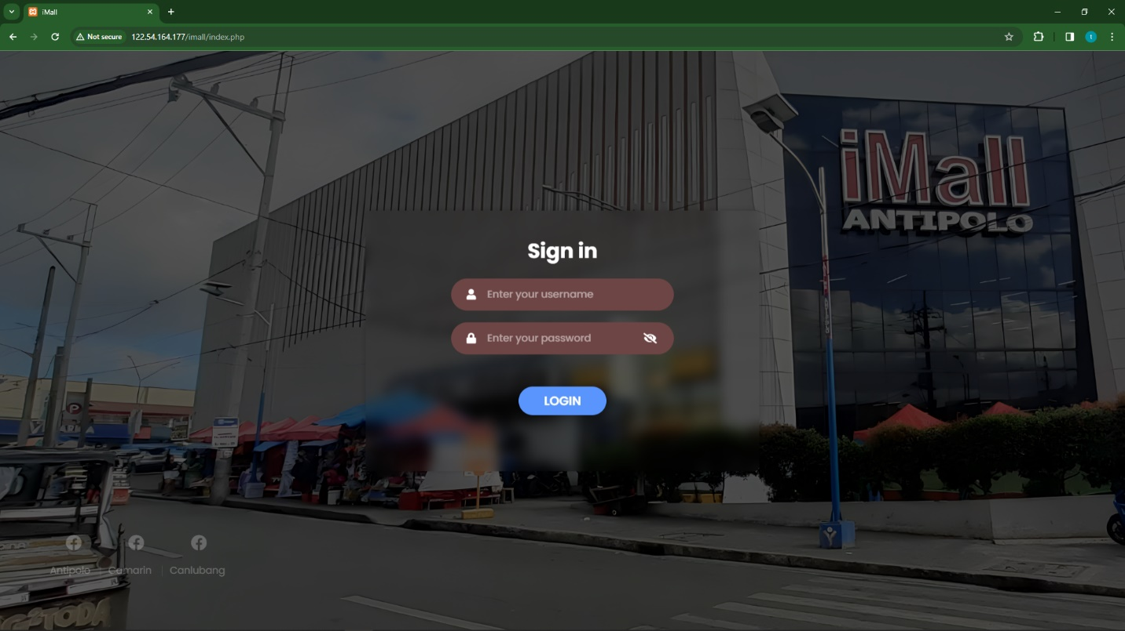

Tenant list button
Access: Click the "Tenant List" button to open the list, revealing a list of tenants.
Search: Use Search: to quickly locate a specific tenant by name or other relevant details.
Selection: Click on the desired tenant from the list. Upon selection, the Contract No., Stall No., and Tenant details will automatically fill into the respective fields.
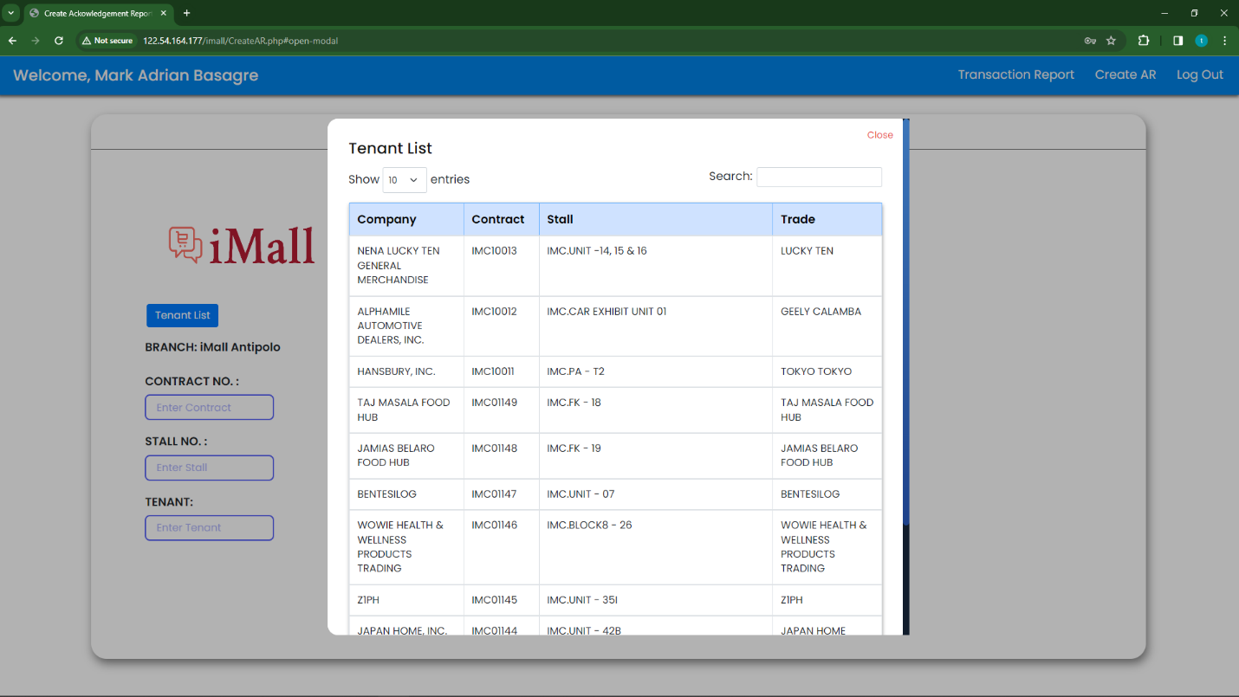
Close : Once you've selected the tenant and populated the necessary fields, close it to return to the main interface.

Creating transactions
Add Transactions:
Click the "Add" or "+" button to generate input fields for additional transactions.
Fill in the necessary details for each transaction, such as payment type, Month, Particulars and the amount in the created input fields.
Review and Edit:
Review the entered information and make any necessary edits before finalizing the transactions.
Submit:
Once all transactions are inputted, click the "Submit" button to process the data.
Redirect to Receipt:
After submission, the system redirects you to the generated receipt, displaying a summary of the entered transactions.
Confirmation:
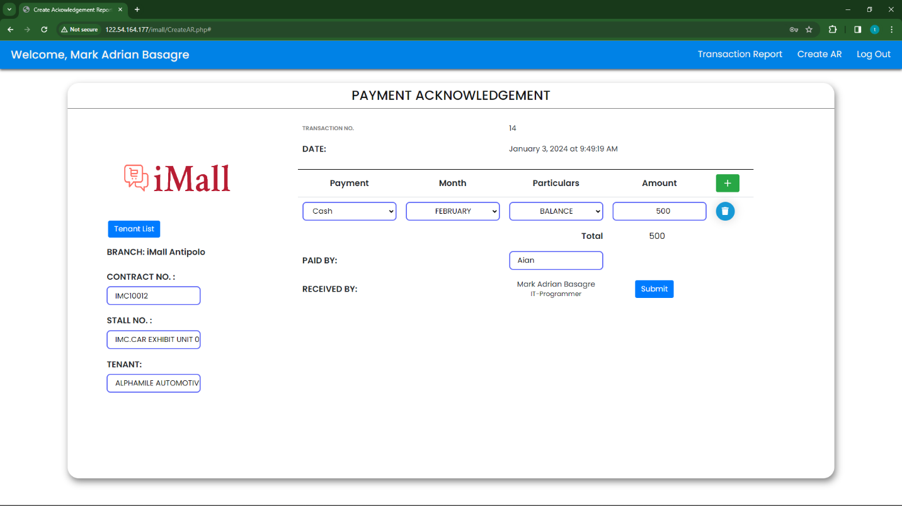
Confirm the details on the receipt to ensure accuracy.

Printing Receipt
To print the receipt click the button “Print Receipt”
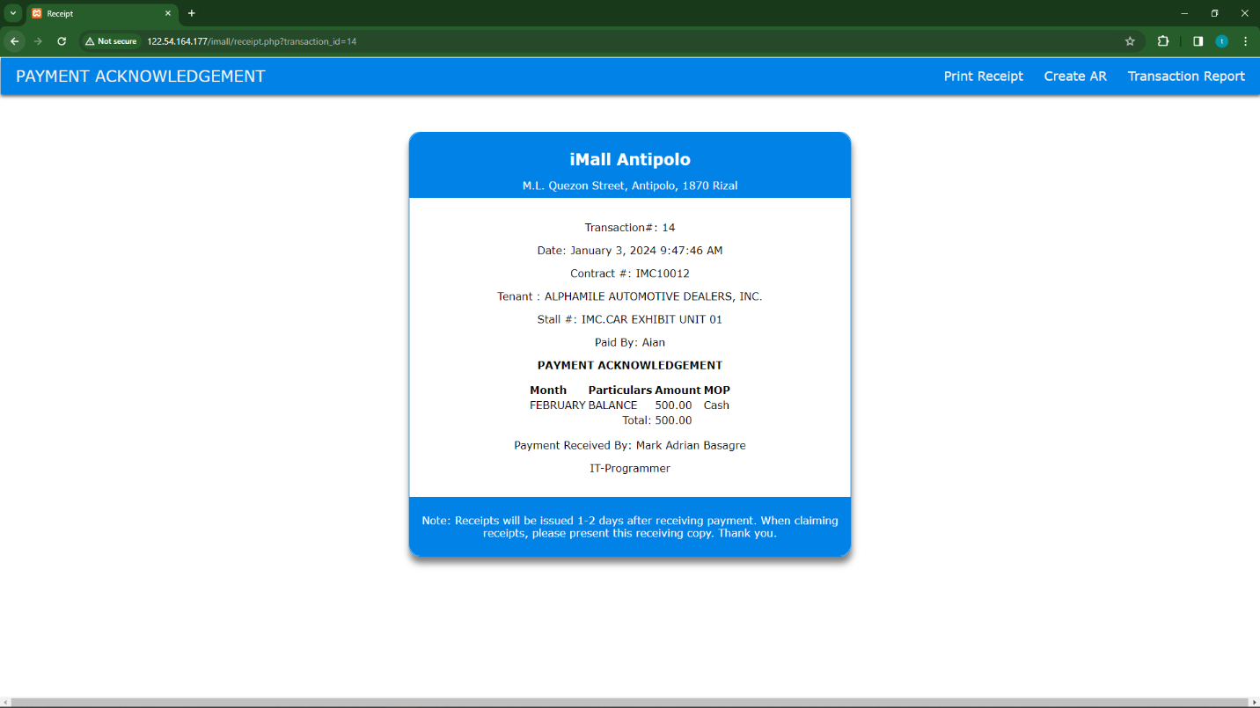

Transaction Report
Today’s Transactions Button
Click the “Today’s Transactions” Button and it will show the transactions that created today.
The transactions can import to excel,csv,pdf by clicking the buttons.
Search Bar: If you need to locate a specific transaction, simply enter relevant keywords in the Search bar. The system will then filter and display transactions that match your search criteria.
Show Entries: Select from options such as 10, 25, 50, 100, or 'All' to customize the presentation of transaction entries according to your desired quantity."
If you want to import selected transaction/s you can use the select check box.
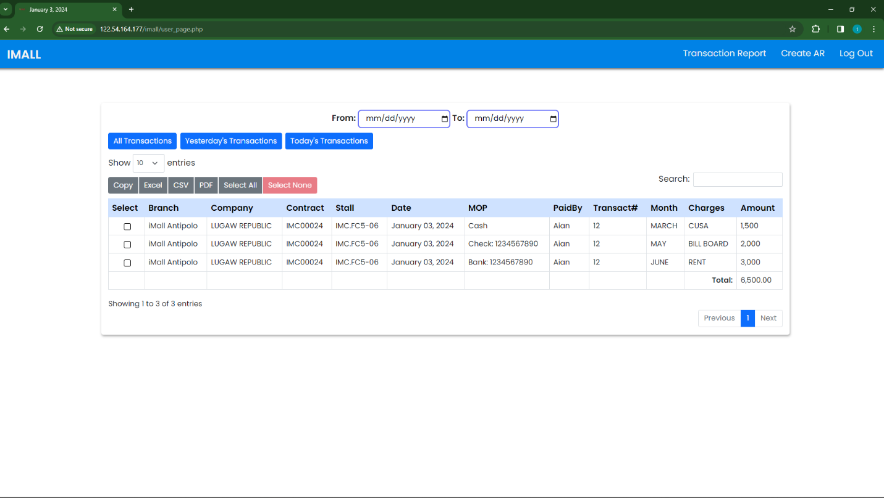

Yesteday’s Transactions Button
Click the “Yesteday’s Transactions” Button and will show the transaction from yestederday.
The function is the same with Today’s Transactions button.
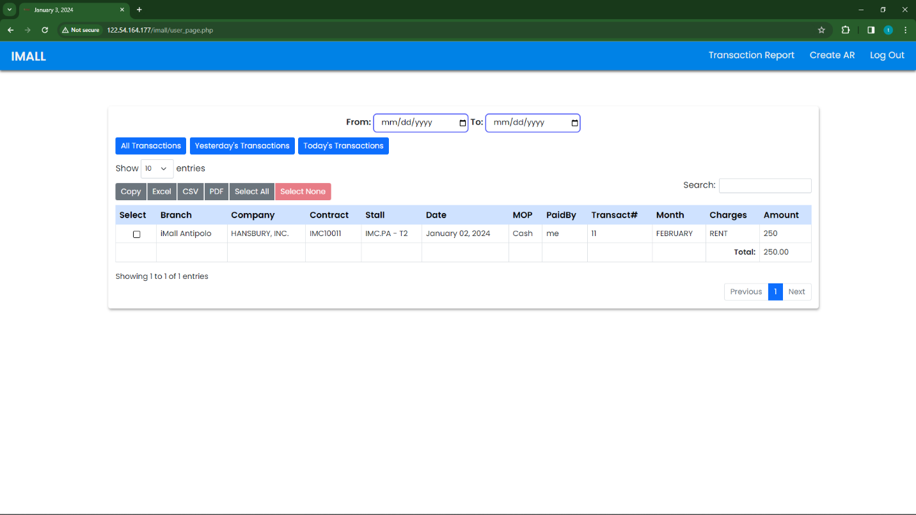

All Transactions button

Click the “All Transactions button” Button and will show all created transactions.
You can use Date range filter if you want to display the transactions From: “Date you want” To: “Date you want” once the date range is filled up click the the “All Transactions button” and it will show the transactions From:”the date that you input” To:”the date that you input”.
The other functions is also the same with the others.
