In your web browser type this web address 122.54.164.177 then login using this credentials
username: admin password: CIIR4styL0p3zCII once successfully logged in it will redirect to dashboard page.
In this page you will see the Tenant List when you click the list the Transaction History will pop up.
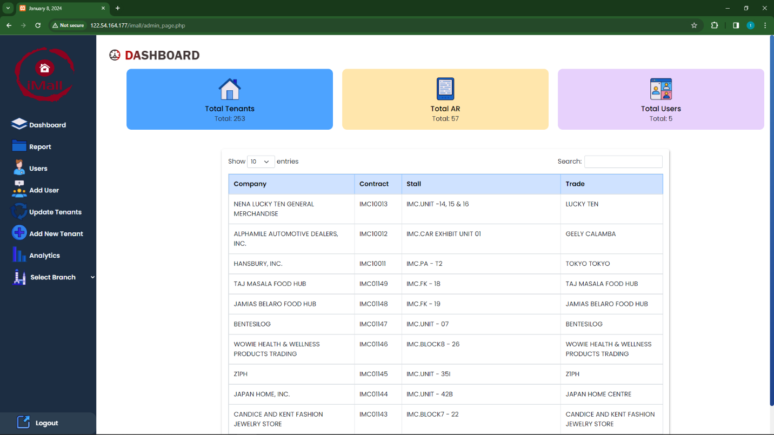
Also you will see the Total Tenants, Total Transactions and Total Users.

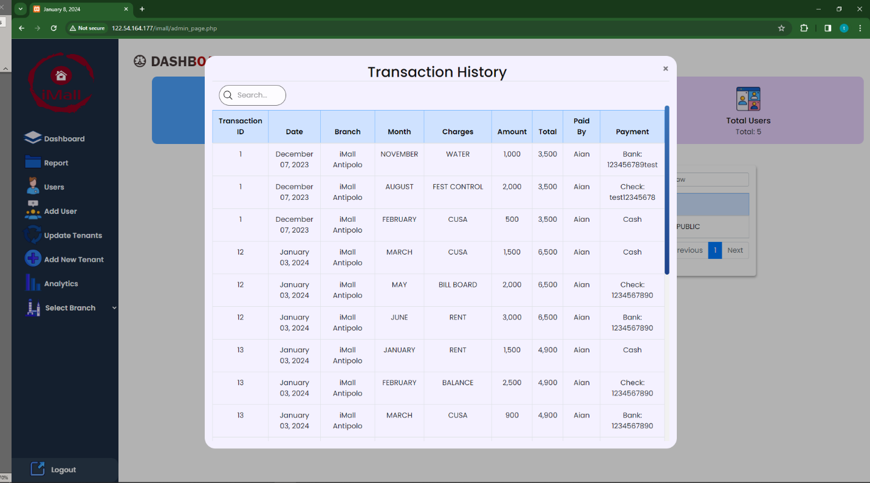

Report Button
Today’s Transactions Button: Click this button to view transactions created today across all branches.
Yesterday’s Transactions Button: This button allows you to review transactions generated yesterday from all branches.
All Transactions Button: Clicking this button displays all transactions created across all branches. To narrow down your search, utilize the Date Range filter. Enter the desired 'From' and 'To' dates, and upon completion, click the 'All Transactions' button again. The system will then present transactions within the specified date range.
Search Bar: If you need to locate a specific transaction, simply enter relevant keywords in the Search bar. The system will then filter and display transactions that match your search criteria.
Show Entries: Select from options such as 10, 25, 50, 100 to customize the presentation of transaction entries according to your desired quantity."
You can export transaction data to Excel, CSV, or PDF formats by clicking the respective buttons. For a more selective approach, use the checkbox to choose specific transactions for import."
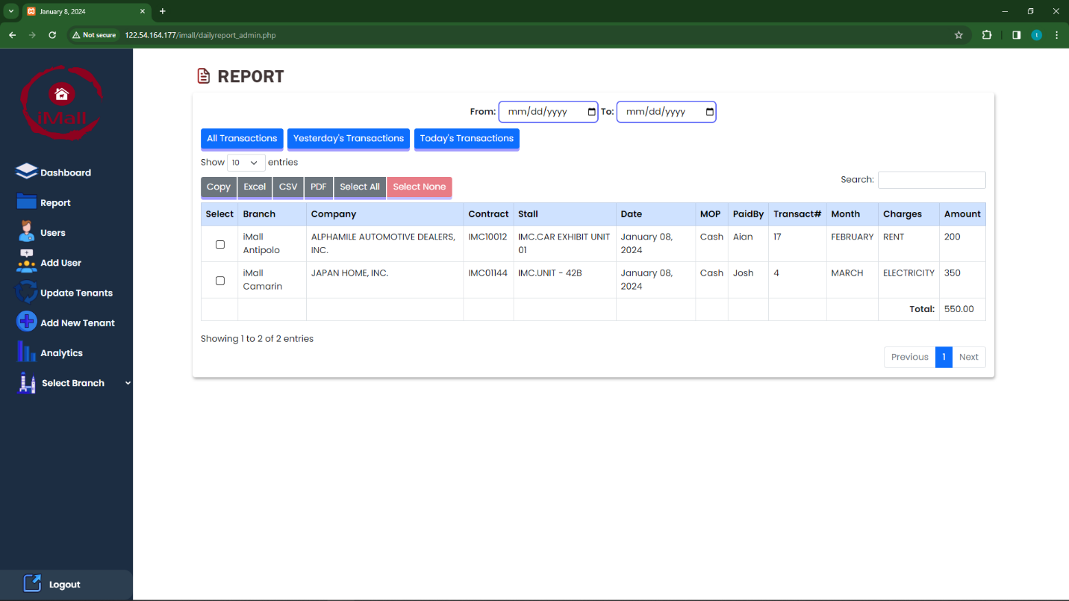

Users
In the user management page, administrators can view a comprehensive table containing user details such as Username, Fullname, Email, Password, Position, Branch, User Type, Last Login, IP Address, and Status. To modify user information, simply click the 'Edit' button. Additionally, administrators have the option to delete users by selecting the 'Delete' option in the corresponding row. 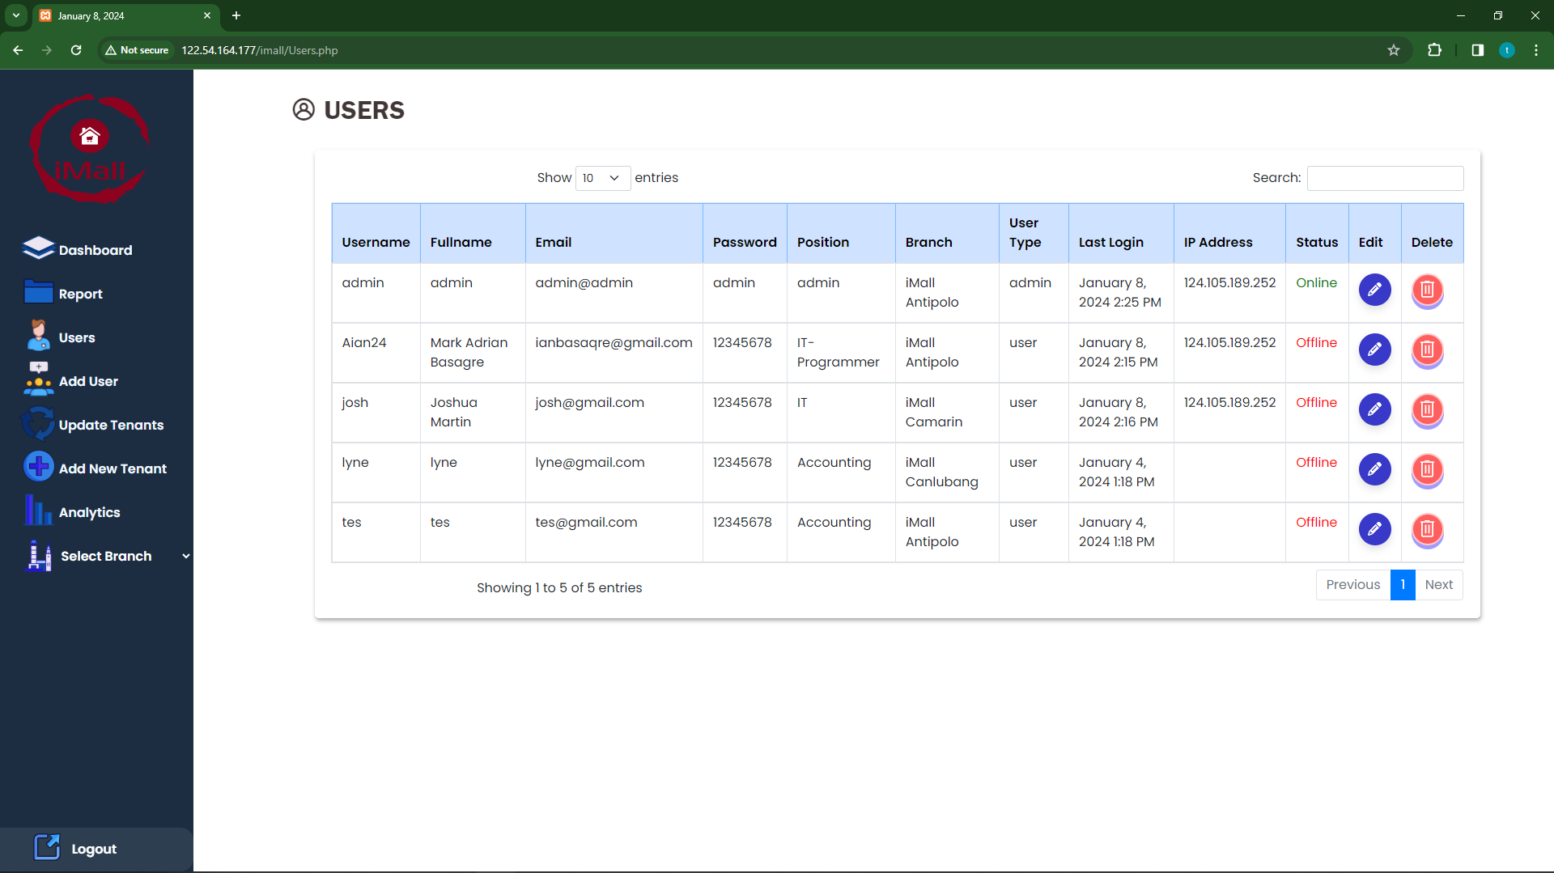

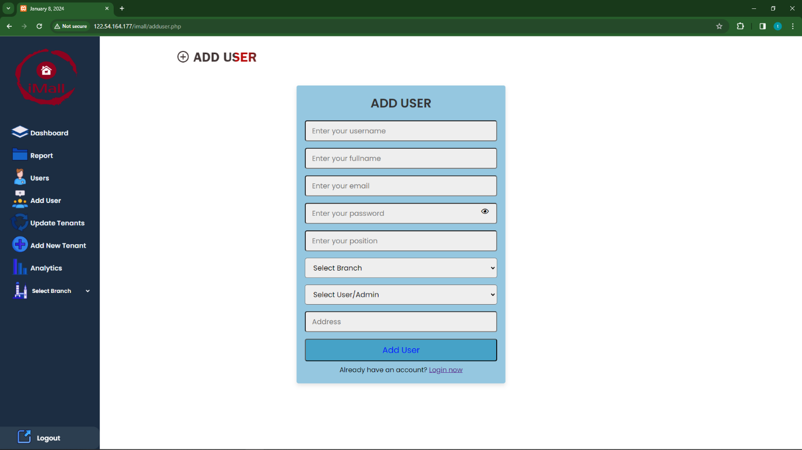
Add User
On the 'Add User' page, administrators can easily create new user profiles by entering the details such as username, fullname, email, password, position, branch, user type, and initial status. Simply fill in the required information and click 'Add User' to successfully register a new user.

Update Tenants
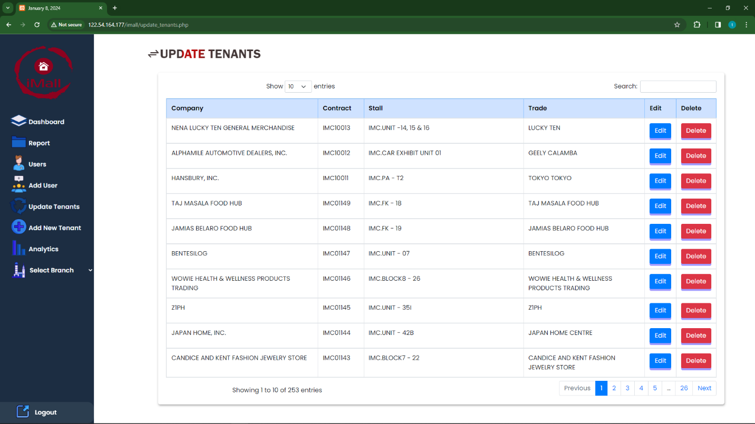
In the 'Update Tenants' section, you can manage tenant information through a table displaying details such as Company, Contract, Stall, and Trade. Use the 'Edit' button to modify tenant details as needed, and the 'Delete' button to remove any outdated or unnecessary records.

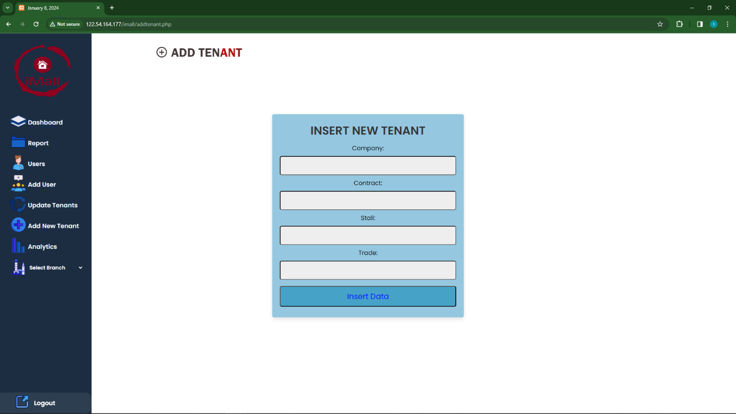
Add New Tenant
On the 'Add New Tenant' page, you can add a new tenant by providing the details of Company, Contract, Stall, and Trade. Input the required information, then click 'Insert Data' to successfully create a new tenant entry.

Analytics
In Analytics page show’s the Daily Total Sales, Weekly Total Sales, Monthly Total Sales, and Yearly Total Sales.
Select Branch: Choose 'All Branches' or specific branches for focused insights.
Date Range: Specify analysis duration with 'From' and 'To' dates in mm/dd/yyyy format.
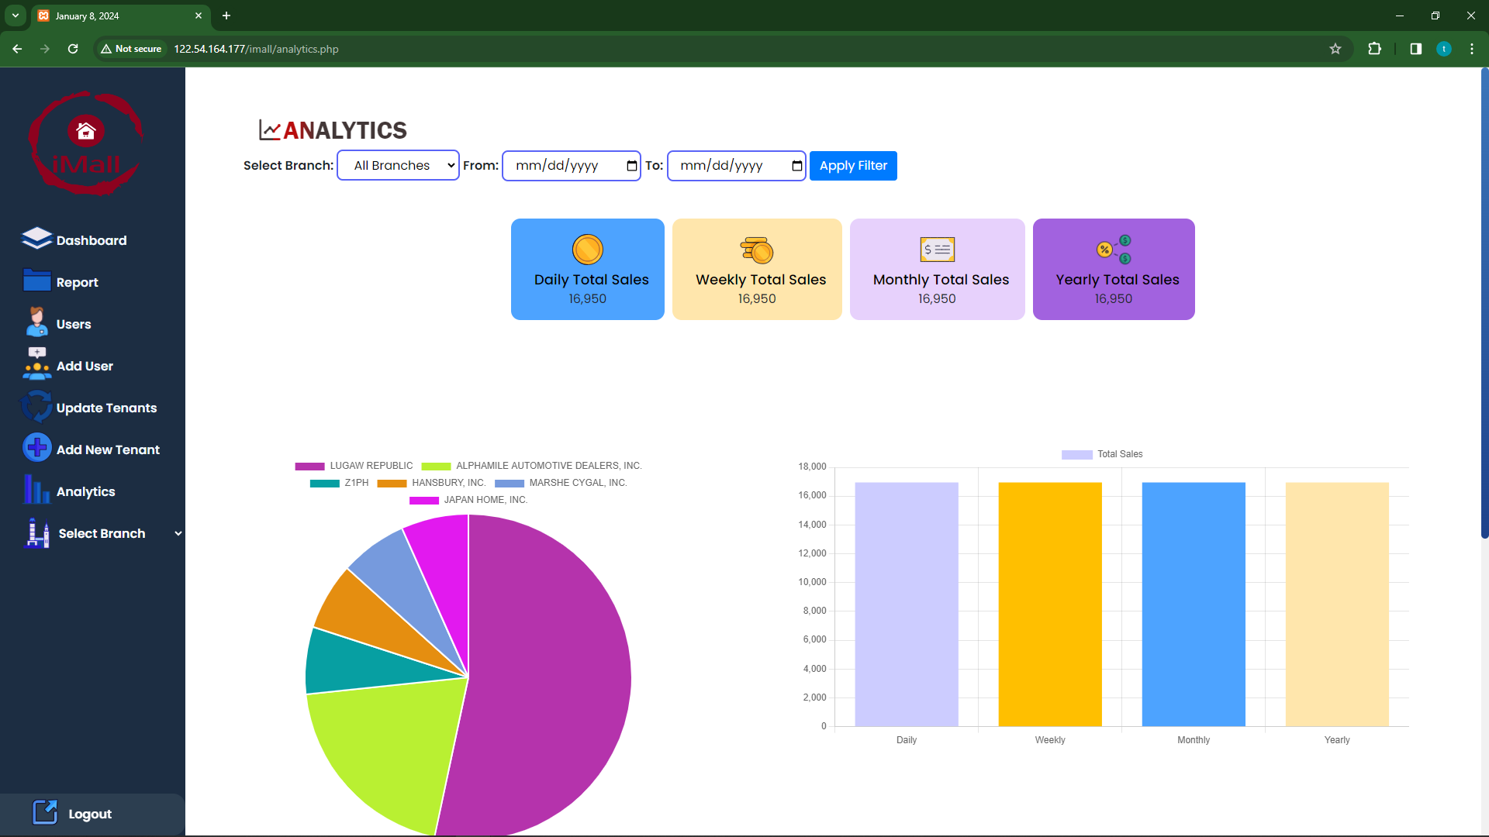

Select Branch
In the 'Select Branch' feature, choose a specific branch to filter and display transactions exclusively from that branch.
Date range filter: Using the 'From' and 'To' date fields to specify a date range. Click the 'Filter' button to view transactions exclusively from the chosen branch within the defined date range.
