**Linear Regression**

**Data_set:-**

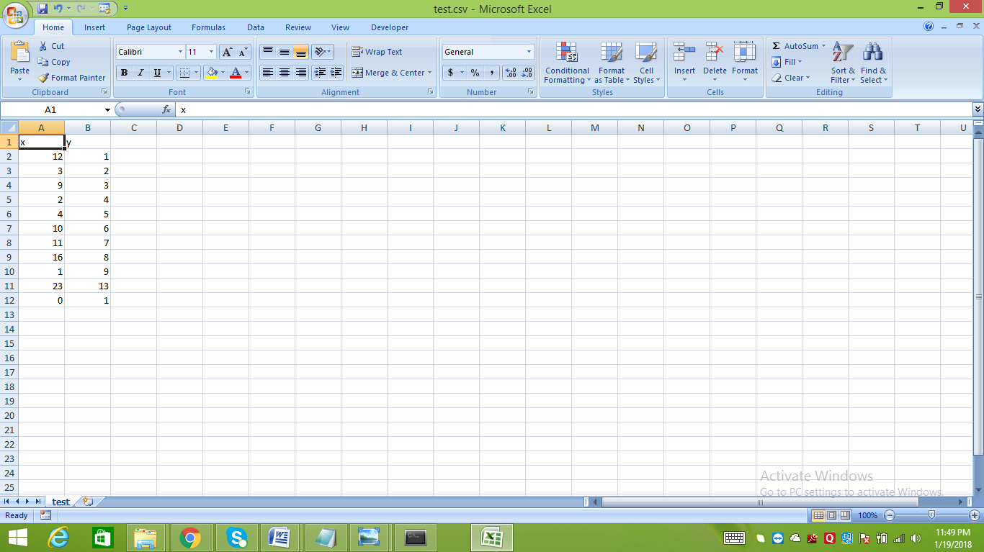

**Data_file_path**

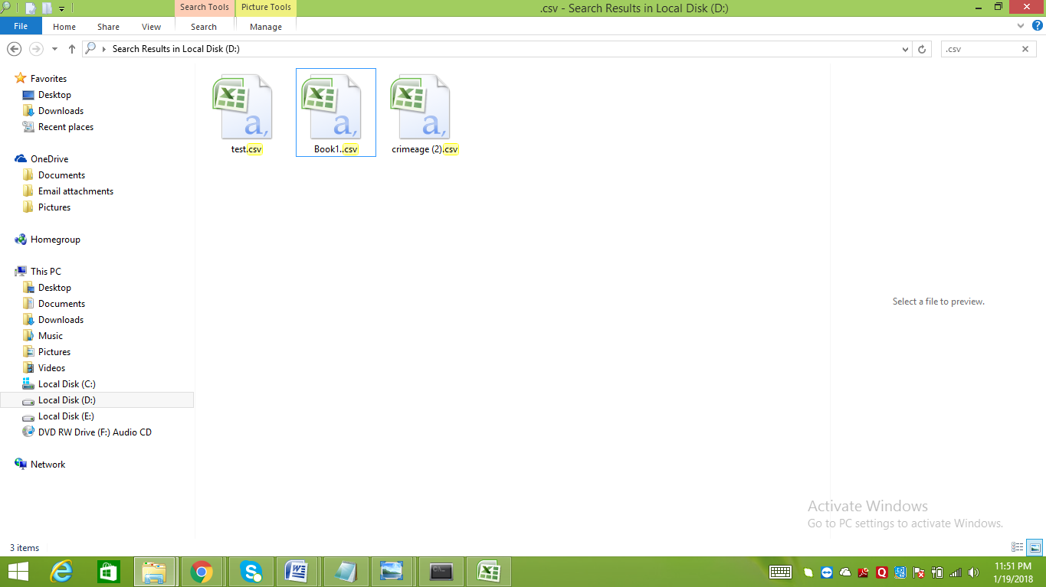

**Coding in Python to compute Linear_Regression with screenshot:-**

*import matplotlib.pyplot as plt*

*from matplotlib import\**

*import numpy as np*

*import pandas as pd*

*import scipy*

*from scipy import\**

*data=pd.read_csv('D://test.csv')*

*x1=data.x*

*y1=data.y*

*#polyfit shows the value of slope and intercept*

*p1=polyfit(x1,y1,1)*

*print("The values of slope and intercept is")*

*for i in p1:*

*print(i)*

*#polyval Evaluate a polynomial at specific values*

*plt.plot(x1,polyval(p1,x1),'r',linewidth=2,label="regressionline")*

*plt.xlabel("x axis")*

*plt.ylabel("y axis")*

*plt.title("GRAPH",color='b')*

*plt.legend()*

*plt.scatter(x1,y1,color='k')*

*plt.show()*

