**Blockchain White Paper: "EcoChain: A Sustainable Future for Blockchain Transactions"**

**Executive Summary**

EcoChain is a new blockchain project designed to solve the growing issue of energy consumption and carbon emissions within the cryptocurrency industry. Utilizing a combination of Proof of Stake (PoS) and green energy incentives, EcoChain introduces an environmentally sustainable blockchain that significantly reduces the energy required for securing decentralized transactions while maintaining transparency, security, and scalability.

The project aims to address two critical concerns:

1. The environmental impact of existing Proof of Work (PoW) blockchains like Bitcoin and Ethereum.

2. The need for faster, scalable, and more secure transactions.

**Problem Statement**

The Energy Crisis in Blockchain

Bitcoin mining consumes more electricity than entire nations such as Argentina, contributing significantly to the global carbon footprint. Traditional Proof of Work (PoW) blockchains require massive computing power to validate transactions, resulting in inefficient energy use. According to the Cambridge Centre for Alternative Finance, Bitcoin's annual electricity consumption is estimated to be over 127 TWh (terawatt-hours) . This reliance on fossil fuel-driven energy sources has raised serious concerns about the long-term sustainability of blockchain technology.

Solution: **EcoChain**

EcoChain is designed to:

1. Reduce energy consumption: By using Proof of Stake (PoS) instead of PoW, EcoChain lowers the energy requirements for transaction validation.

2. Incentivize green energy use: Validators are rewarded for contributing to the network using renewable energy sources, encouraging a shift away from traditional, non-renewable energy consumption.

3. Maintain scalability and security: The hybrid consensus model ensures that transactions are both fast and secure without compromising on decentralization.

**Technical Architecture**

EcoChain's architecture is built on a hybrid consensus mechanism that blends Proof of Stake (PoS) with Delegated Proof of Stake (DPoS). This architecture allows for enhanced security and flexibility while reducing the computational workload.

Key Features:

1. **Sharding**: EcoChain implements sharding technology to allow for the parallel processing of transactions across multiple shards. This improves the throughput of the network.

2. **Smart Contracts**: The platform supports Ethereum Virtual Machine (EVM), making it compatible with existing dApps and allowing developers to easily deploy smart contracts.

3. **Cross-Chain Compatibility**: EcoChain integrates with Polkadot and Cosmos networks, enabling seamless transactions across multiple blockchains.

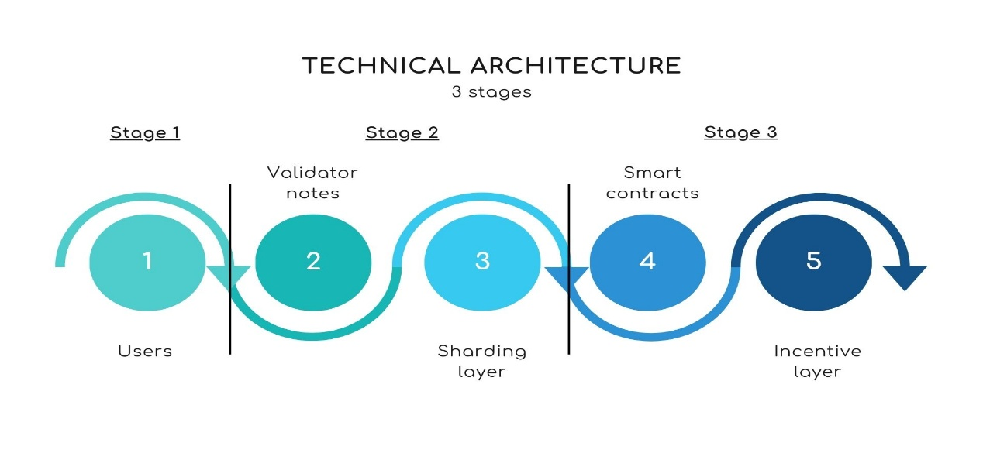**Governance Model**

EcoChain follows a decentralized governance model, where token holders can vote on key network upgrades, economic policies, and validator rewards. Governance decisions are made through on-chain voting, using the ECN token as the governance token.

**Security Measures**

EcoChain implements robust security protocols to ensure the safety and integrity of the network and its users.

1. **Consensus Mechanism**

We use Proof of Stake (PoS), which is energy-efficient and provides enhanced security against attacks compared to traditional Proof of Work (PoW).

1. **Validator Security**

Validators are required to stake tokens, ensuring they have a vested interest in maintaining the network’s integrity. Misconduct leads to penalties, ensuring honest behavior.

1. **Smart Contract Audits**

All smart contracts on EcoChain undergo rigorous third-party security audits to prevent vulnerabilities or malicious exploits.

1. **Data Encryption**

User data and transaction information are encrypted, ensuring confidentiality and protection against unauthorized access.

1. **Multi-Signature Wallets**

EcoChain supports multi-signature wallets, requiring multiple approvals for transactions, adding an additional layer of security for high-value transactions.

**Community & Ecosystem Development**

EcoChain is committed to fostering a strong community and building a thriving ecosystem around its platform.

1. **Developer Support**

We provide tools, documentation, and incentives to support developers in building decentralized applications (dApps) on the EcoChain network.

1. **Community Engagement**

Through regular updates, forums, and social media, we actively engage with the community to ensure transparency and gather feedback for continuous improvement.

1. **Reward Programs**

Incentive programs are available for early adopters, developers, and validators to encourage participation and contributions to the ecosystem.

1. **Strategic Partnerships**

We are forming partnerships with key industry players to expand the reach of EcoChain and integrate our platform into various sectors.

1. **Educational Initiatives**

EcoChain runs educational campaigns to inform users about blockchain technology and the benefits of our platform, fostering a knowledgeable and engaged community.

**Tokenomics**

ECN Token

The EcoChain ecosystem operates using the ECN Token, which serves as the utility and governance token for the network.

1. Total Supply: 1,000,000,000 ECN

2. Initial Coin Offering (ICO): 500,000,000 ECN (50% of total supply)

3. Team Allocation: 100,000,000 ECN (10%)

4. Staking Rewards: 200,000,000 ECN (20%)

5. Development Fund: 200,000,000 ECN (20%)

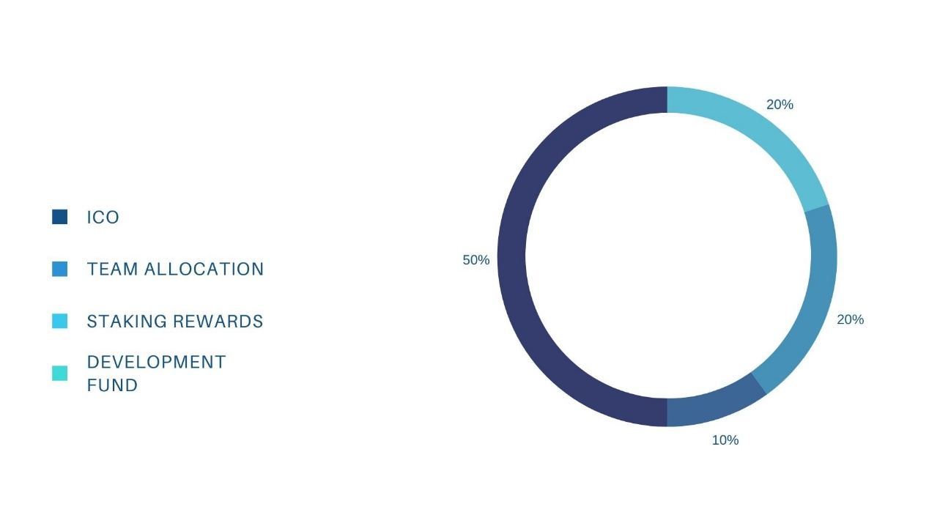

**Economic Model**

EcoChain’s economic model is designed to drive utility, incentivize participation, and ensure long-term sustainability.

**Token Utility**

ECN Tokens serve multiple purposes**:**

**Transaction fees**: Required for processing transactions.

**Access to dApps**: Developers and users need ECN for interacting with applications.

**Governance**: Token holders vote on network decisions.

For example, deploying a DeFi application on EcoChain requires ECN tokens for smart contract execution.

**Developer Grants**: Funding from the development fund for dApp creators.

Revenue from transaction fees and partnerships supports network upgrades and ecosystem expansion, ensuring the platform evolves with demand.

**Staking and Rewards**

Validators are required to stake a minimum of 10,000 ECN to participate in the network. The staking mechanism is designed to be energy-efficient, with validators incentivized to use renewable energy sources. Stakers can expect an annual yield of approximately 5-8%, depending on network activity and energy contributions.

**Market Analysis**

Growth of Green Energy in Blockchain

The adoption of green energy in the cryptocurrency space is gaining momentum. According to a report by CoinShares, approximately 74% of Bitcoin mining operations are already using renewable energy to some degree . With regulatory pressure and public opinion shifting towards sustainable solutions, projects like EcoChain are well-positioned to lead the charge in green blockchain initiatives.

Competitor Landscape

Key competitors in the green blockchain space include:

Chia Network: Uses Proof of Space and Time (PoST) to lower energy consumption.

Algorand: A high-performance blockchain that claims to be carbon-neutral by offsetting its energy consumption.

While these projects have made strides toward energy efficiency, EcoChain's unique incentive structure for renewable energy usage sets it apart.

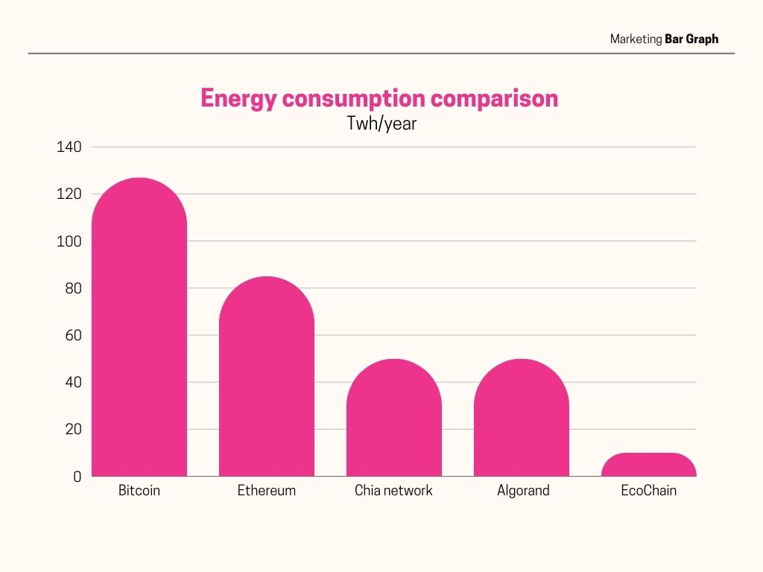

**Roadmap**

|  |  |  |
| --- | --- | --- |
| Phase | Milestones | Timeline |
| Phase 1 | White paper release and community engagement | In process |
| Phase 2 | Testnet launch and staking feature rollout | >> |
| Phase 3 | Main network launch with cross-chain compatibility | >> |
| Phase 4 | Introduction of green energy validator rewards program | >> |
| Phase 5 | Expansion of dApp ecosystem and strategic partnerships | >> |

**Environmental Impact**

By focusing on energy-efficient validation and renewable energy incentives, EcoChain can reduce the carbon footprint of blockchain transactions by as much as 85% compared to PoW-based networks like Bitcoin. The estimated annual energy consumption of EcoChain is less than 10 TWh, making it one of the most sustainable blockchain platforms.

**Legal Compliance**

EcoChain ensures compliance with all applicable laws and regulations to build trust and security for users and investors.

1. **KYC/AML Compliance**

EcoChain adheres to Know Your Customer (KYC) and Anti-Money Laundering (AML) regulations to prevent illegal activities. All users must undergo identity verification before participating in transactions.

1. **GDPR Compliance**

We are fully compliant with the General Data Protection Regulation (GDPR) to protect user data. Users have the right to access, modify, or delete their personal data as needed.

1. **Token Legal Framework**

ECN Tokens are classified as utility tokens and comply with all legal standards for token distribution and use. They provide no ownership or equity rights but are used to access services within the network.

1. **International Compliance**

EcoChain complies with international regulations, including those in the United States, European Union, and other regions. Special procedures will be followed for investors in countries with strict cryptocurrency regulations.

**Conclusion**

EcoChain is poised to become a leading player in the sustainable blockchain space. By addressing both environmental and scalability concerns, the project offers a compelling solution for the future of decentralized finance and transactions. With a clear roadmap, strong tokenomics, and a focus on green energy, EcoChain is positioned for long-term success in the evolving blockchain ecosystem.

**References**

1. Cambridge Centre for Alternative Finance. (2023). Bitcoin Energy Consumption Index.

2. CoinShares. (2022). Bitcoin Mining and Renewable Energy Report.