**PIZZA SALES SQL QUERIES**

**Create database**

CREATE DATABASE IF NOT EXISTS pizzaSales;

**Create Table**

CREATE TABLE IF NOT EXISTS pizza_sales (

    order_details_id INT NOT NULL AUTO_ICREMAENT PRIMARY KEY,

    order_id INT NOT NULL,

    pizza_id VARCHAR(30) NOT NULL,

    total_orders DECIMAL(10,2) NOT NULL,

    quantity INT NOT NULL,

    unit_price DECIMAL(10,2) NOT NULL,

    order_date DATETIME NOT NULL,

    order_time TIME NOT NULL,

    total_price DECIMAL(12, 4) NOT NULL,

    pizza_size VARCHAR(15) NOT NULL,

    pizza_category VARCHAR(15) NOT NULL,

    pizza_ingredients VARCHAR(100) NOT NULL,

    pizza_name VARCHAR(15) NOT NULL,

);

**KPI**

1. **Total Revenue:**

SELECT SUM(total_price) AS total_revenue FROM pizza_sales;



1. **Average Order Value:**

SELECT SUM(total_price)/ COUNT( DISTINCT order_id) AS avg_order_value FROM pizza_sales;



1. **Total Pizzas Sold:**

SELECT SUM(quantity) AS total_pizza_sold FROM pizza_sales;



1. **Total Orders:**

SELECT COUNT(DISTINCT order_id) AS total_order FROM pizza_sales;



1. **Average Pizzas Per Order:**

SELECT CONVERT(SUM(quantity)/ COUNT(DISTINCT order_id), DECIMAL(10,2)) AS avg_pizzas_per_order FROM pizza_sales;



**Percentage of Sales by Pizza Size**

[SELECT](http://localhost/phpmyadmin/url.php?url=https://dev.mysql.com/doc/refman/8.0/en/select.html) pizza_size, CONVERT(([SUM](http://localhost/phpmyadmin/url.php?url=https://dev.mysql.com/doc/refman/8.0/en/aggregate-functions.html%23function_sum)(total_price)* 100)/([SELECT](http://localhost/phpmyadmin/url.php?url=https://dev.mysql.com/doc/refman/8.0/en/select.html) [SUM](http://localhost/phpmyadmin/url.php?url=https://dev.mysql.com/doc/refman/8.0/en/aggregate-functions.html%23function_sum)(total_price) FROM pizza_sales), DECIMAL(10,2)) AS `%_of_sales`

FROM pizza_sales

GROUP BY pizza_size;

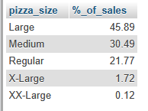

**Hourly Trend for Total Pizzas Sold**

SELECT TIME_FORMAT(order_time,"%H") AS order_hours,

COUNT(DISTINCT order_id) AS total_orders

FROM pizza_sales

GROUP BY order_hours

ORDER BY order_hours;

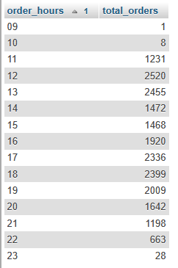

**daily Trend for Total Orders**

SELECT DATE_FORMAT(order_date, '%W') AS day_of_week, COUNT(DISTINCT order_id) AS total_order

FROM pizza_sales

GROUP BY day_of_week

ORDER BY FIELD(day_of_week, 'Sunday', 'Monday', 'Tuesday', 'Wednesday', 'Thursday', 'Friday', 'Saturday');

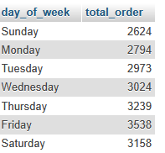

**Percentage of Sales by Pizza Category**

SELECT pizza_category,

SUM(total_price) AS total_revenue,

CONVERT(SUM(total_price) * 100 / (SELECT SUM(total_price) FROM pizza_sales) , DECIMAL(10,2)) AS `%_of_sales`

FROM pizza_sales

GROUP BY pizza_category

ORDER BY total_revenue;

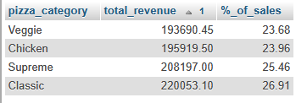

**Percentage of Sales by Pizza Size**

SELECT pizza_size,

SUM(total_price) AS total_revenue,

CONVERT(SUM(total_price) * 100 / (SELECT SUM(total_price) FROM pizza_sales) , DECIMAL(10,2)) AS `%_of_sales`

FROM pizza_sales

GROUP BY pizza_size

ORDER BY total_revenue DESC;

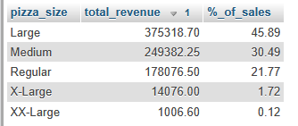

**Total Pizzas Sold by Pizza Category**

SELECT pizza_category,

SUM(quantity) AS total_quqntity_sold

FROM pizza_sales

GROUP BY pizza_category

ORDER BY total_quqntity_sold DESC;

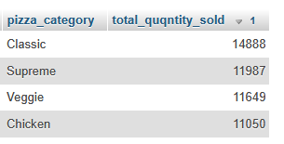

**Top 5 Best Sellers by Revenue, Total Quantity and Total Orders**

SELECT pizza_name,

CONVERT(SUM(total_price), DECIMAL(10,2)) AS revenue,

SUM(quantity) AS total_quantity,

COUNT(DISTINCT order_id) AS total_order

FROM pizza_sales

GROUP BY pizza_name

ORDER BY revenue DESC

LIMIT 5;

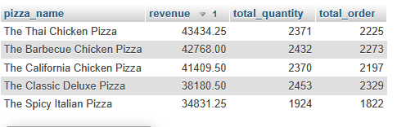

**Bottom 5 Best Sellers by Revenue, Total Quantity and Total Orders**

SELECT pizza_name,

CONVERT(SUM(total_price), DECIMAL(10,2)) AS revenue,

SUM(quantity) AS total_quantity,

COUNT(DISTINCT order_id) AS total_order

FROM pizza_sales

GROUP BY pizza_name

ORDER BY revenue

LIMIT 5;

