COURSE CODE/TITLE: | CPE212 Automating Server Management |  | SECTION: | CPE31S2
DATE PERFORMED: | 07/18/2026 |  | DATE SUBMITTED: | 07/23/2026
NAME: | Aicon H. Keliste |  | INSTRUCTOR: | Engr, Jimlord Quejado

ACTIVITY NO. 2.1 | SSH Key-Based Authentication and GIT Setup
1. PROCEDURE OUTPUT
Task 1:
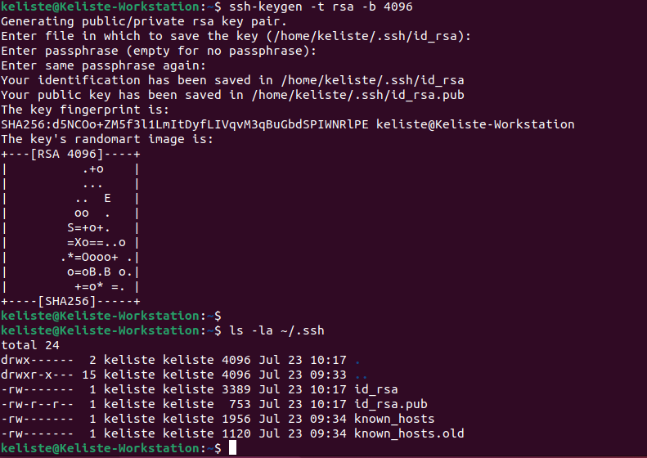
\

Task 2:
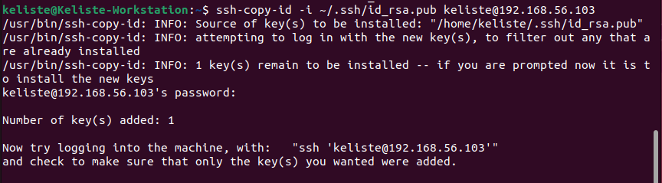
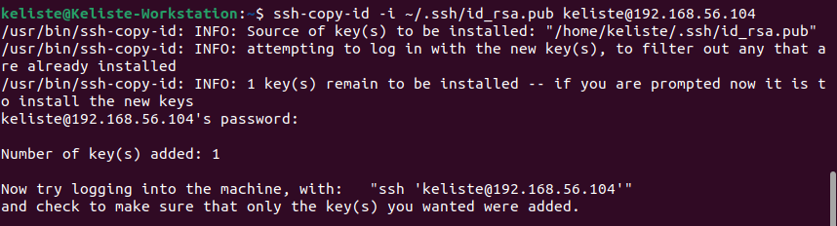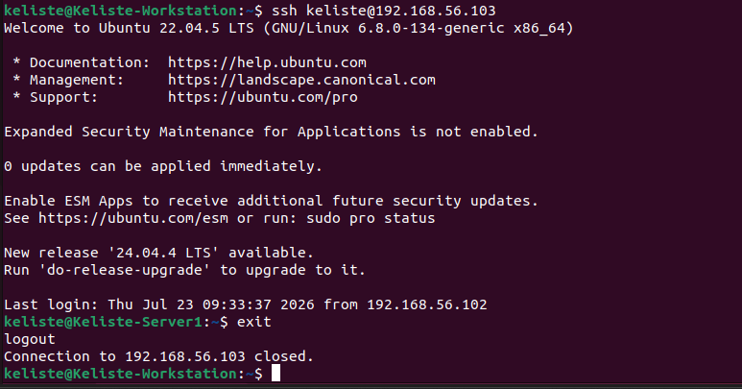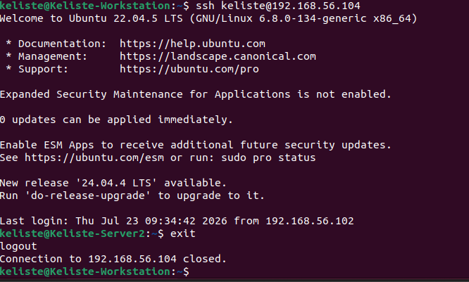
Task 3:
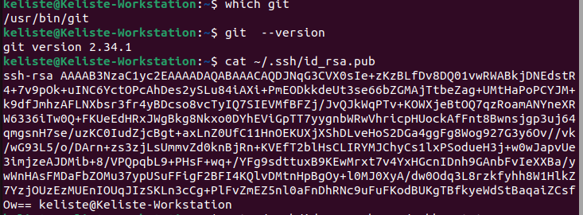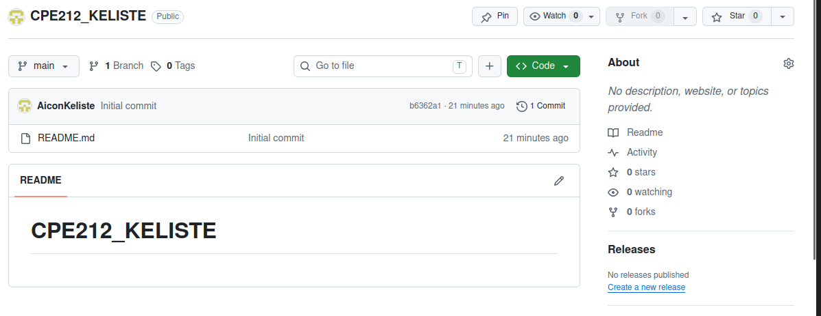
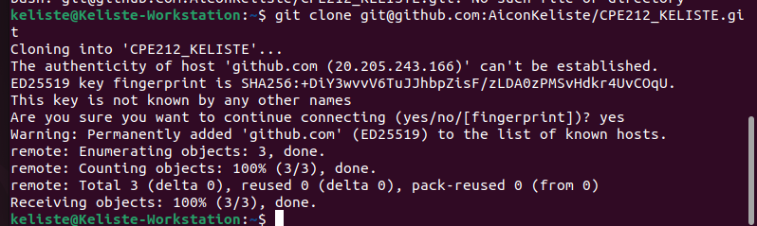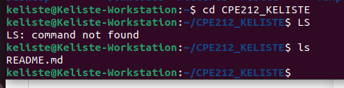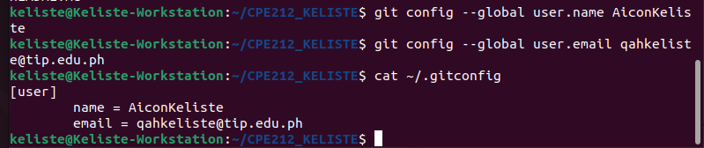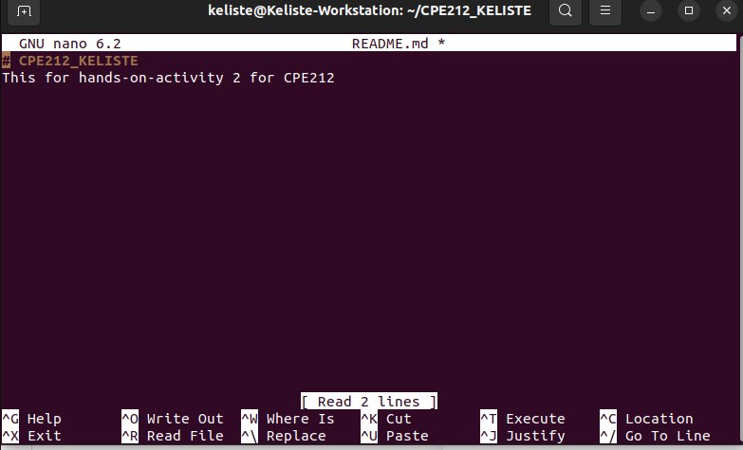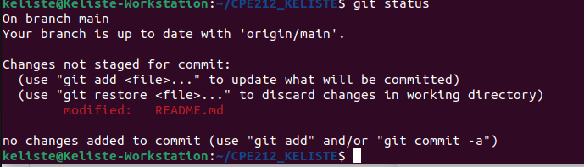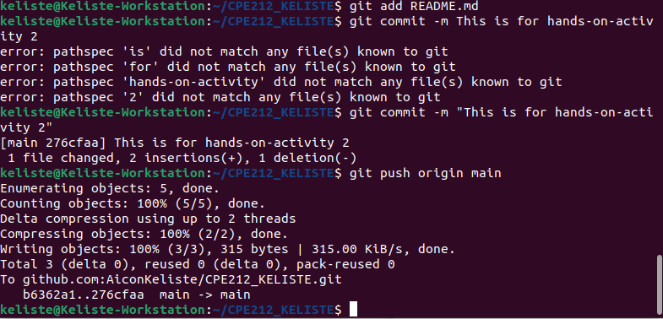
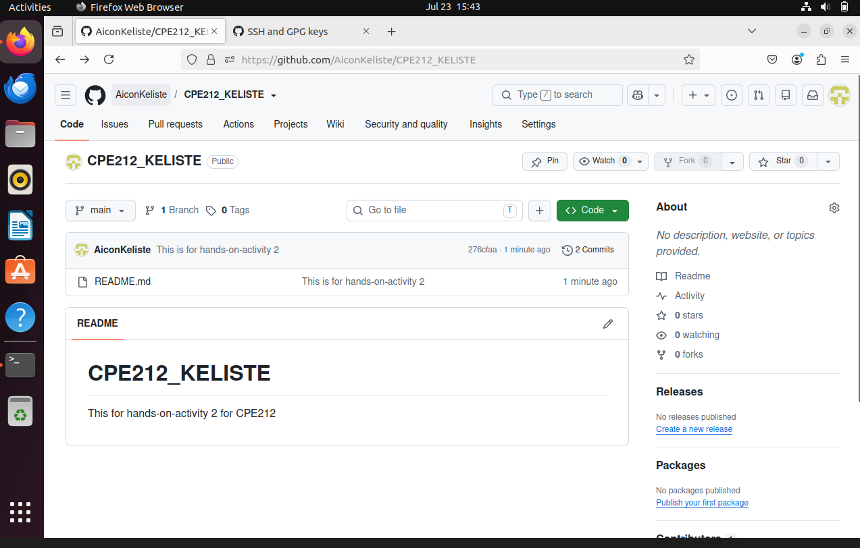
2. ANSWERS TO SUPPLEMENTAL ACTIVITY
1. How will you describe the ssh-program? What does it do?
- SSH is a network protocol that allows the user to connect and control a remote computer over an unsecured network. Unlike other protocols, ssh encrypts all communication such as passwords and datas.
2. How do you know that you already installed the public key to the remote servers?
- You can check the remote server by running cat ~/.ssh/authorized_keys which will display the public key.
3. What sort of things have we so far done to the remote servers using ansible commands?
- Ansible ad-hoc commands to test connectivity such as ansible all -m pign that can be used to ping another server or system.
4. How important is the inventory file?
- Inventory file is important because it tells ansible exactly which remote servers to manage.
3. ARTIFICIAL INTELLIGENCE (AI) USE DISCLOSURE STATEMENT
I hereby declare that artificial intelligence (AI) tools were used, if applicable, in the preparation of this academic work. The following indicates the nature and extent of AI assistance:

Tools Used: | Chatgpt
Examples: ChatGPT, Microsoft Copilot, Grammarly, QuillBot, etc.

Purpose of Use: | Idea generation
Examples: grammar correction, idea generation, formatting, summarization, code assistance, explanation of concepts, etc.

Extent of Use: | Used for idea generations and also for grammar checking
Explain how AI was used and confirm that it did not replace original thinking, analysis, authorship, or completion of the required work.

By submitting this activity, I affirm that my use of AI complies with T.I.P.’s AI usage policy and does not exceed the permitted limits for similarity, automated content generation, or academic assistance.

I understand that any false, incomplete, or misleading disclosure may be subject to investigation in accordance with due process and may result in sanctions for violation of existing T.I.P. policies.

Lab activities, templates, and related instructional materials shall not be reuploaded, reproduced, distributed, or shared with external organizations or third parties without the prior express written permission of the Technological Institute of the Philippines.

