COURSE CODE/TITLE: | CPE212 Automating Server Management |  | SECTION: | CPE31S2
DATE PERFORMED: | 8/25/26 |  | DATE SUBMITTED: | 8/26/26
NAME: | Aicon H. Keliste |  | INSTRUCTOR: | Engr. Jimlord Quejado

ACTIVITY NO. 5.1 | Implement Ansible roles in playbooks
1. PROCEDURE OUTPUT
Task 1:
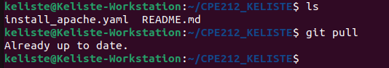
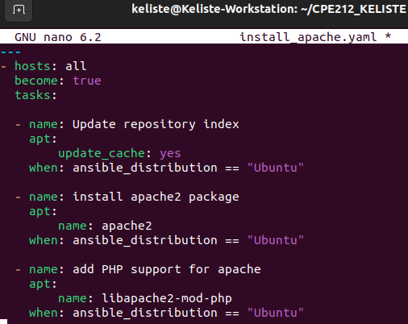
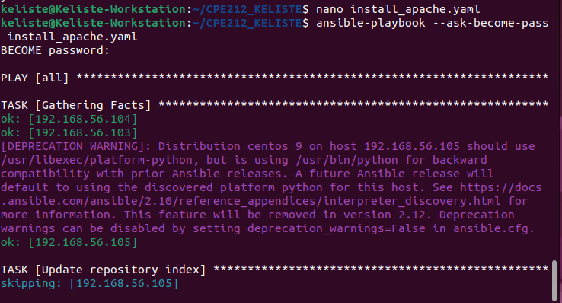
Describe: It shows skipping because 192.168.56.105 is a CentOS machine
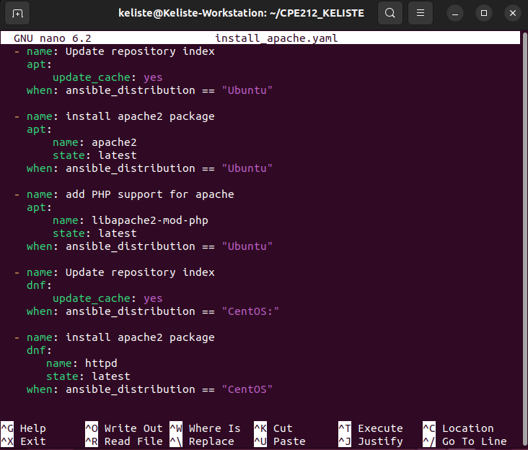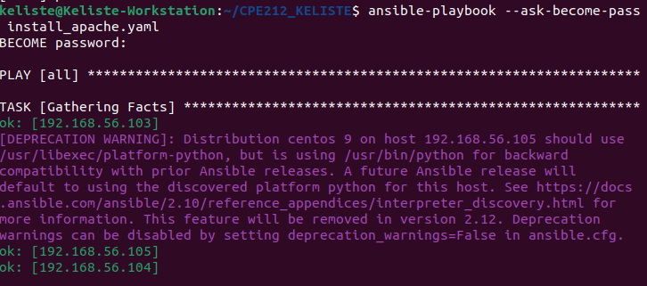
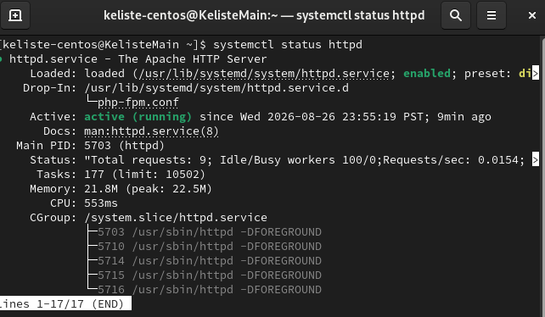
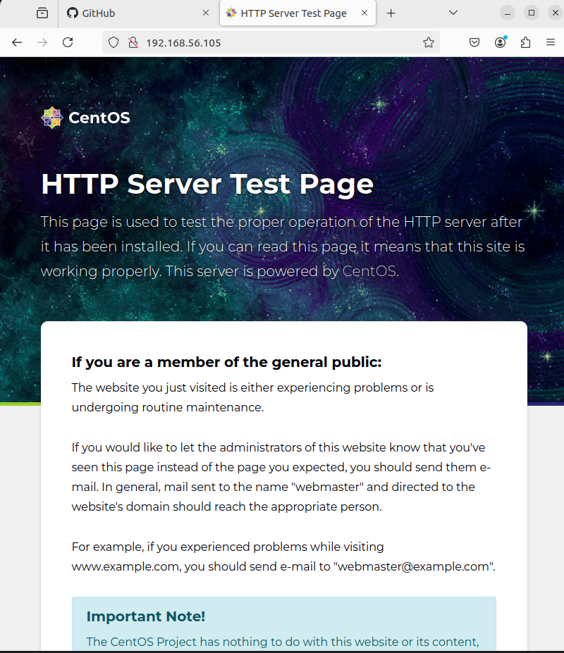
Task 2:
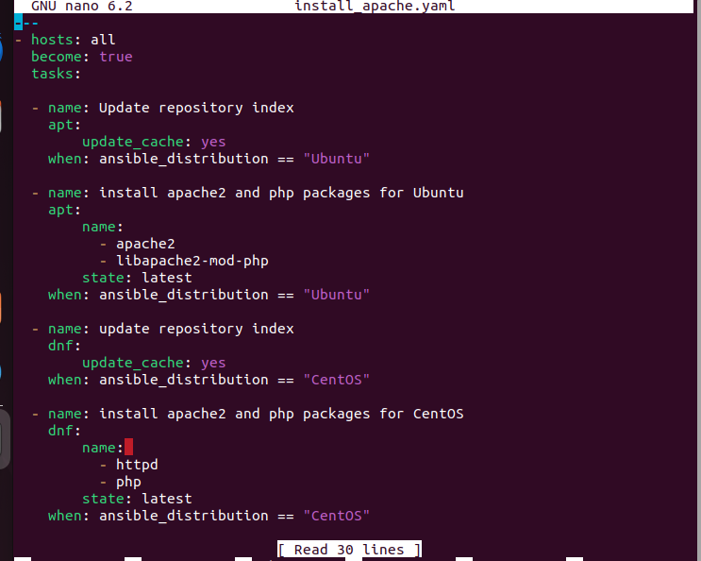
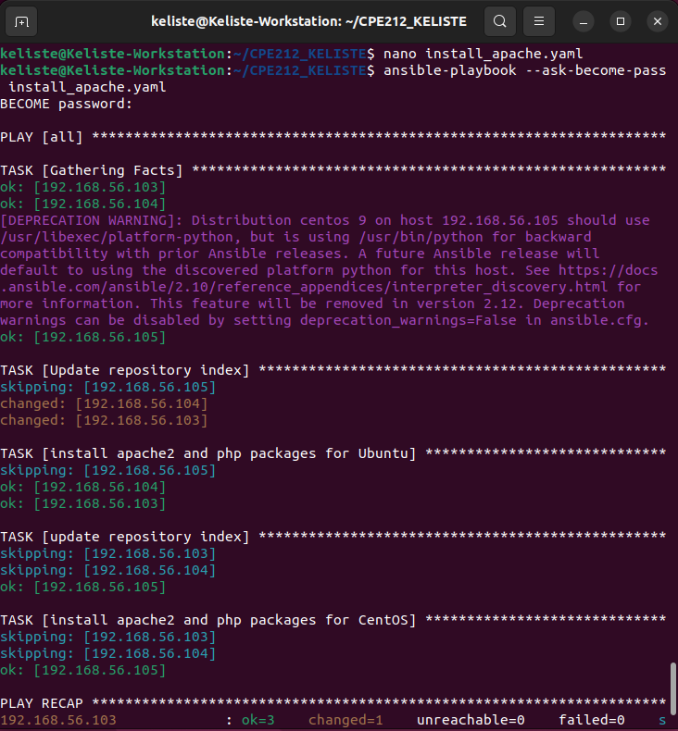
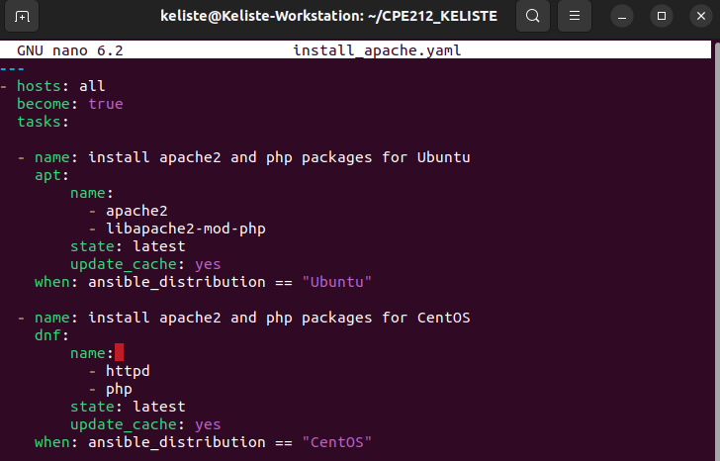
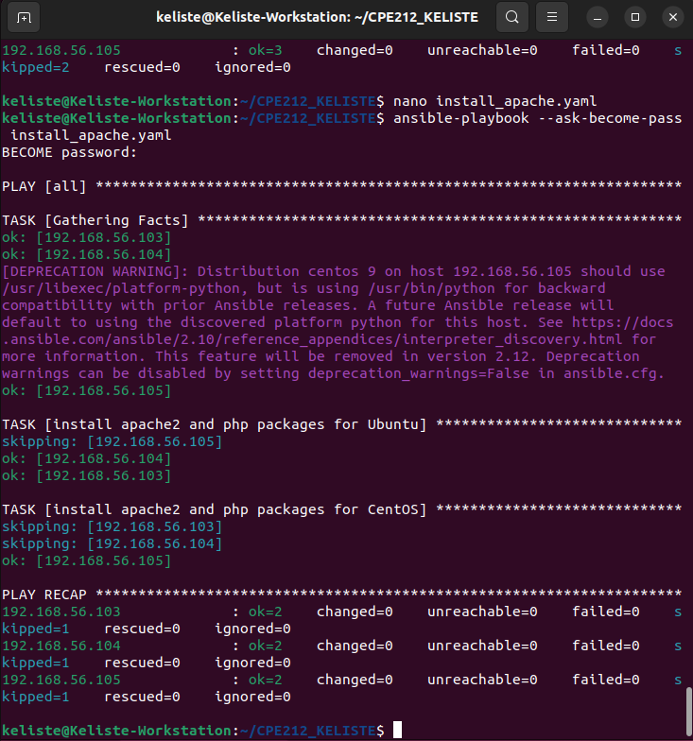
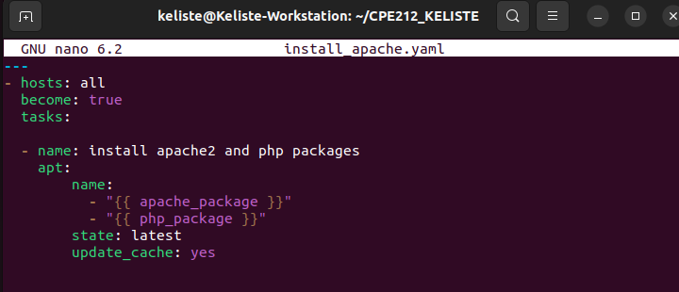
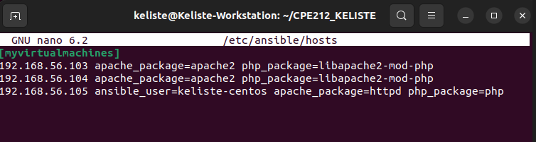
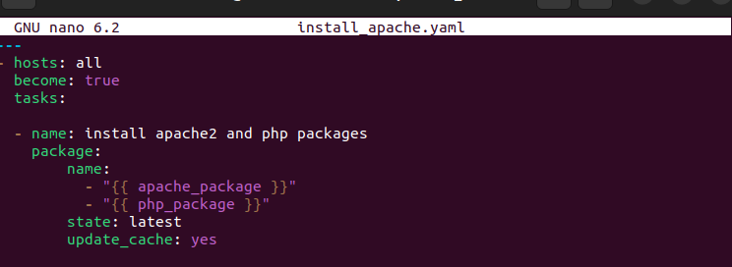
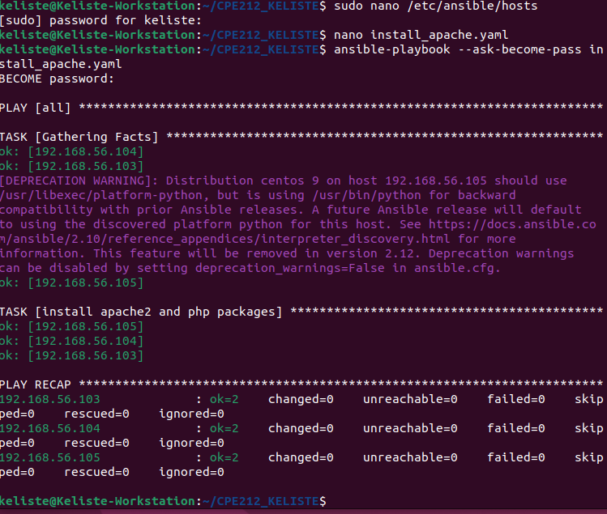
2. ANSWERS TO SUPPLEMENTAL ACTIVITY
1. Create a playbook that could do the previous tasks in Red Hat OS.
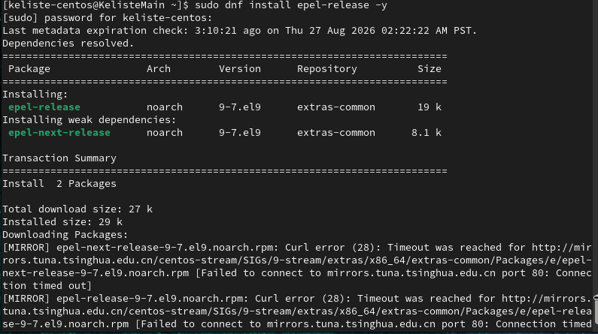
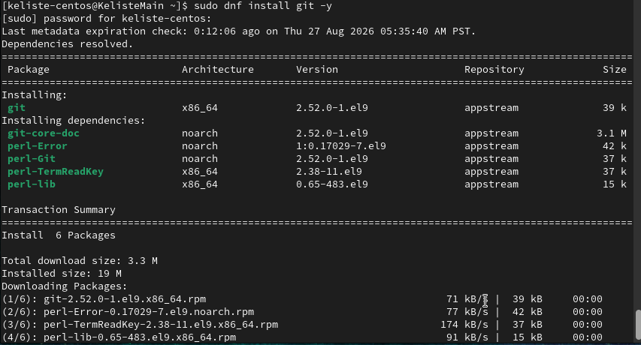
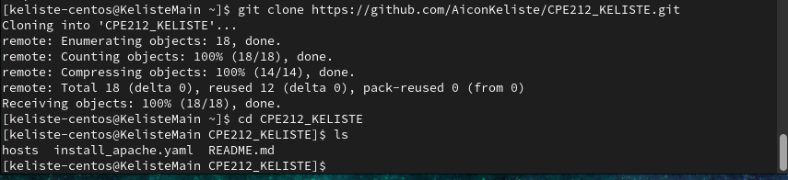
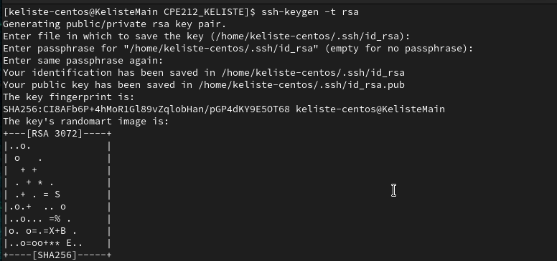
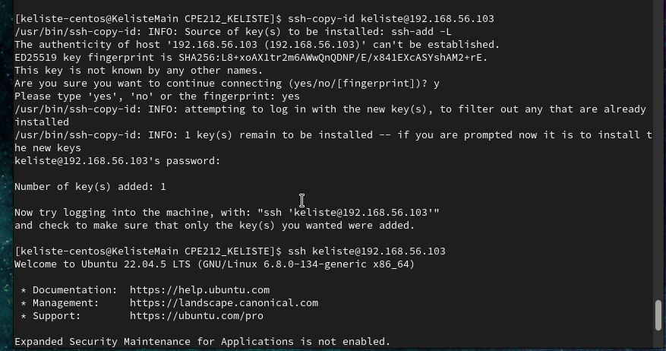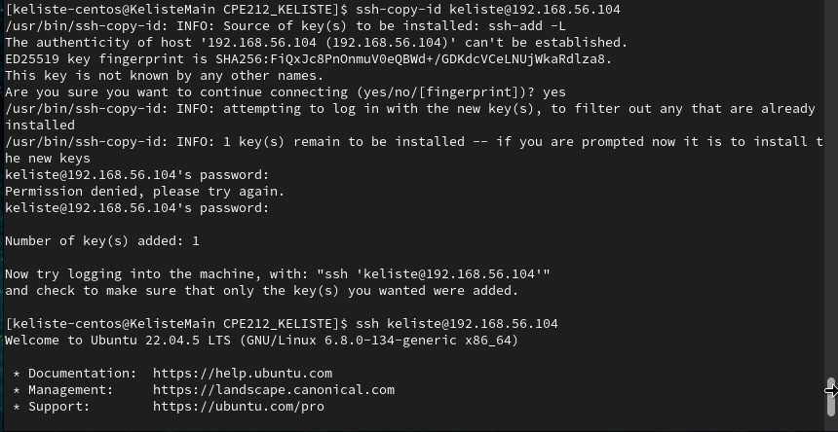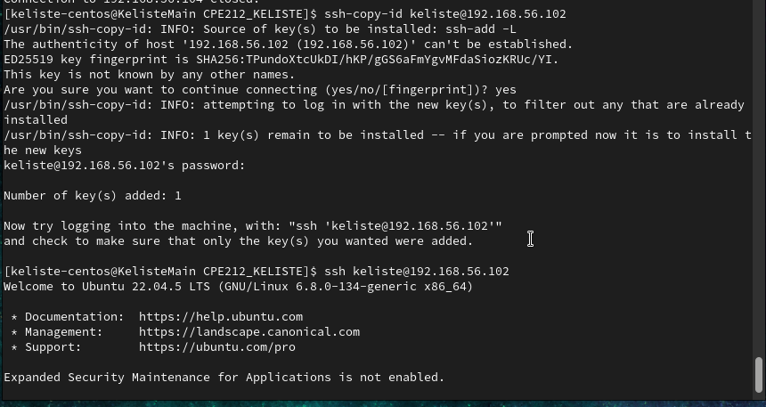

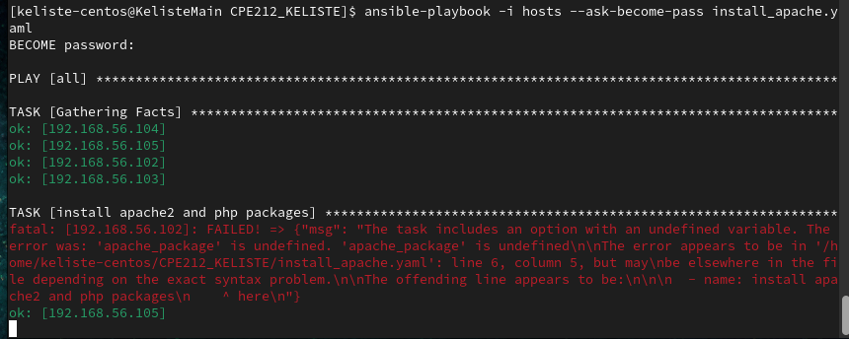
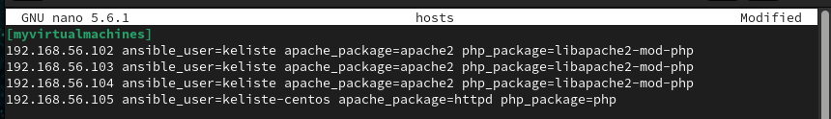
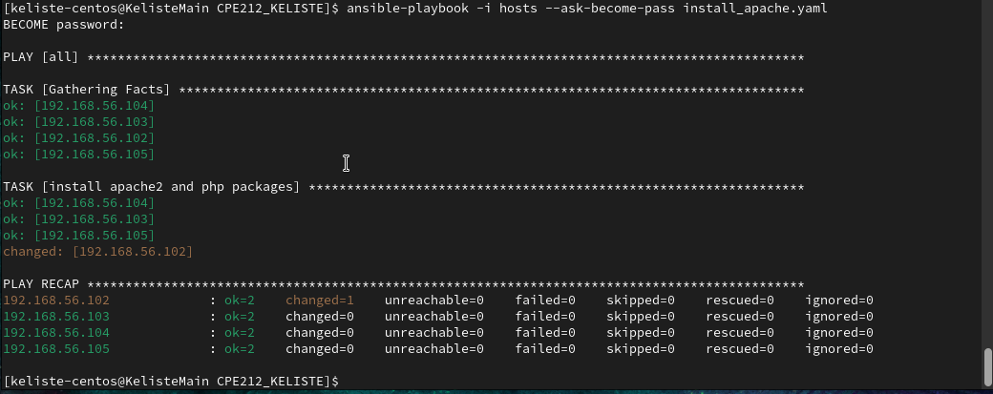

Reflections:
Answer the following:
1. Why do you think refactoring of playbook codes is important?
- Refactoring makes the playbook easier to read and maintain, since one variable-based task replaces multiple OS-specific ones. It also cuts execution time, since Ansible runs fewer tasks per host.

2. When do we use the “when” command in playbook?
- I use when whenever a task should only run on hosts meeting a specific condition, like ansible_distribution. It was essential once I had a mixed Ubuntu/CentOS environment, since each needed different package managers. Without it, Ansible would try running apt on CentOS and fail instead of skipping the task.

3. ARTIFICIAL INTELLIGENCE (AI) USE DISCLOSURE STATEMENT
I hereby declare that artificial intelligence (AI) tools were used, if applicable, in the preparation of this academic work. The following indicates the nature and extent of AI assistance:

Tools Used: | Claude AI
Examples: ChatGPT, Microsoft Copilot, Grammarly, QuillBot, etc.

Purpose of Use: | Command Assistance
Examples: grammar correction, idea generation, formatting, summarization, code assistance, explanation of concepts, etc.

Extent of Use: | I asked claude ai on how to transfer the directory from ubuntu into centos vm via ssh and git.
Explain how AI was used and confirm that it did not replace original thinking, analysis, authorship, or completion of the required work.

By submitting this activity, I affirm that my use of AI complies with T.I.P.’s AI usage policy and does not exceed the permitted limits for similarity, automated content generation, or academic assistance.

I understand that any false, incomplete, or misleading disclosure may be subject to investigation in accordance with due process and may result in sanctions for violation of existing T.I.P. policies.

Lab activities, templates, and related instructional materials shall not be reuploaded, reproduced, distributed, or shared with external organizations or third parties without the prior express written permission of the Technological Institute of the Philippines.

