COURSE CODE/TITLE: | CPE212 Automating Server Management |  | SECTION: | CPE31S2
DATE PERFORMED: | 08/18/2026 |  | DATE SUBMITTED: | 08/18/2026
NAME: | Aicon H. Keliste |  | INSTRUCTOR: | Engr. Jimlord Quejado

ACTIVITY NO. 4 | Running Elevated Ad hoc Commands
1. PROCEDURE OUTPUT
Task1:
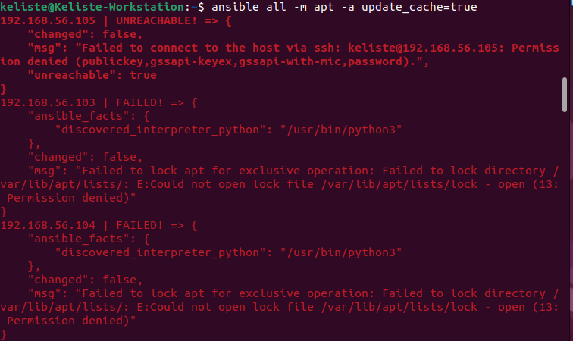
Ubuntu Server
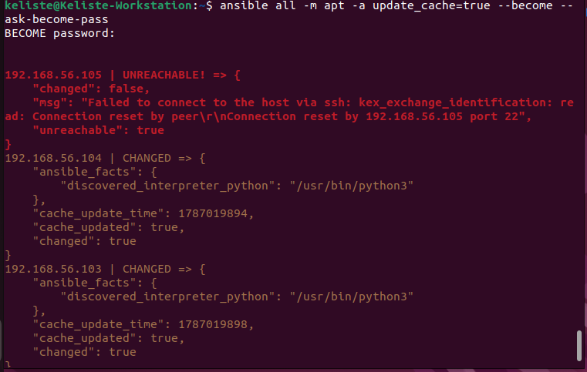
CentOS
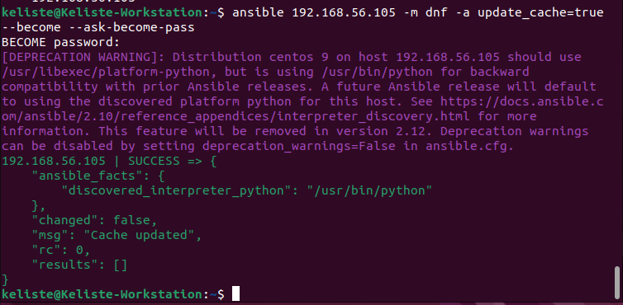
Ubuntu
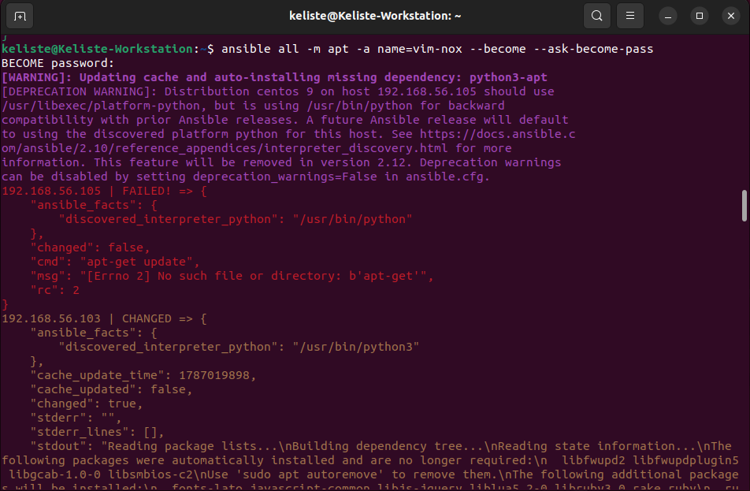

CentOS
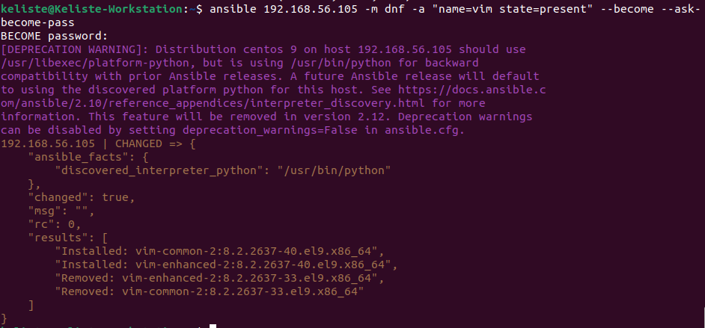
Server 1
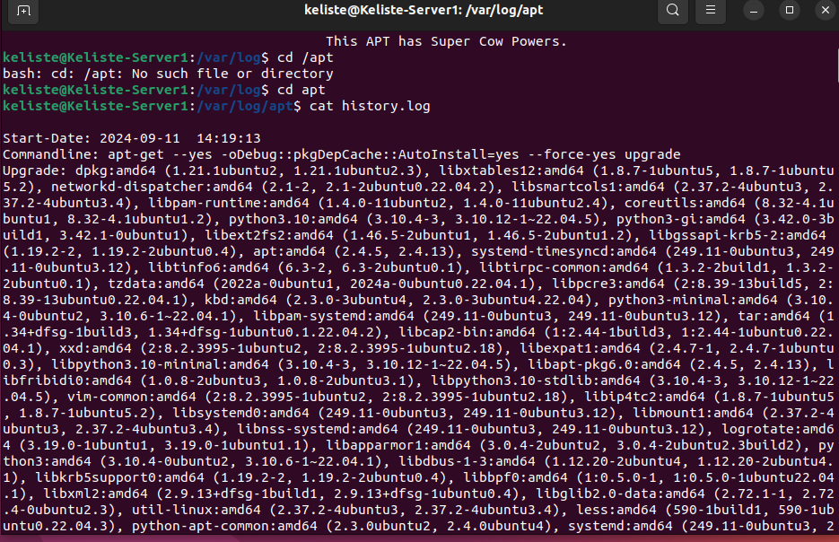

Server 2
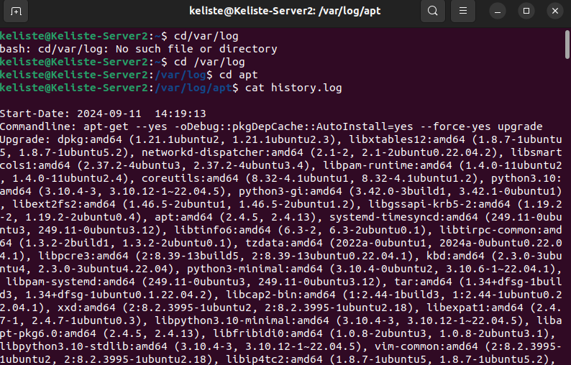
Describe what you see in the history.log.
→ The history.log shows many system packages and libraries being installed and updated to newer versions.
Ubuntu
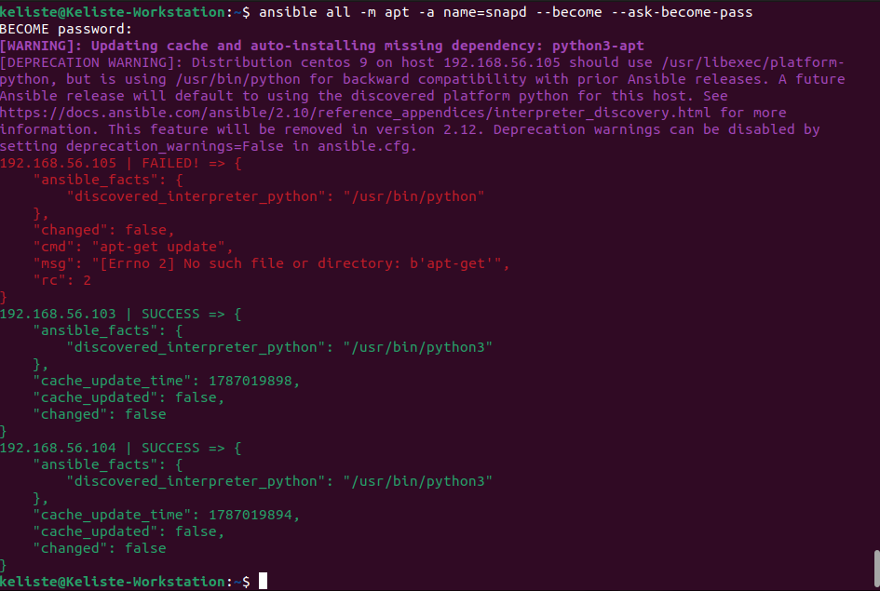
Can you describe the result of this command? Is it a success? Did it change anything in the
remote servers?
→ No, because the command shows changed: false meaning the ansible did not make any changes to the remote server.
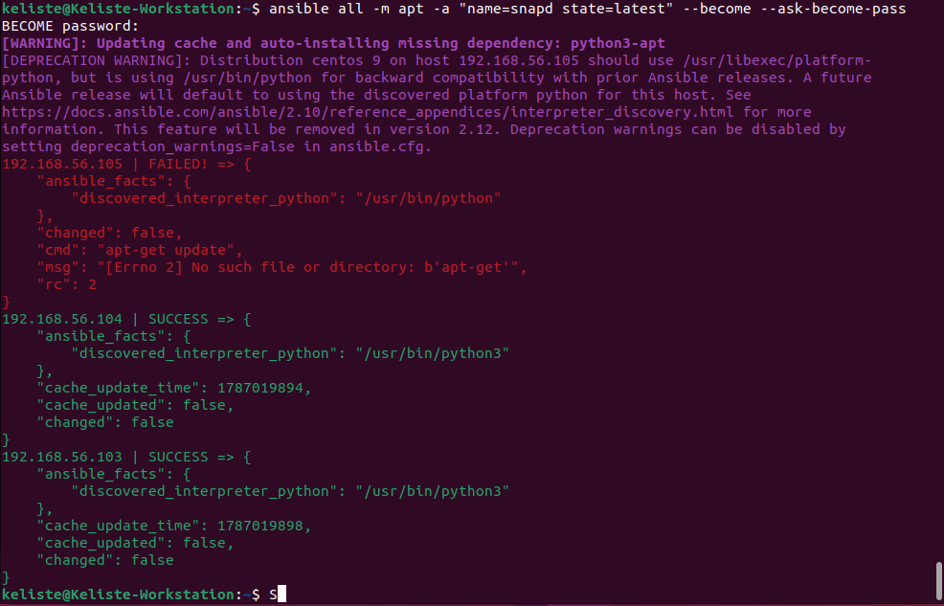
Describe the output of this command. Notice how we added the command state=latest and placed
them in double quotations
→ The command tries to install or update snapd to the latest version on all hosts using ansible apt module. It succeeded in both Ubuntu servers while in Centos it failed.
Task2:
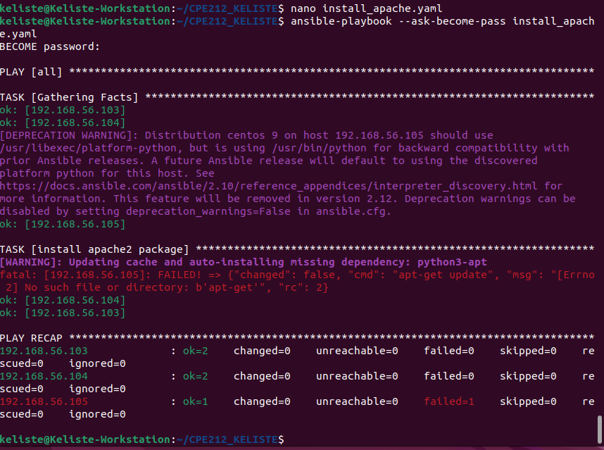
Server 1:
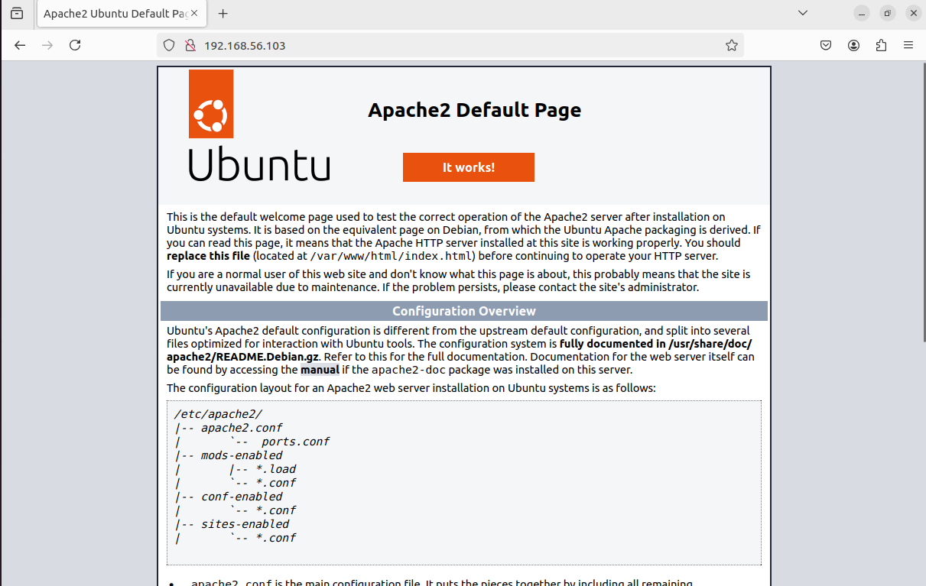
Server 2:
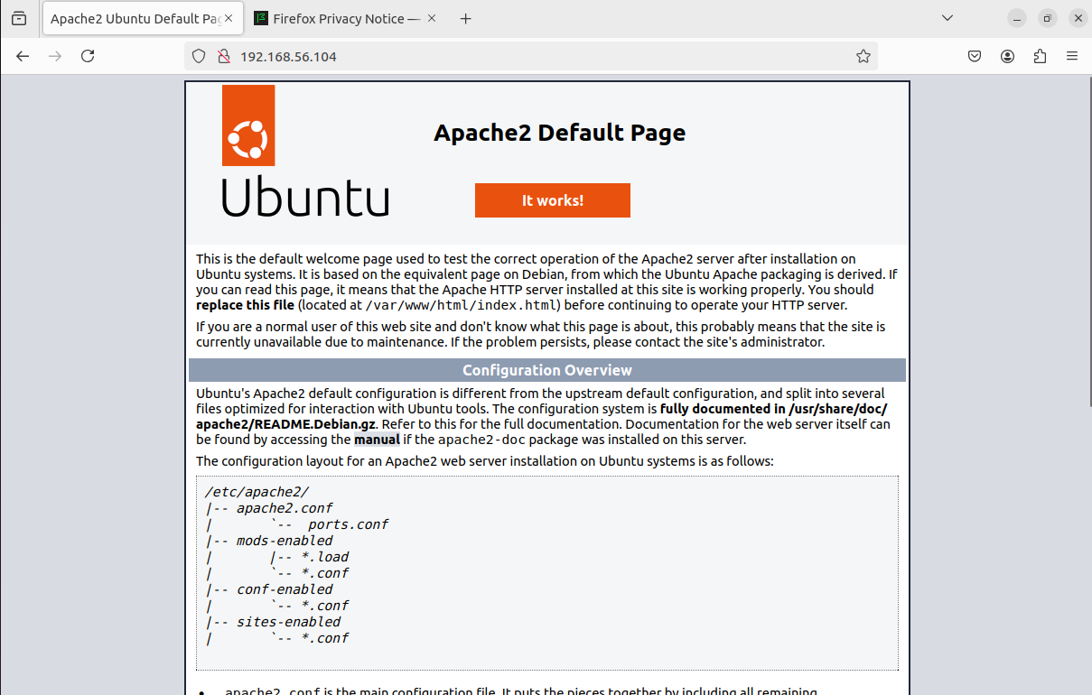
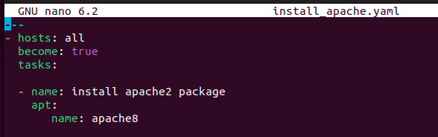
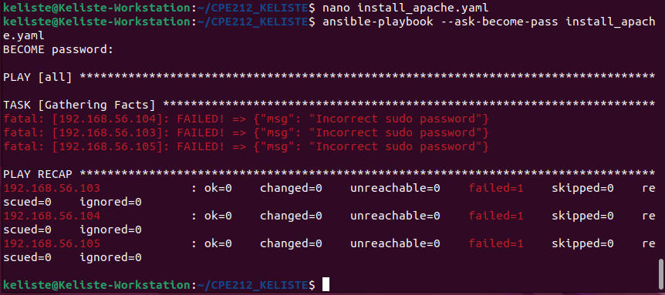
Try to edit the install_apache.yml and change the name of the package to any name that will not be
recognized. What is the output? → The output shows a package not found/error message because Ansible cannot install a package that does not exist.

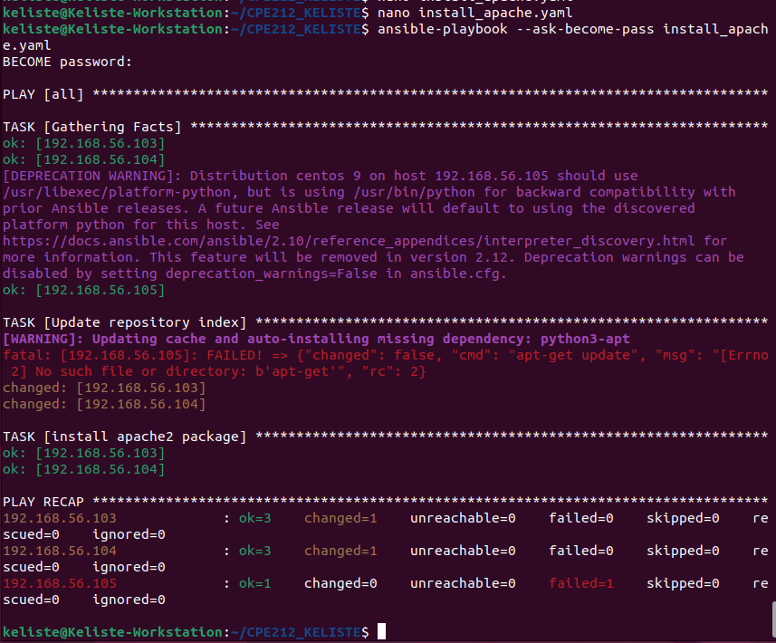
Did the new command change anything on the remote servers?
→ Yes, the new command changed the remote servers 192.168.56.103 and 192.168.56.104 which are both Ubuntu servers. However, 192.168.56.105 failed because it is running CentOS and does not use apt.

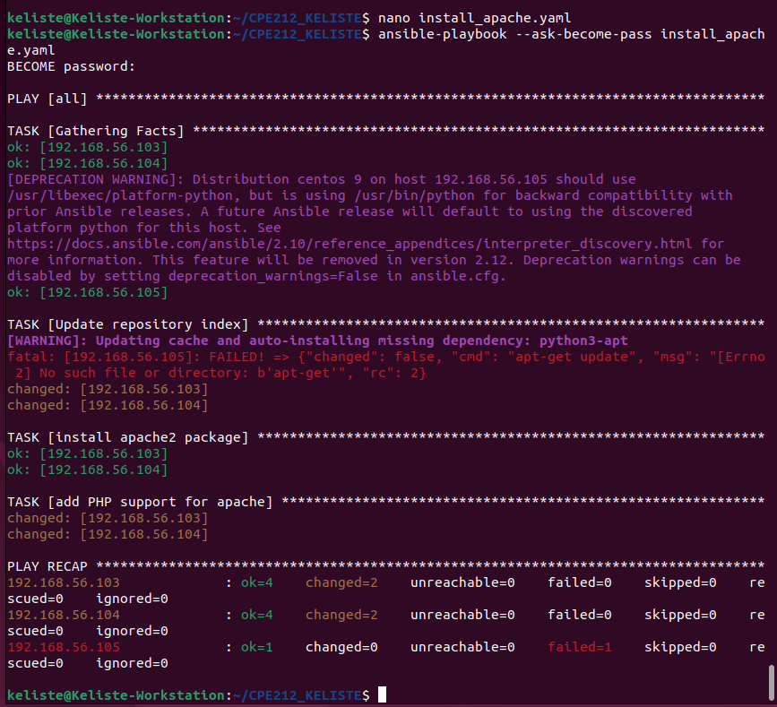
Did the new command change anything on the remote servers?
→ Yes, the command changed the remote servers 192.168.56.103 and 192.168.56.104 by installing Apache and PHP support. However, 192.168.56.105 failed during the repository update, so no changes were made there.

Github Repository Link: https://github.com/AiconKeliste/CPE212_KELISTE.git
2. ANSWERS TO SUPPLEMENTAL ACTIVITY
Answer the following:
1. What is the importance of using a playbook?
- Playbook is important because it organizes tasks across multiple servers. It also saves time and reduces manual errors to make server management easier.
2. Summarize what we have done on this activity.
- In this activity, we created and executed an Ansible playbook to install Apache and PHP support on remote servers. We also synchronized our files with the repository on GitHub to keep our work updated and organized.
Conclusions/Learnings:
- I learned how Ansible playbooks can be used to automate server configuration and manage multiple remote machines efficiently. I also learned that checking the playbook output is important for identifying successful tasks and troubleshooting errors on servers that fail.

3. ARTIFICIAL INTELLIGENCE (AI) USE DISCLOSURE STATEMENT
I hereby declare that artificial intelligence (AI) tools were used, if applicable, in the preparation of this academic work. The following indicates the nature and extent of AI assistance:

Tools Used: | Chatgpt
Examples: ChatGPT, Microsoft Copilot, Grammarly, QuillBot, etc.

Purpose of Use: | Command Assistance
Examples: grammar correction, idea generation, formatting, summarization, code assistance, explanation of concepts, etc.

Extent of Use: | I used chatgpt for command assistance especially with the centos 9 error in vim.
Explain how AI was used and confirm that it did not replace original thinking, analysis, authorship, or completion of the required work.

By submitting this activity, I affirm that my use of AI complies with T.I.P.’s AI usage policy and does not exceed the permitted limits for similarity, automated content generation, or academic assistance.

I understand that any false, incomplete, or misleading disclosure may be subject to investigation in accordance with due process and may result in sanctions for violation of existing T.I.P. policies.

Lab activities, templates, and related instructional materials shall not be reuploaded, reproduced, distributed, or shared with external organizations or third parties without the prior express written permission of the Technological Institute of the Philippines.

